Module 6) JAVASCRIPT BASIC & DOM

# Q.1 What is JavaScript. How to use it?

Ans: JavaScript is the Programming Language.

JavaScript can update and change both HTML and CSS.

JavaScript can calculate, manipulate and validate data.

JavaScript variables:-

1.Numbers

2.Strings

3.Objects

4.Arrays

5.Functions

Syntax of Javascript:-

<script>

// JavaScript Code

</script>

Use of JavaScript:-

Web Application

Web Development

Mobile Development

Games Development

Server Application

Web Servers

Client Side Validation

# Q.2 How many type of Variable in JavaScript?

Ans: JavaScript Variables:- There are four types of varibles in Javascript.

1. Automatically:-

It takes value automatic. Automatically variable is a very easy to use.

2. var :- You can use same var multiple time.

var a=10;

var b=20;

var c=a+b

document.write(c);

3. let :- You can not use same var multiple time.

let a=10;

let b=30;

let c=a+b

document.write(c);

4. const :- const is used when you want constant value is Js.

var a=10;

var b=20;

const c=a+b

document.write(c);

# Q.3 Define a Data Types in js?

Ans: Javascript Data Types :-

Primitive data type:-

JavaScript primitive data types

1.String:- sequence of characters e.g. "hello"

2.Number:- numeric values e.g. 100

3.Boolean:- boolean value either false or true

4.Undefined:- undefined value

5.Null:- null i.e. no value at all

Non-primitive data type:-

JavaScript non-primitive data types

1.Object:- access members

2.Array:- group of similar values

3.RegExp:- regular expression

# Q.4 Write a mul Function Which will Work Properly When invoked With Following Syntax.

Ans: The MUL function is used to the multiplication function.

In this function, we call the function that required an argument as a first number, and that function calls another function that required another argument and this step goes on.

Syntax of MUL:-

function mul(x) {

return function (y) {

return function (z) {

return x * y * z;

};

};

}

Mul Function Which will Work Properly when Invoked With Following syntax.

‘mul(2)(3)(4)’

function mul(x) {

return function(y) {

return function(z) {

return x*y*z;

};

}

}

document.write(mul(2)(3)(5));

document.write(mul(2)(3)(4));

Output:-

30

24

# Q.5 What the deference between undefined and undeclare in JavaScript?

Ans: Undefined: It occurs when a variable has been declared but has not been assigned any value. Undefined is not a keyword.

let delsy;

undefined

console.log(delsy)

Undeclared: It occurs when we try to access any variable that is not initialized or declared earlier using the var or const keyword.

console.log(myVariable)

If we use ‘typeof’ operator to get the value of an undeclared variable, we will face the runtime error with the return value as “undefined”. The scope of the undeclared variables is always global.

# Q.6 Using console.log() print out the following statement: The quote 'There is no exercise better for the heart than reaching down and lifting people up.' by John Holmes teaches us to help one another. Using console.log() print out the following quote by Mother Teresa:

Ans:

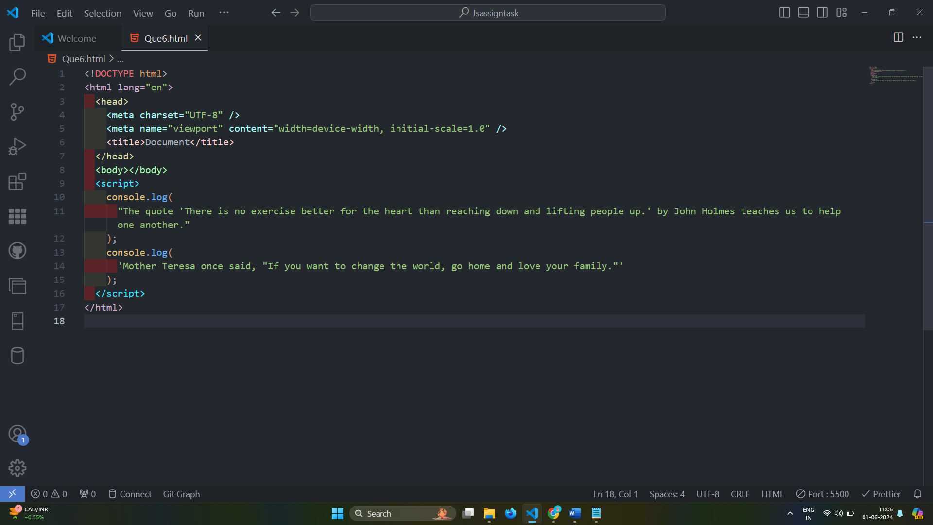

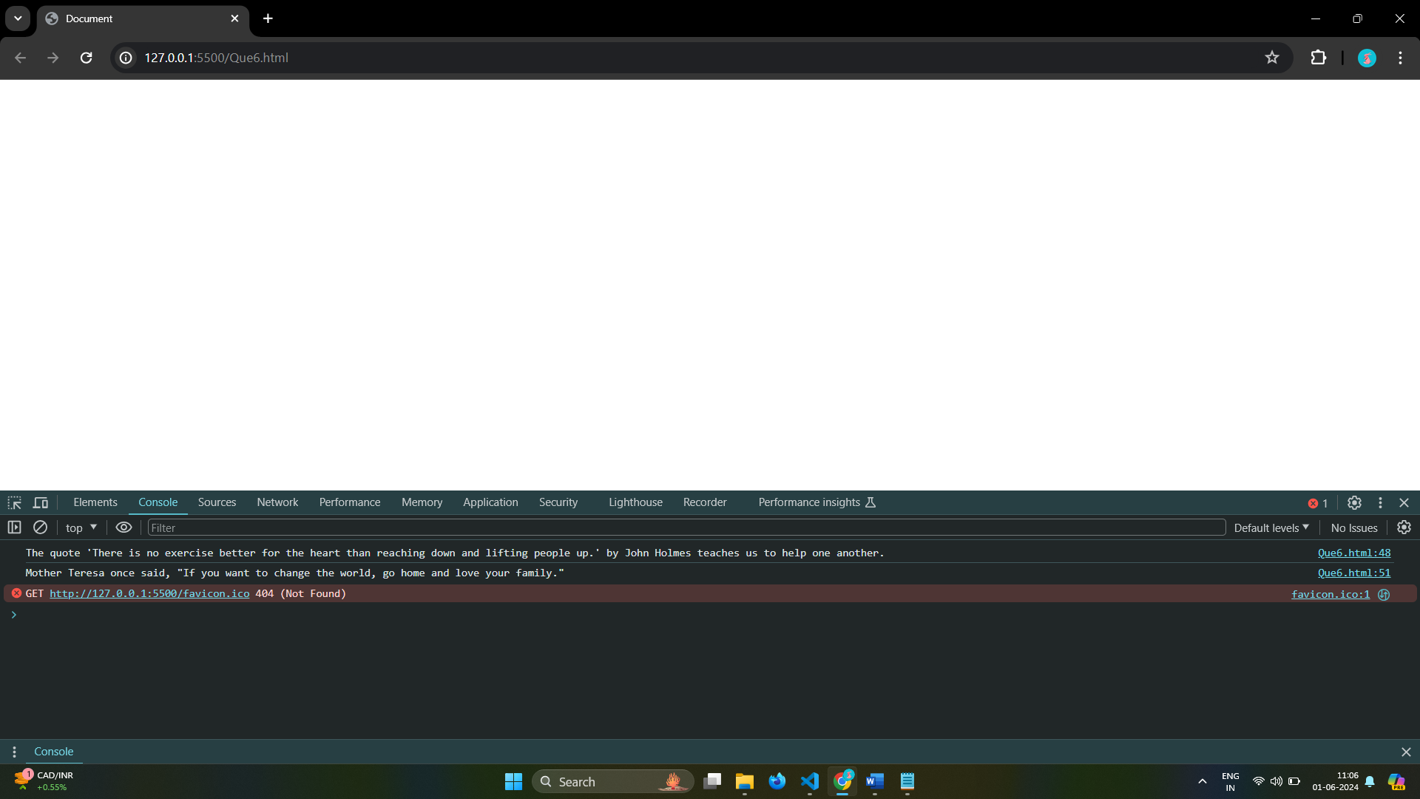

# Q.7 Check if typeof '10' is exactly equal to 10. If not make it exactly equal?

Ans:

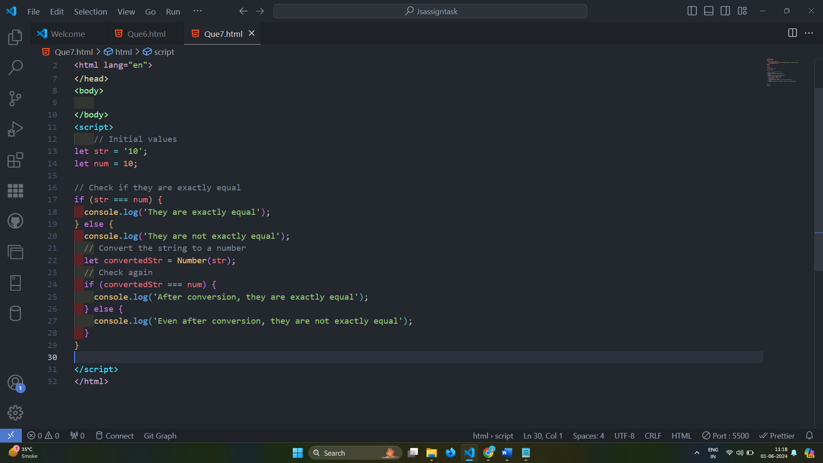

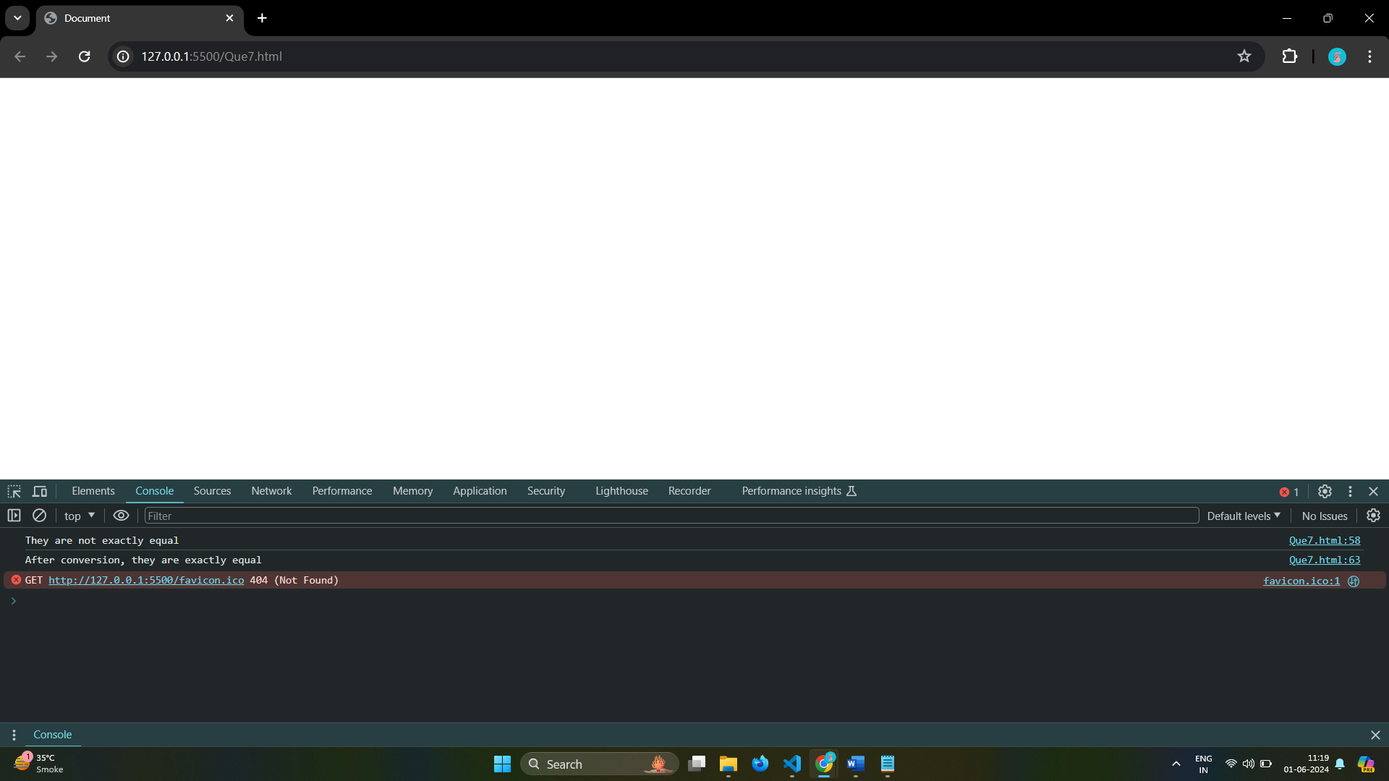

# Q.8 Write a JavaScript Program to find the area of a triangle?

Ans:

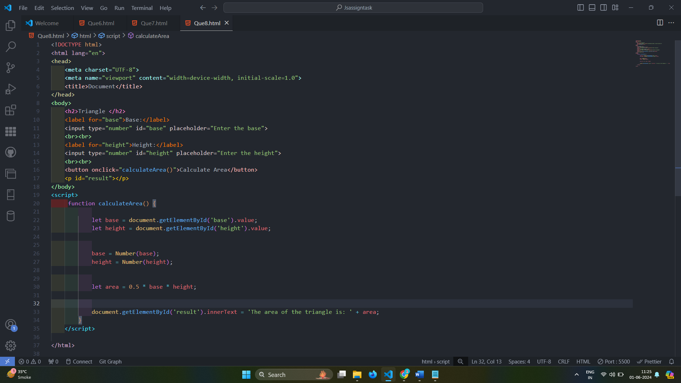

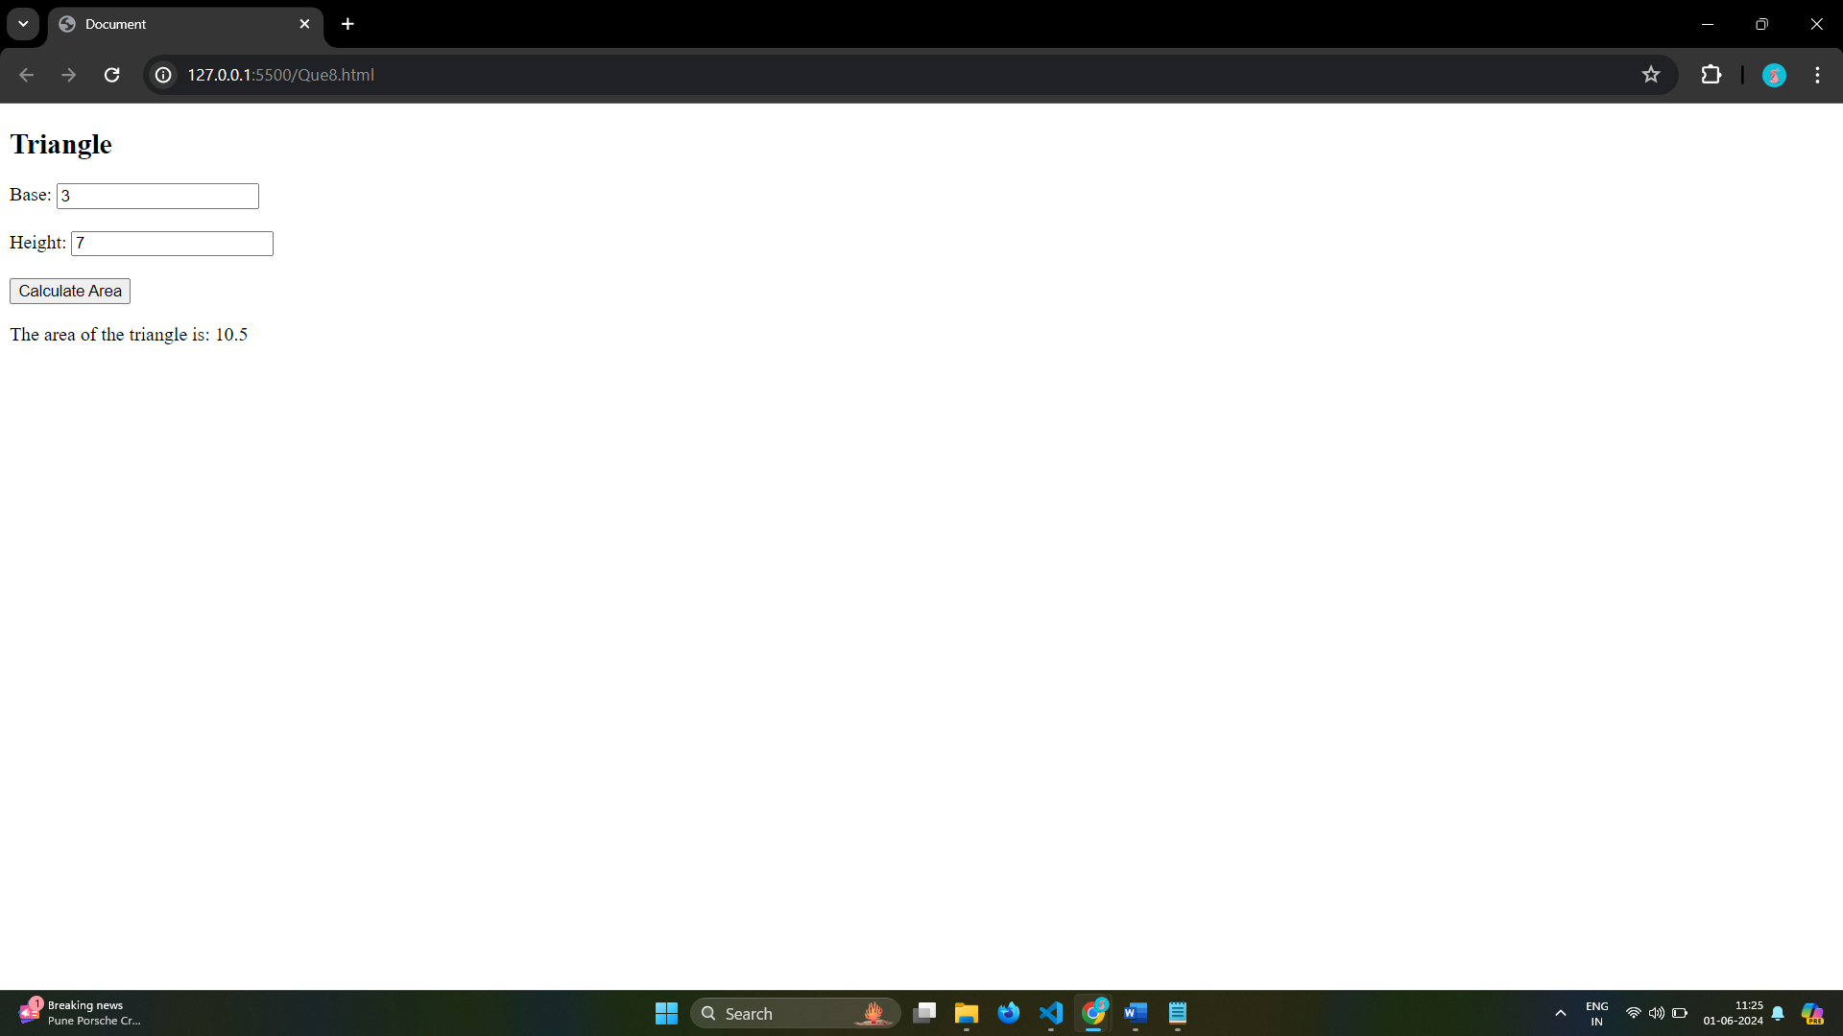

# Q.9 Write a JavaScript program to calculate days left until next Christmas?

Ans:

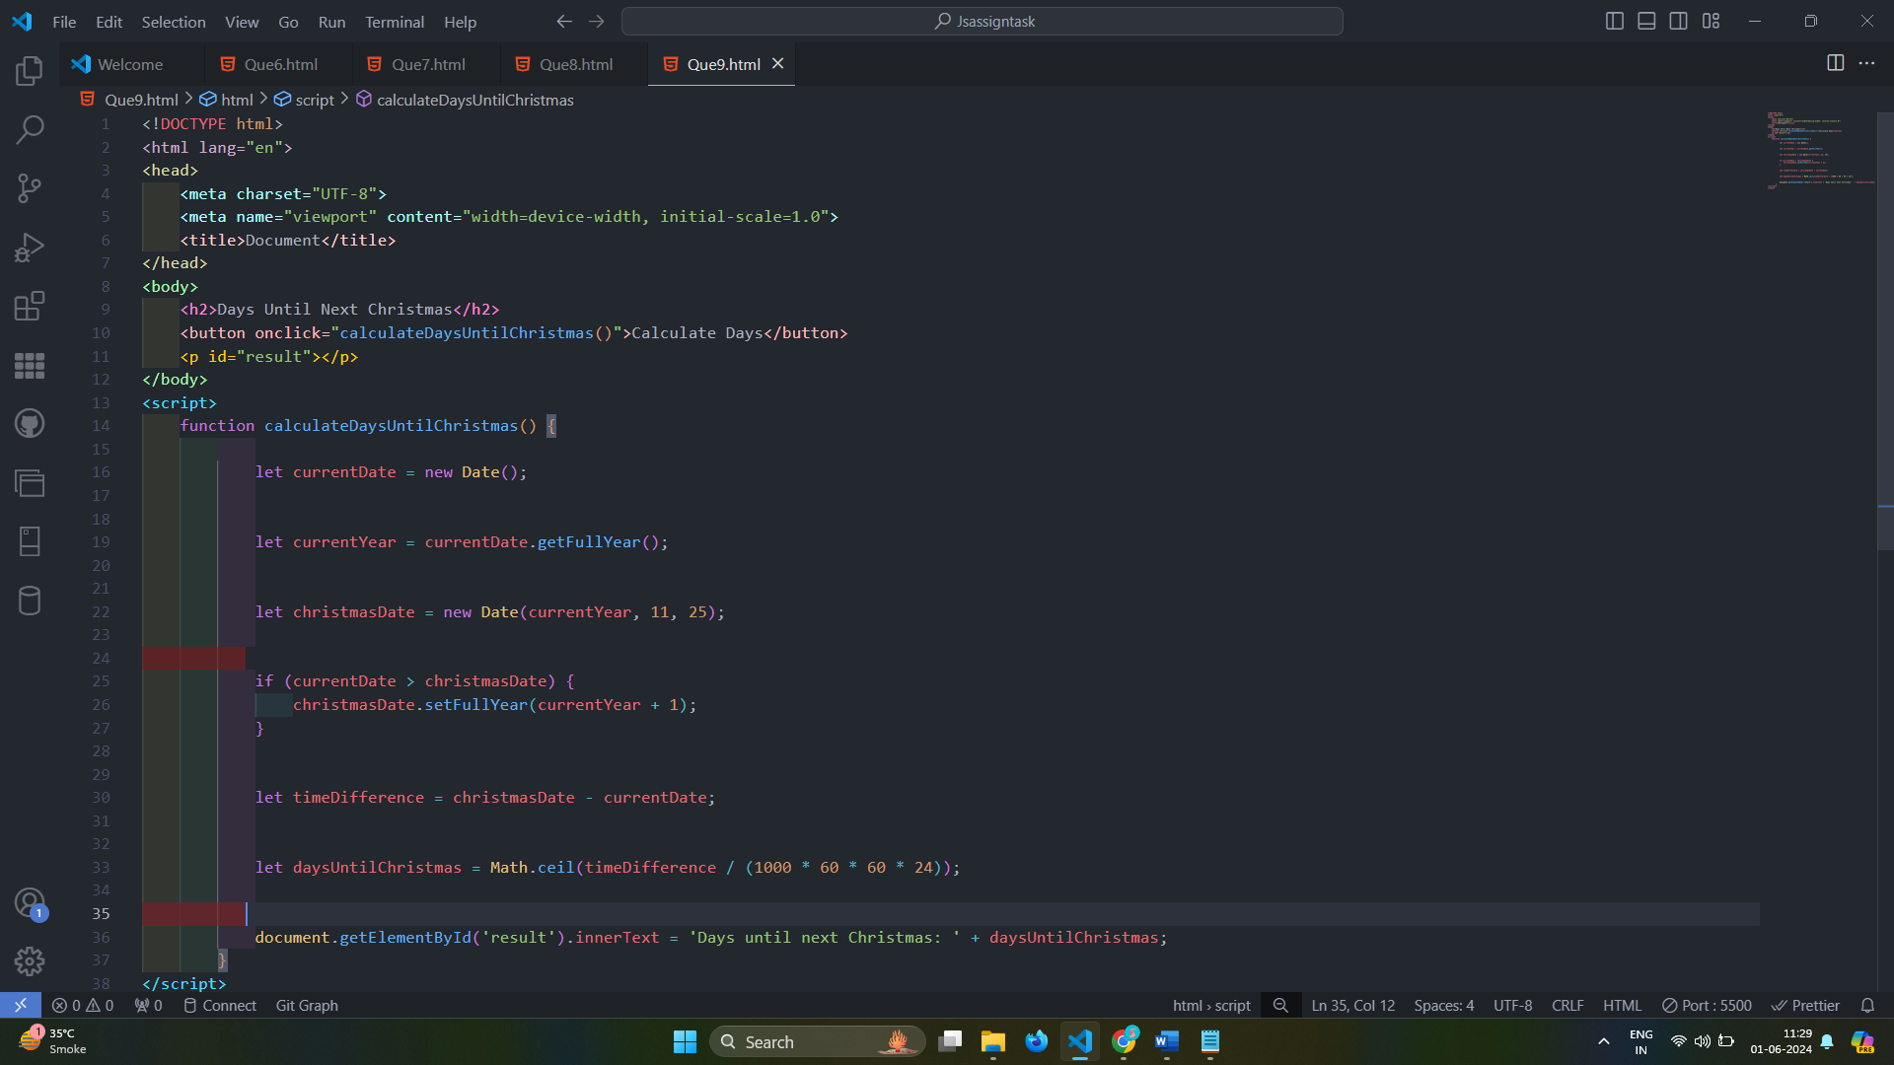

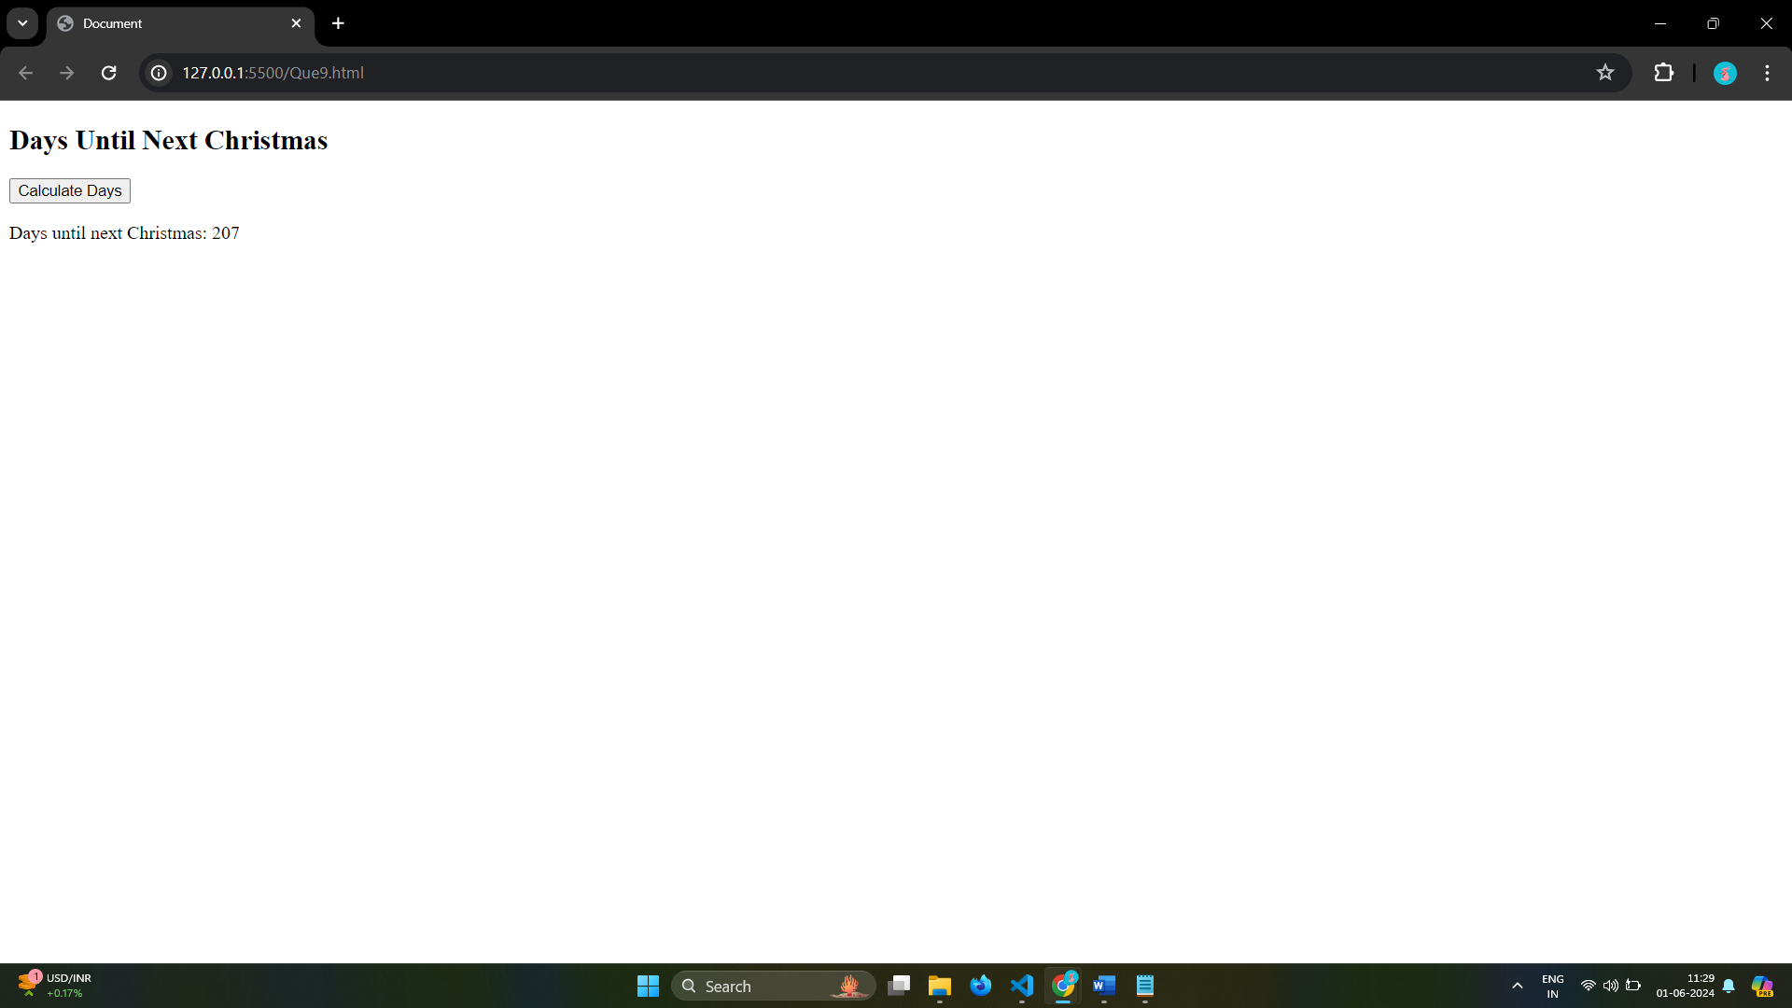

# Q.10 What is Condition Statement?

Ans: Conditional statements in programming are used to control the flow of a program based on certain conditions.

These statements allow the execution of different code blocks depending on whether a specified condition evaluates to true or false, providing a fundamental mechanism for decision-making in algorithms.

Conditional Statement:-

1.If Statement

2.If-Else Statement

3.If- Else-If Statement

4.Switch Statement

5.Nested Statement

# Q.11 Find circumference of Rectangle formula : C = 4 * a ?

Ans:

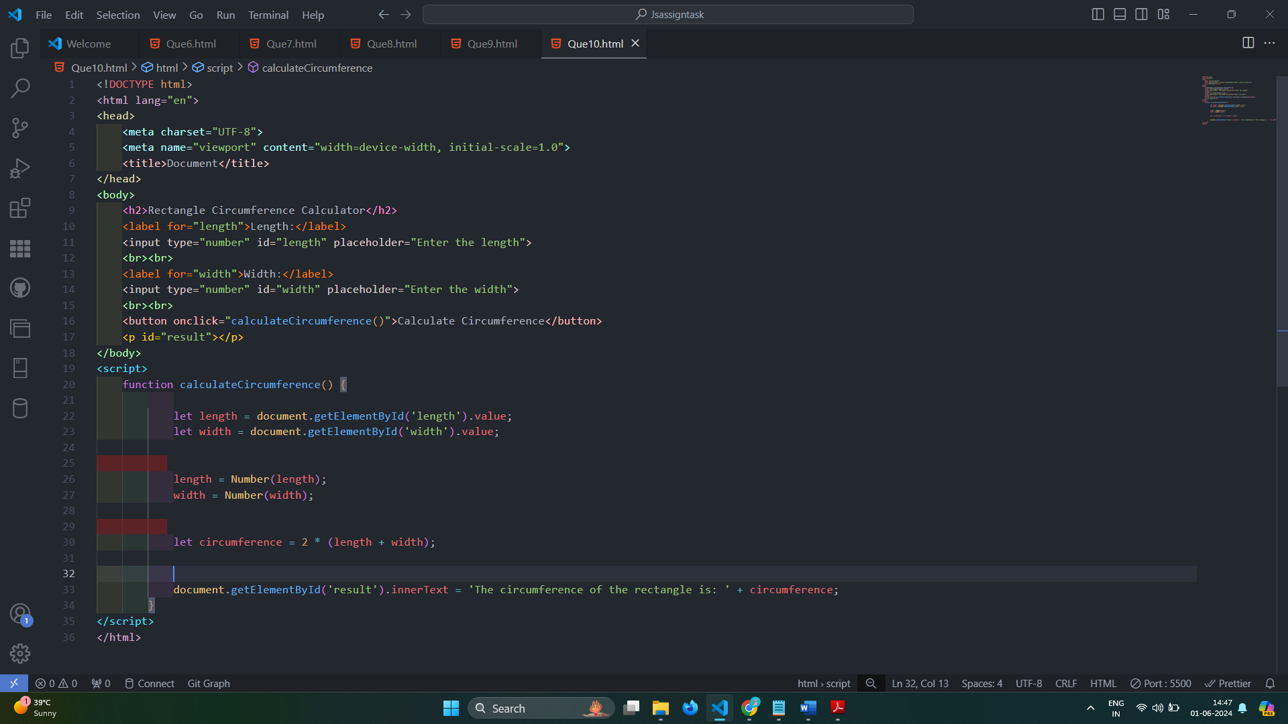

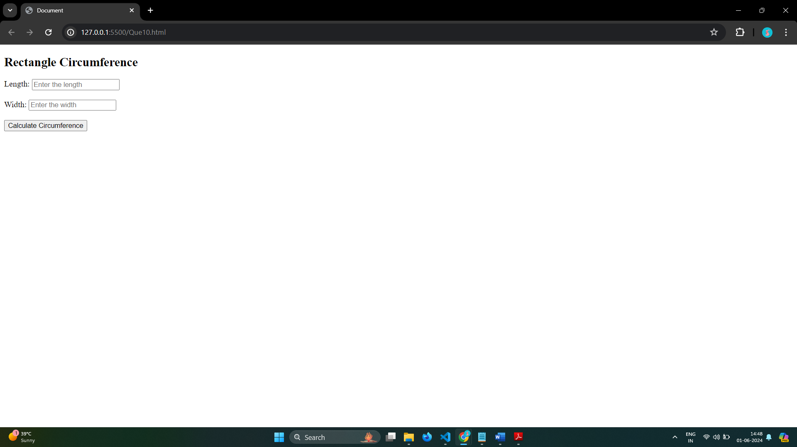

# Q.12 WAP to convert years into days and days into years?

Ans: 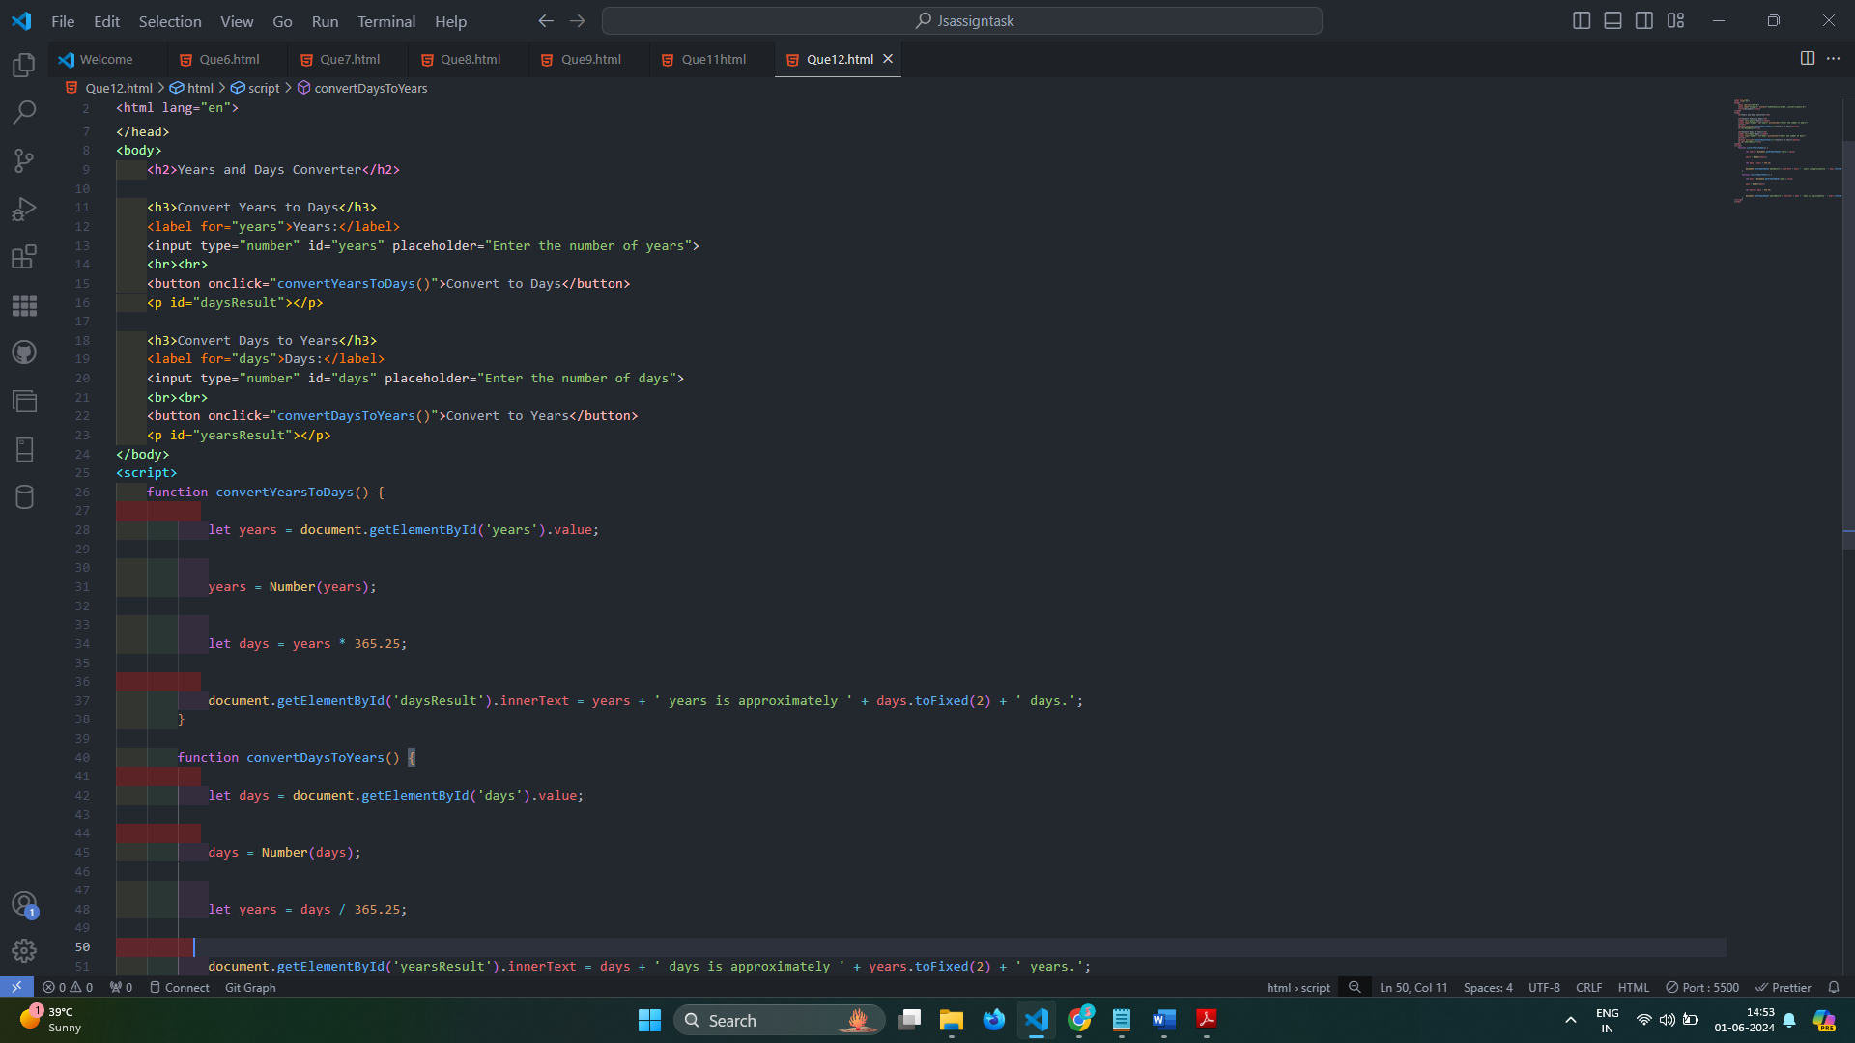

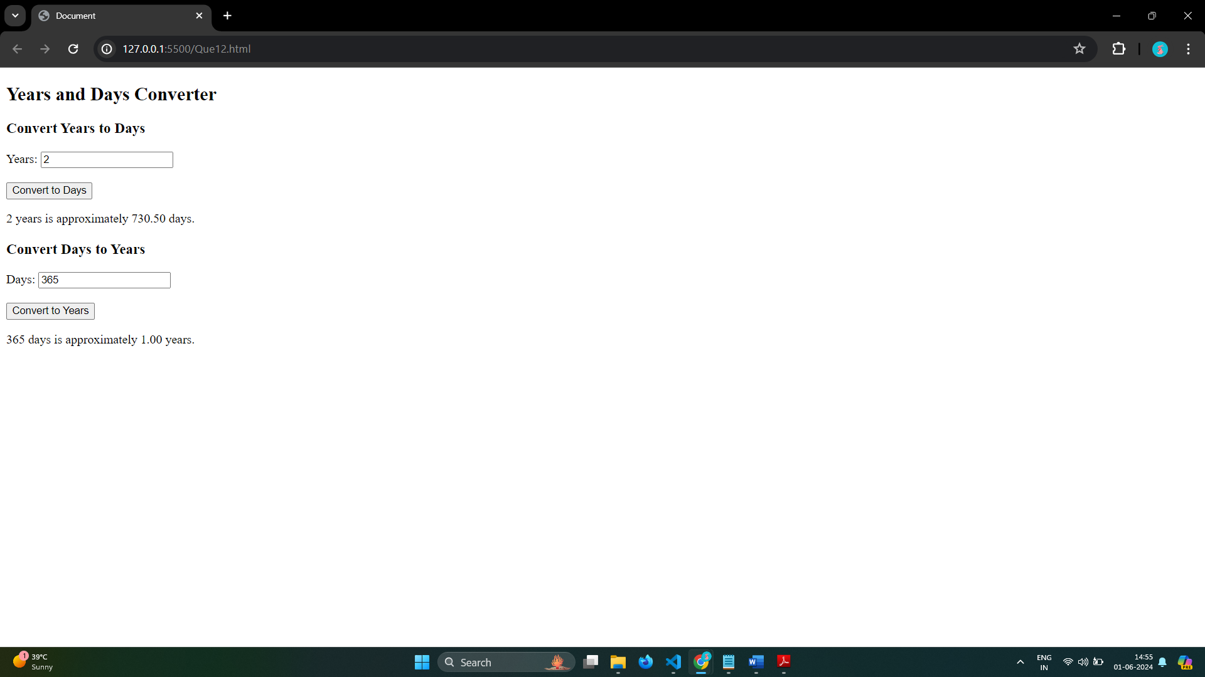

# Q.13 Convert temperature Fahrenheit to Celsius? (Conditional logic Question)

Ans: 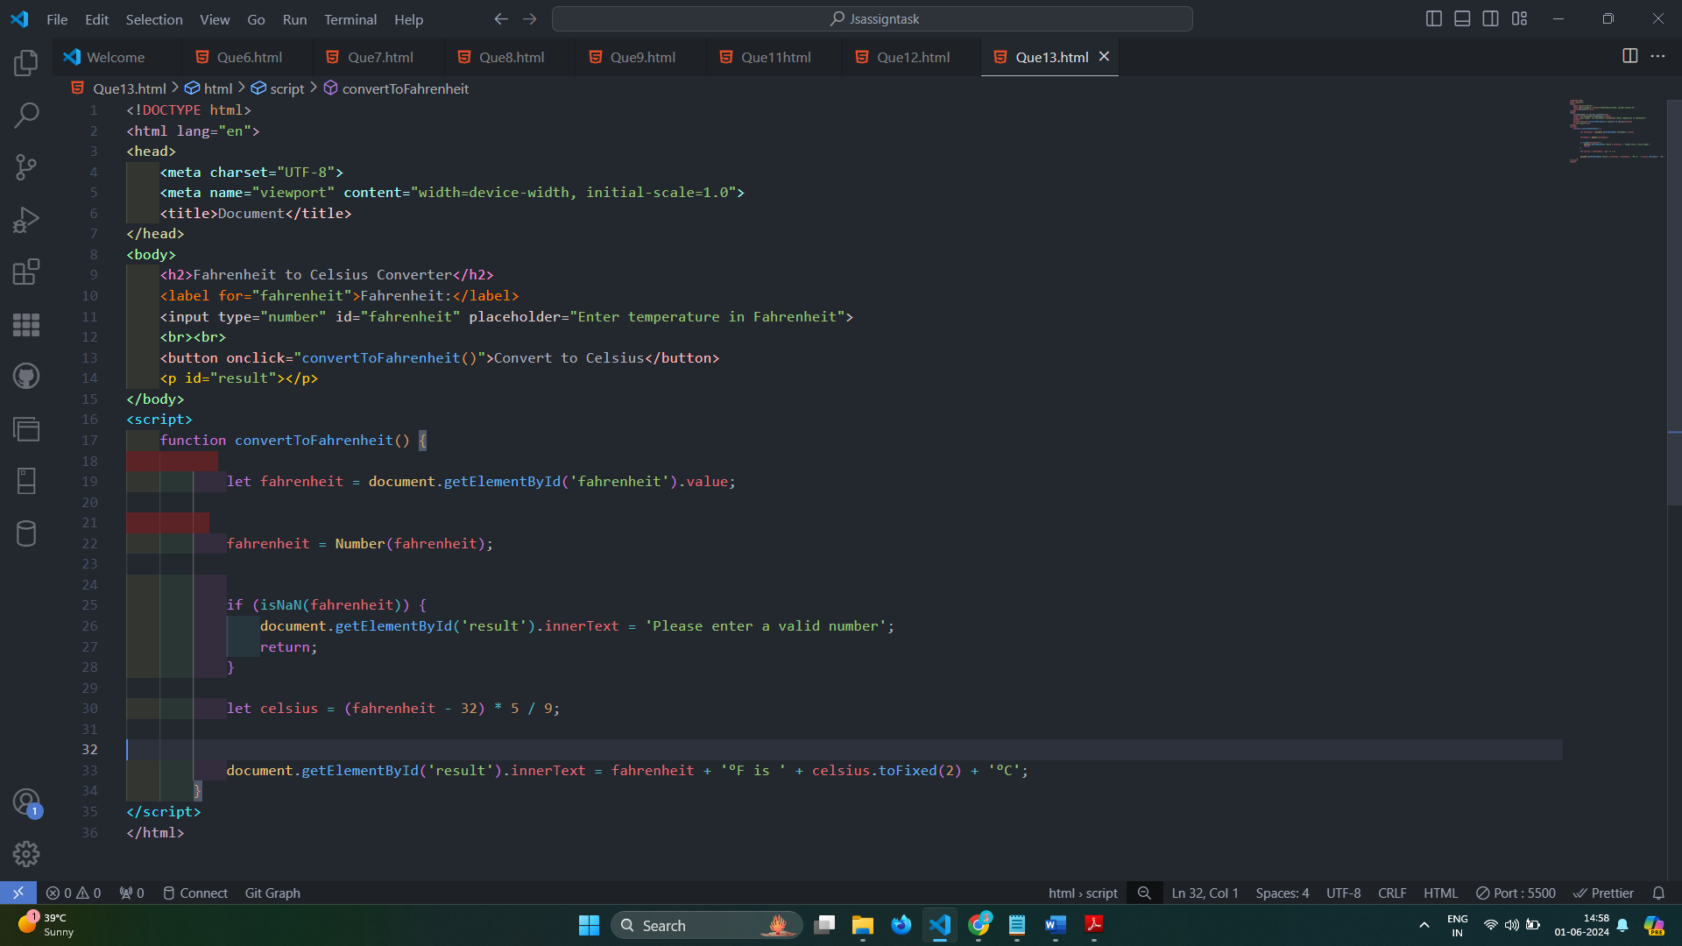

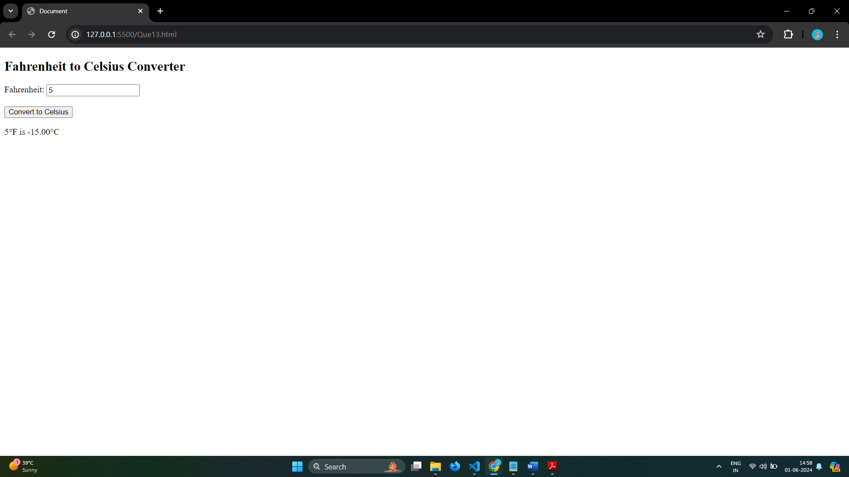

# Q.14 Write a JavaScript exercise to get the extension of a filename.?

Ans:

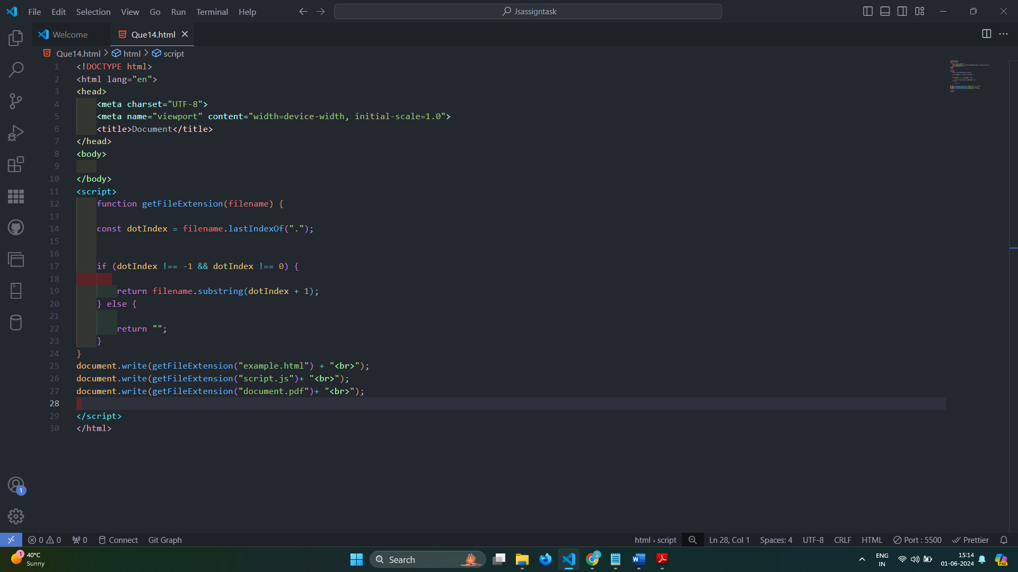

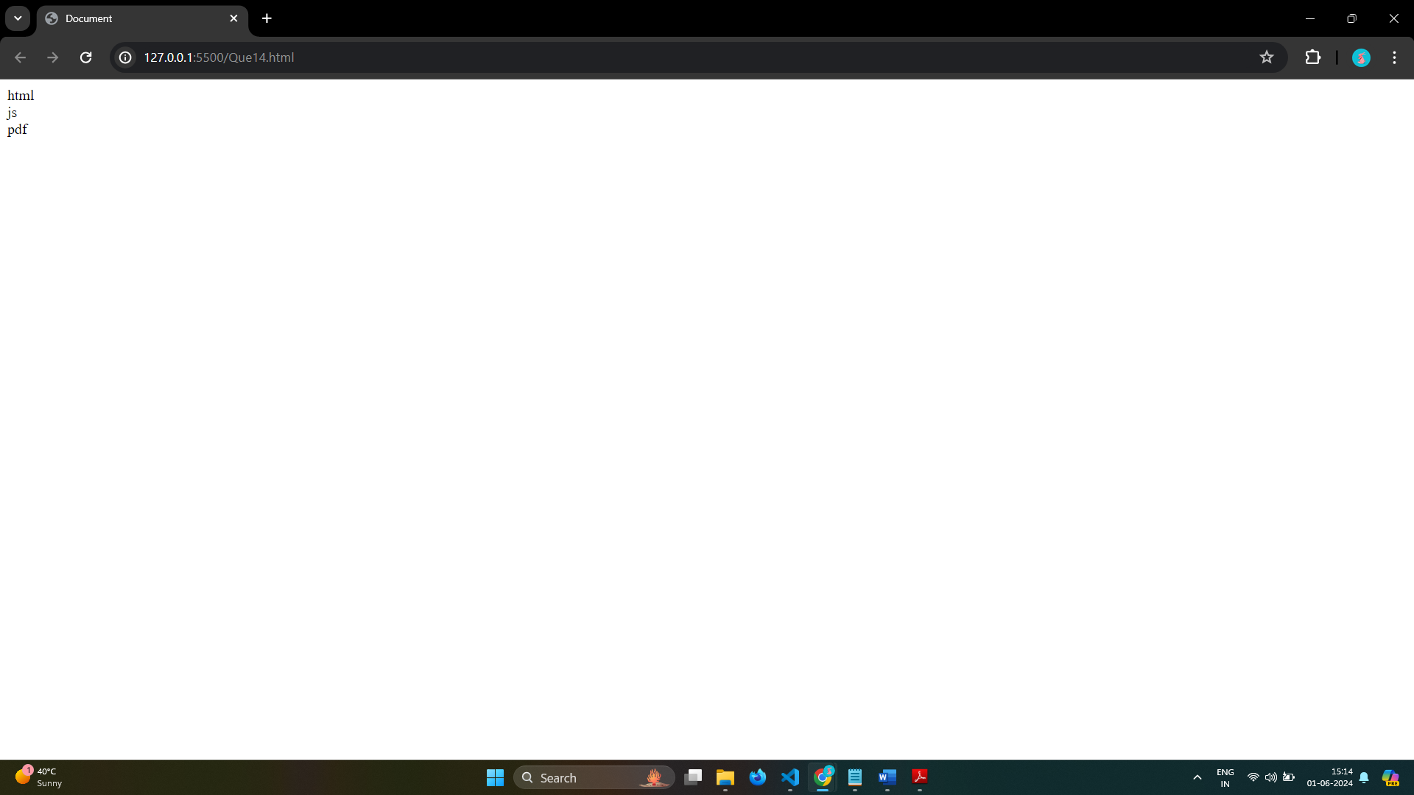

# Q.15 What is the result of the expression (5 > 3 && 2 < 4)?

Ans: Both conditions in the logical AND (&&) operator must be true for the whole expression to be true, and in this case, both 5 > 3 and 2 < 4 are true. Therefore, the result is true.

# Q.16 What is the result of the expression (true && 1 && "hello")?

Ans: when using the logical AND (&&) operator, if all operands are truthy values, the result is the value

expression is:

1.true

2.1

3.”hello”

# Q.17 What is the result of the expression true && false || false && true?

Ans: JavaScript, the logical AND (&&) operator

true && false = false

false && true = false

Both ans are false that's why

true && false || false && true

false || false = false

# Q.18 What is a Loop and Switch Case in JavaScript define that ?

Ans:

Loop in Javascript:-

Loops in JavaScript execute a block of code again and again while the condition is true.

suppose we want to print “Hello World” 5 times. This can be done using JS Loop easily. In Loop, the statement needs to be written only once and the loop will be executed 5 times.

Types of loop:-

1.For loop

2.While loop

3.do-while loop

4.Break Statement

5.Continue Statement

Switch Case:-

The switch statement is used to perform different actions based on different conditions.

Syntax

switch(expression) {

case x:

break;

case y:

break;

default:

}

# Q.19 What is the use of is Nan function?

Ans: isNaN() method returns true if a value is Not-a-Number.

Number.isNaN() returns true if a number is Not-a-Number.

isNaN() converts the value to a number before testing it.

# Q.20 What is the difference between && and || in JavaScript?

Ans: The && operator returns true if both operands are true, otherwise, it returns false.

It evaluates from left to right and stops as soon as it encounters the first false operand, because further evaluation is unnecessary for the result to be false.

true && false = false.

The || operator returns true if at least one of the operands is true, otherwise, it returns false.

It also evaluates from left to right and stops as soon as it encounters the first true operand, because further evaluation is unnecessary for the result to be true.

true || false = true.

# Q.21 What is the use of Void (0)?

Ans: The void operator is used to evaluate an expression and returns the undefined.

This operator is used for obtaining the undefined primitive value.

It is often used with hyperlinks.

Usually the browser refreshes the page or loads a new page on clicking a link.

The javascript:void(0) can be used when we don't want to refresh or load a new page in the browser on clicking a hyperlink.

Syntax

void expression;

# Q.22 Check Number Is Positive or Negative in JavaScript?

Ans: 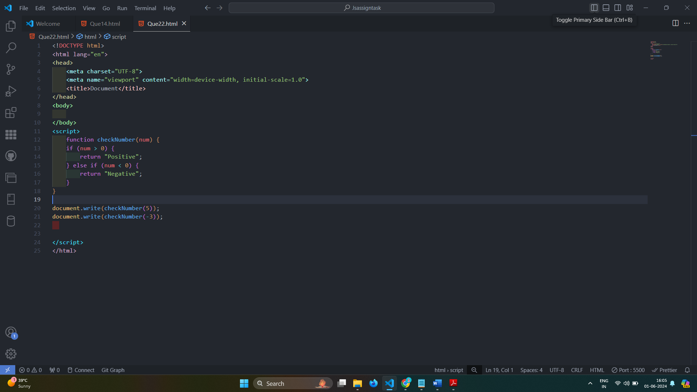

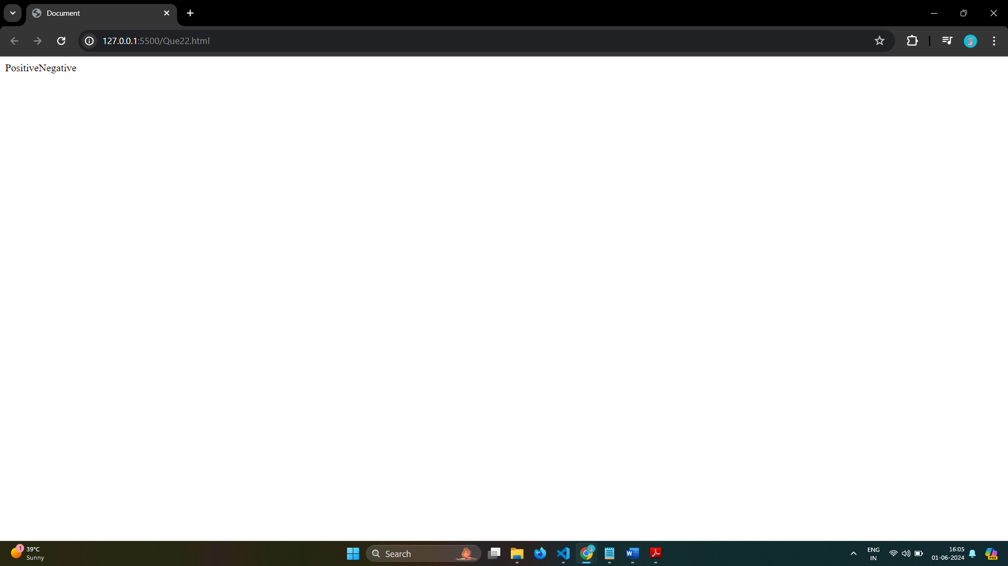

# Q.23 Find the Character Is Vowel or Not ?

Ans: 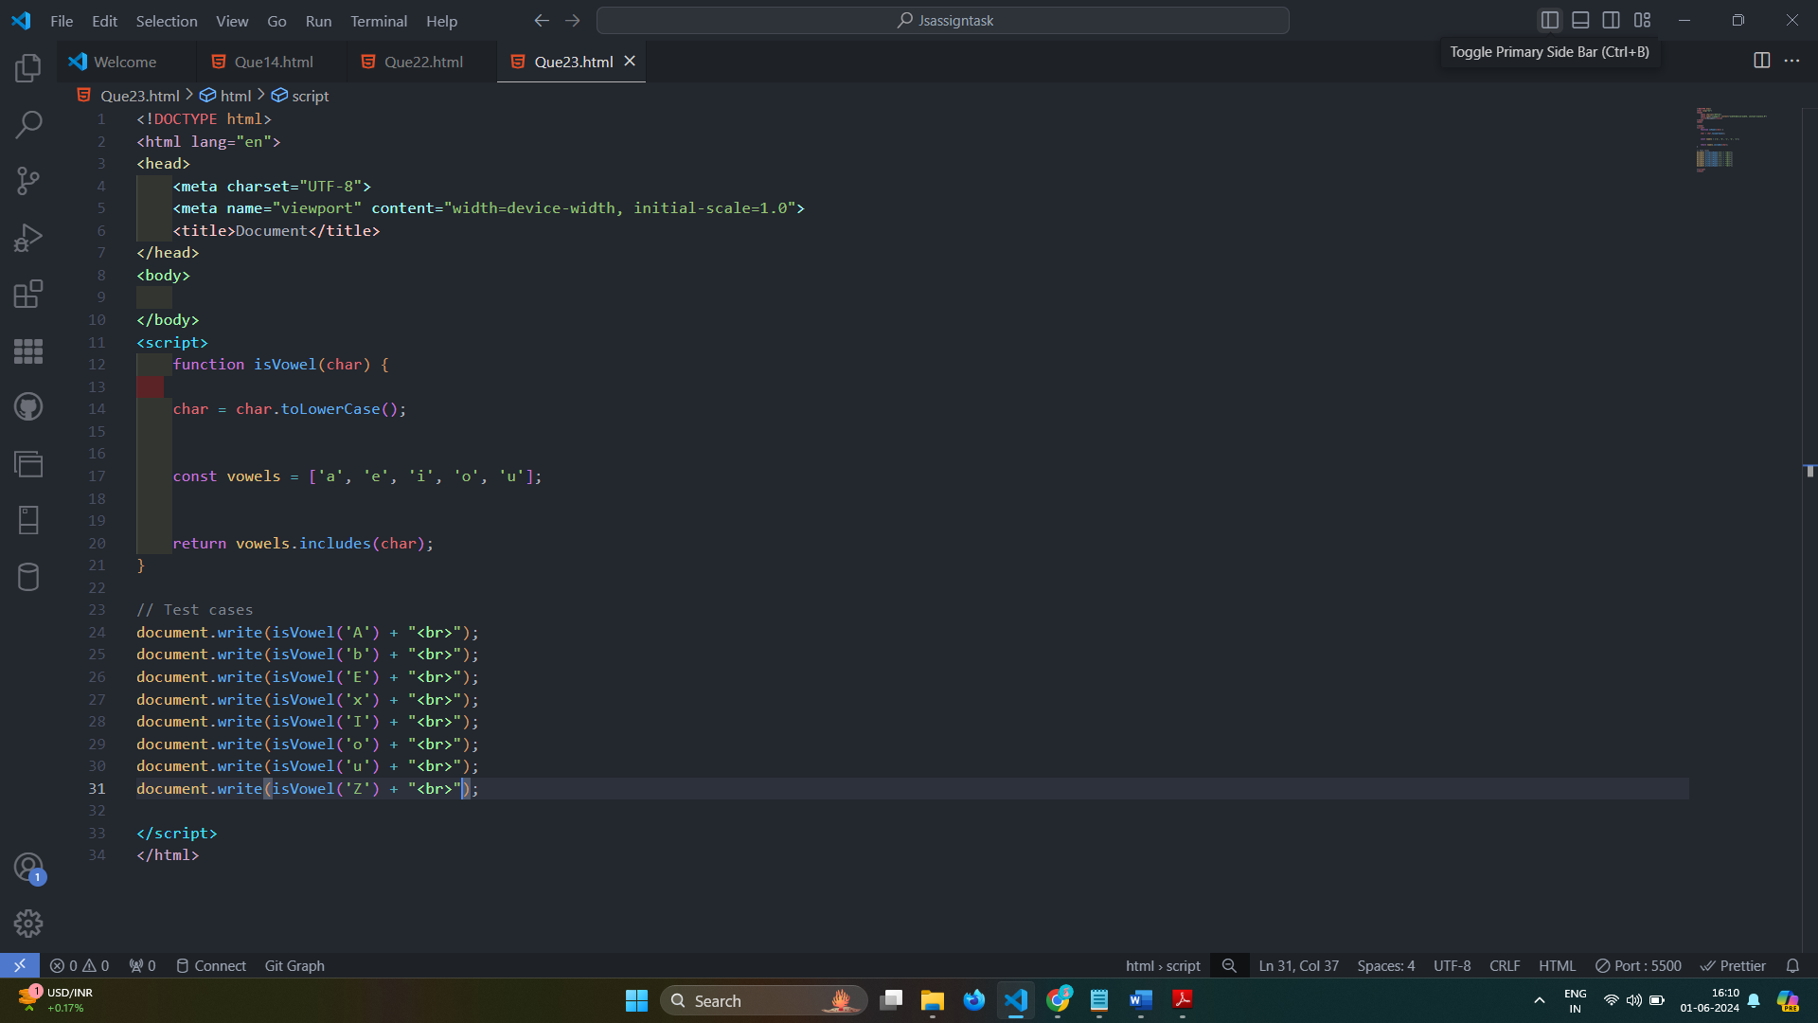

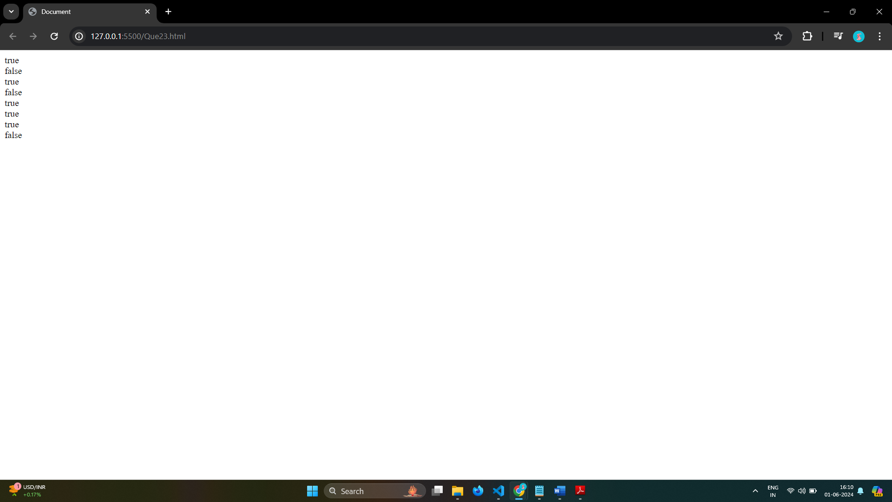

# Q.24 Write to check whether a number is negative, positive or zero?

Ans: 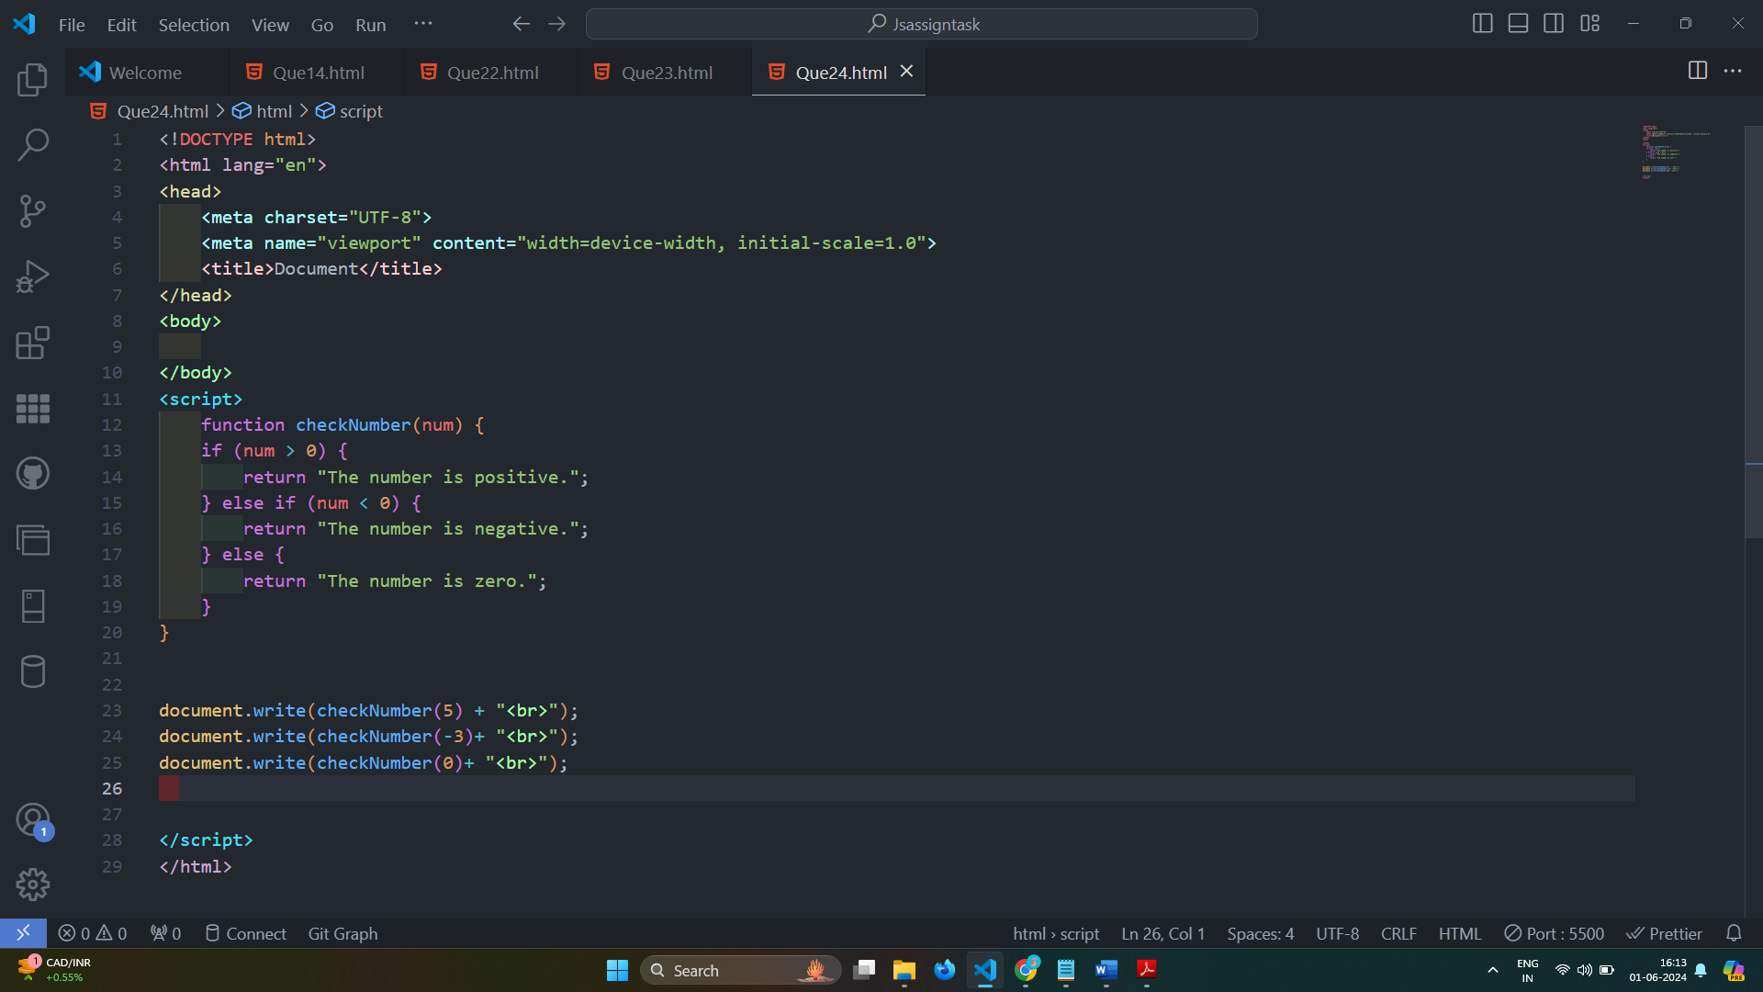

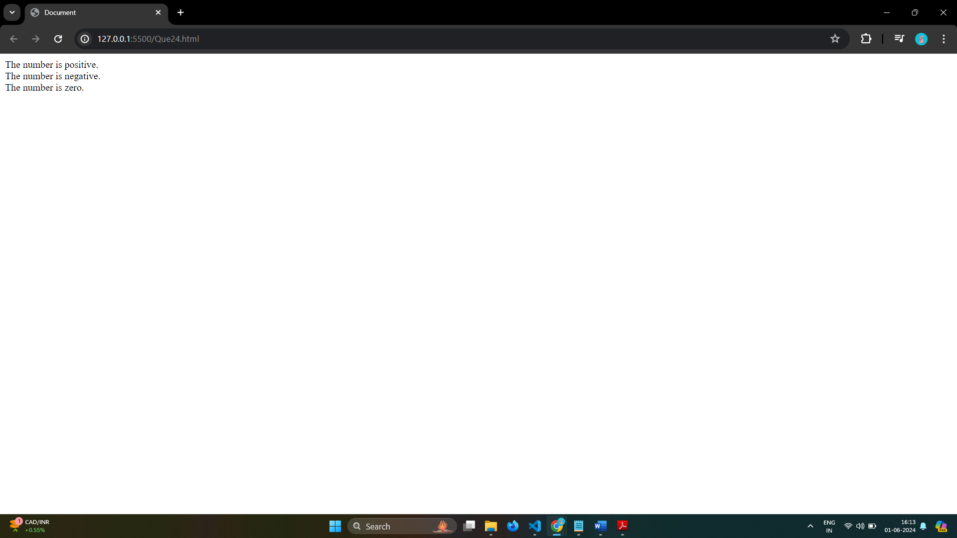

# Q.25 Write to find number is even or odd using ternary operator in JS?

Ans: 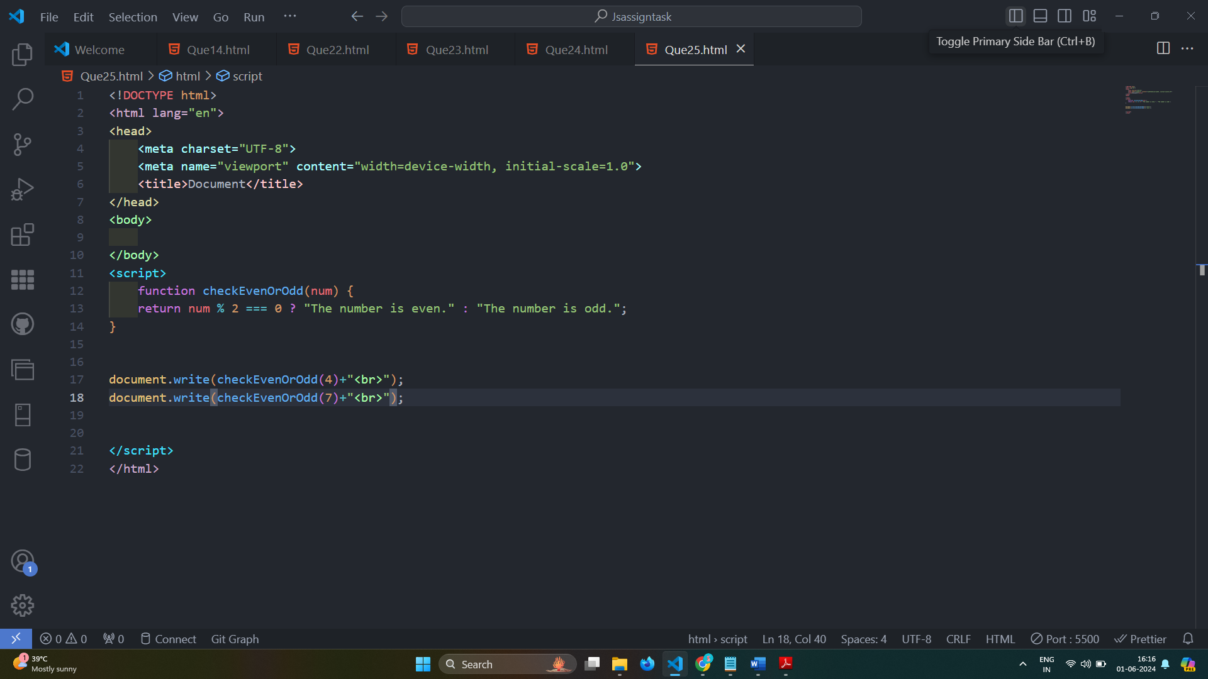

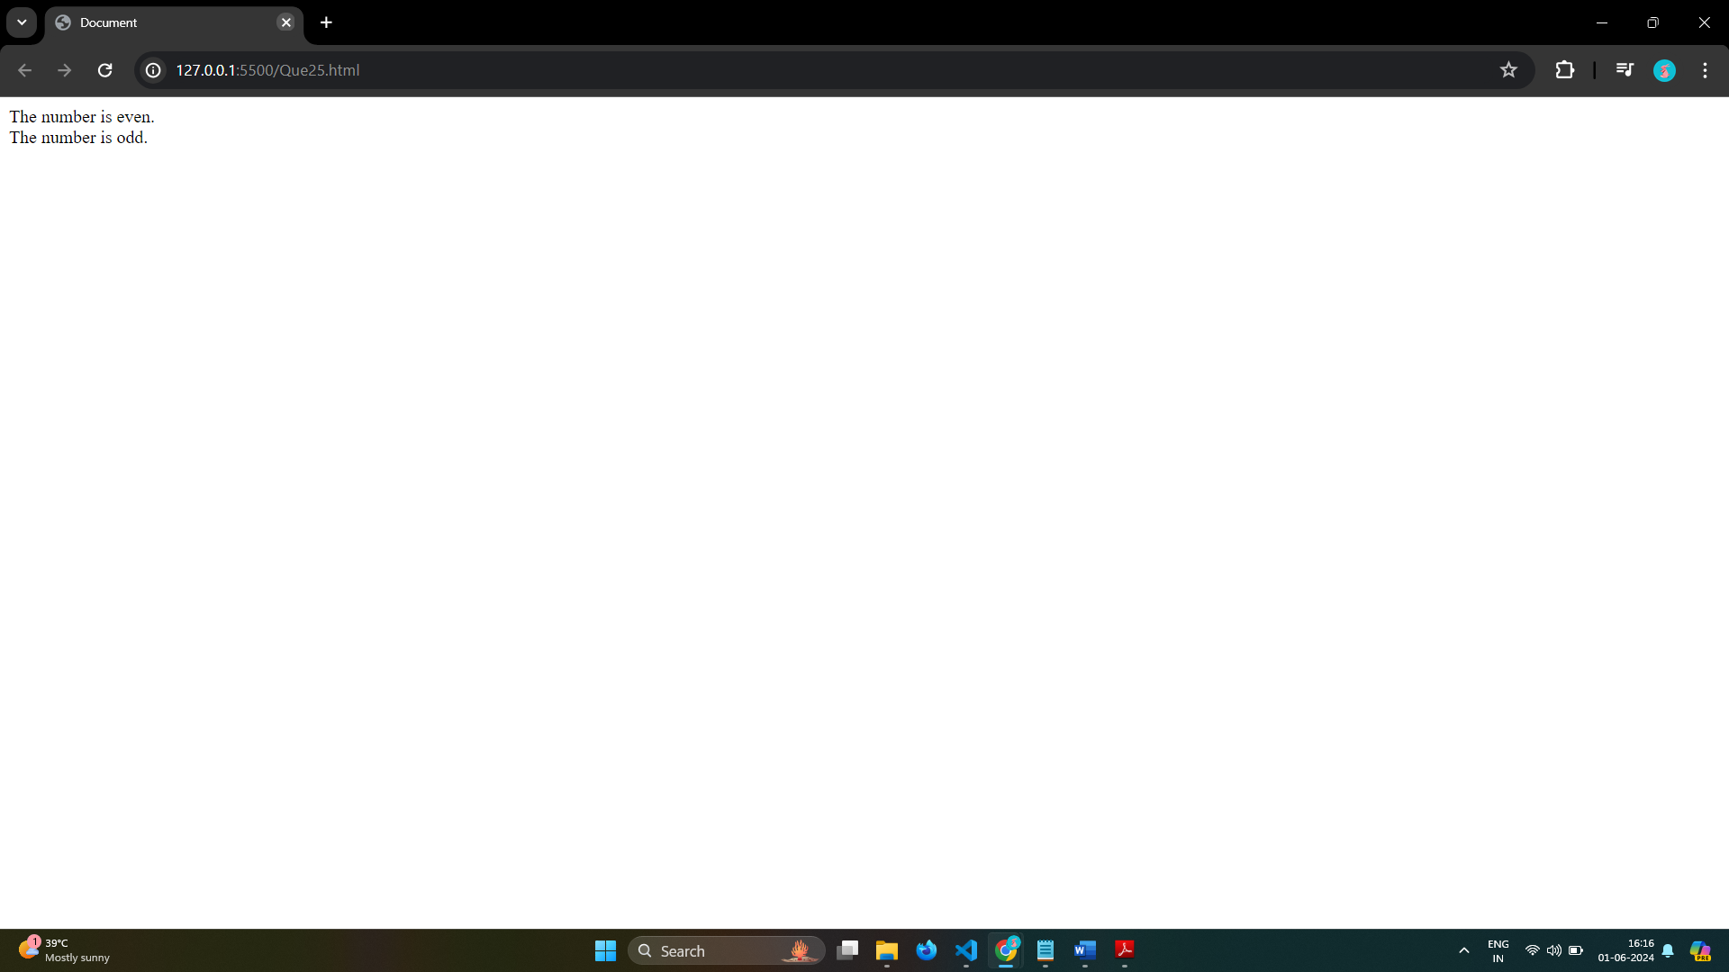

# Q.26 Write find maximum number among 3 numbers using ternary operator in JS?

Ans: 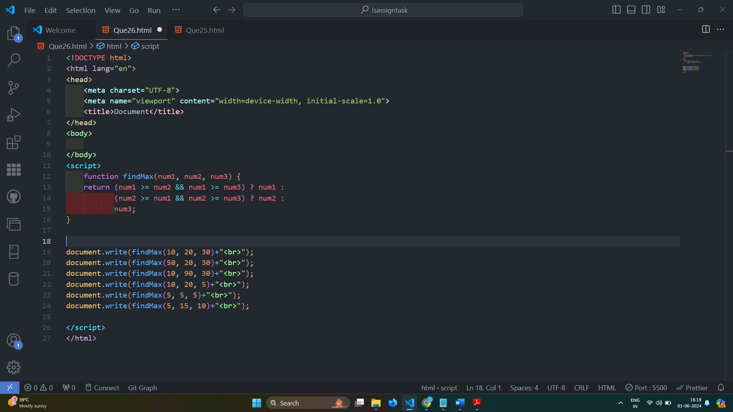

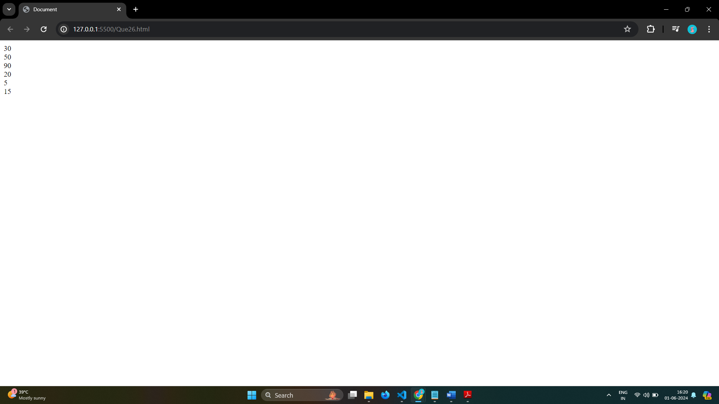

# Q.27 Write to find minimum number among 3 numbers using ternary operator in JS?

Ans: 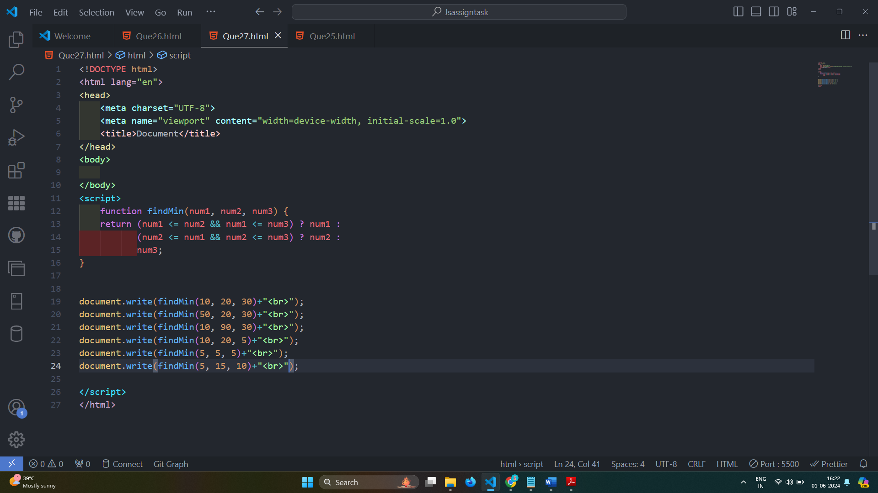

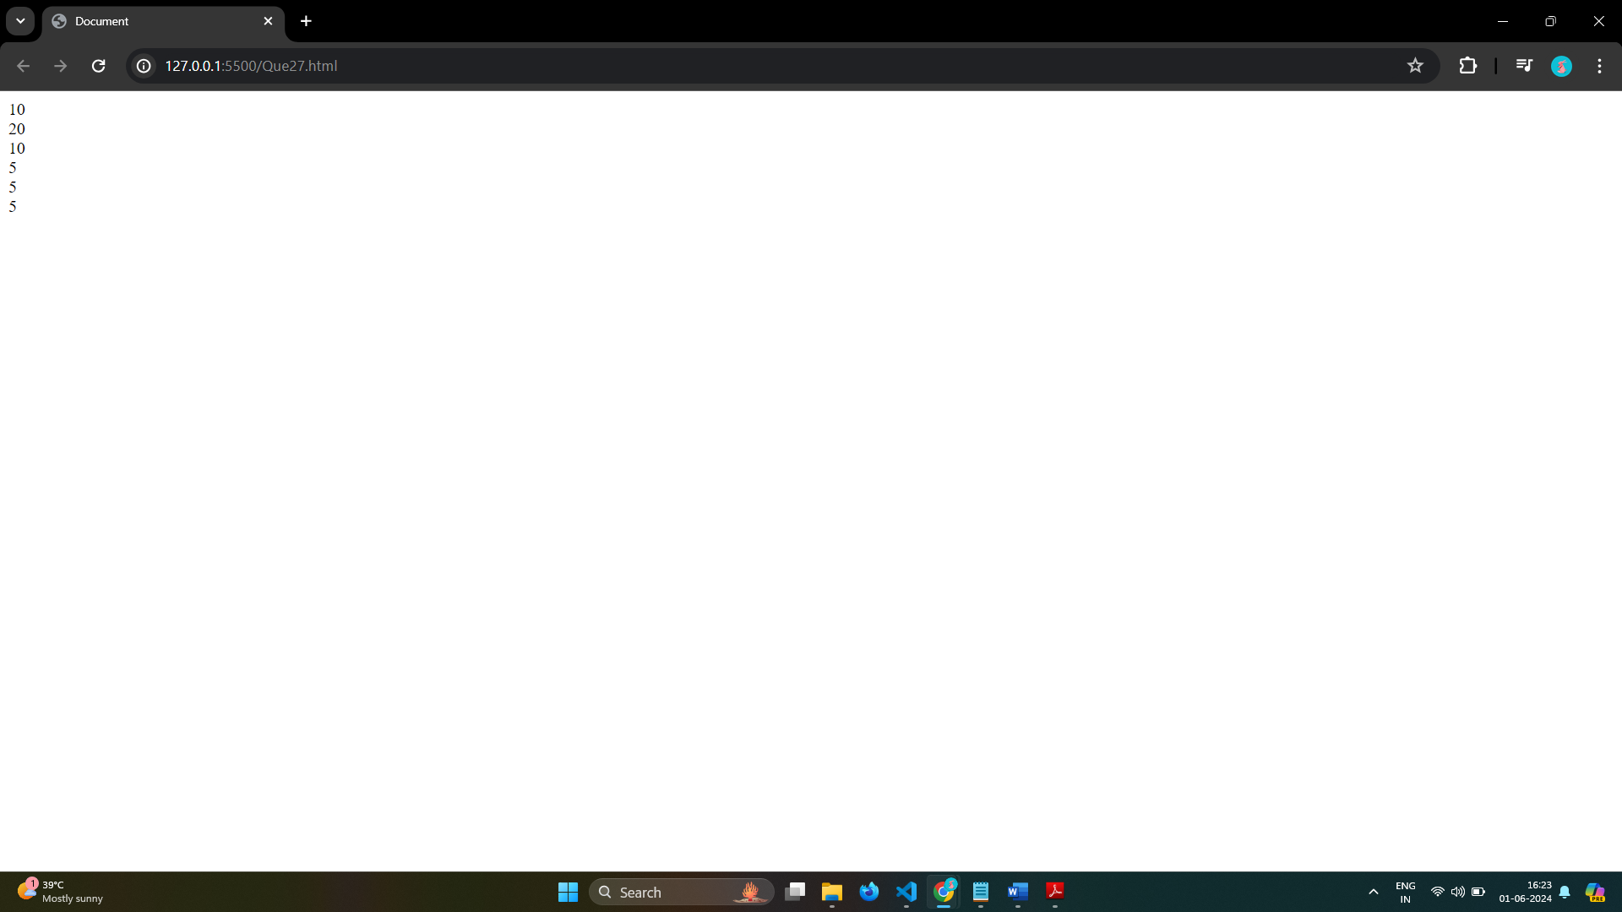

# Q.28 Write to find the largest of three numbers in JS?

Ans:

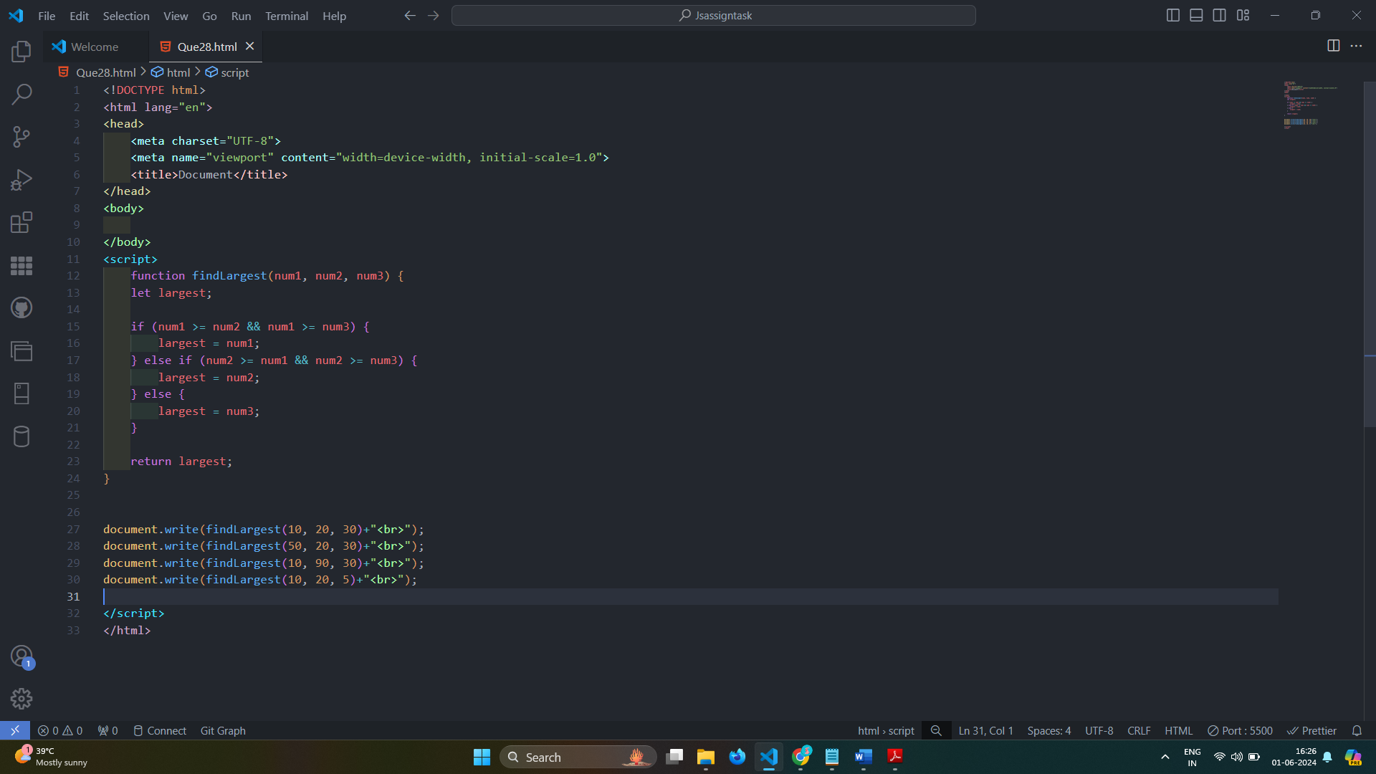

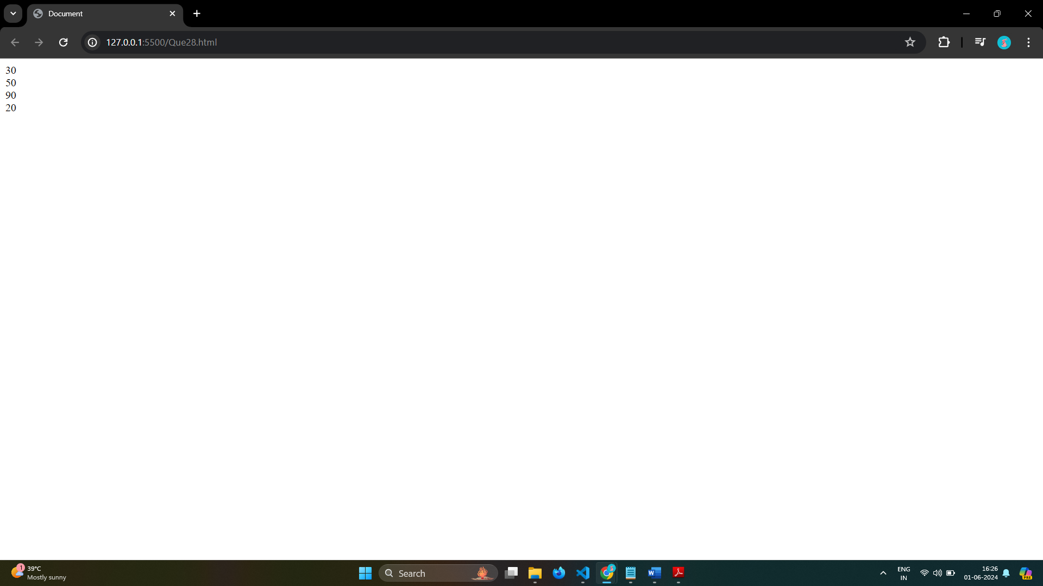

# Q.29 Write to show

# i. Monday to Sunday using switch case in JS?

Ans: 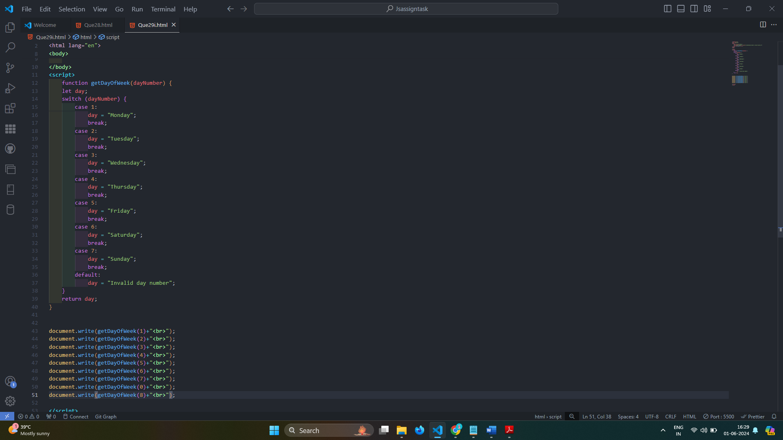

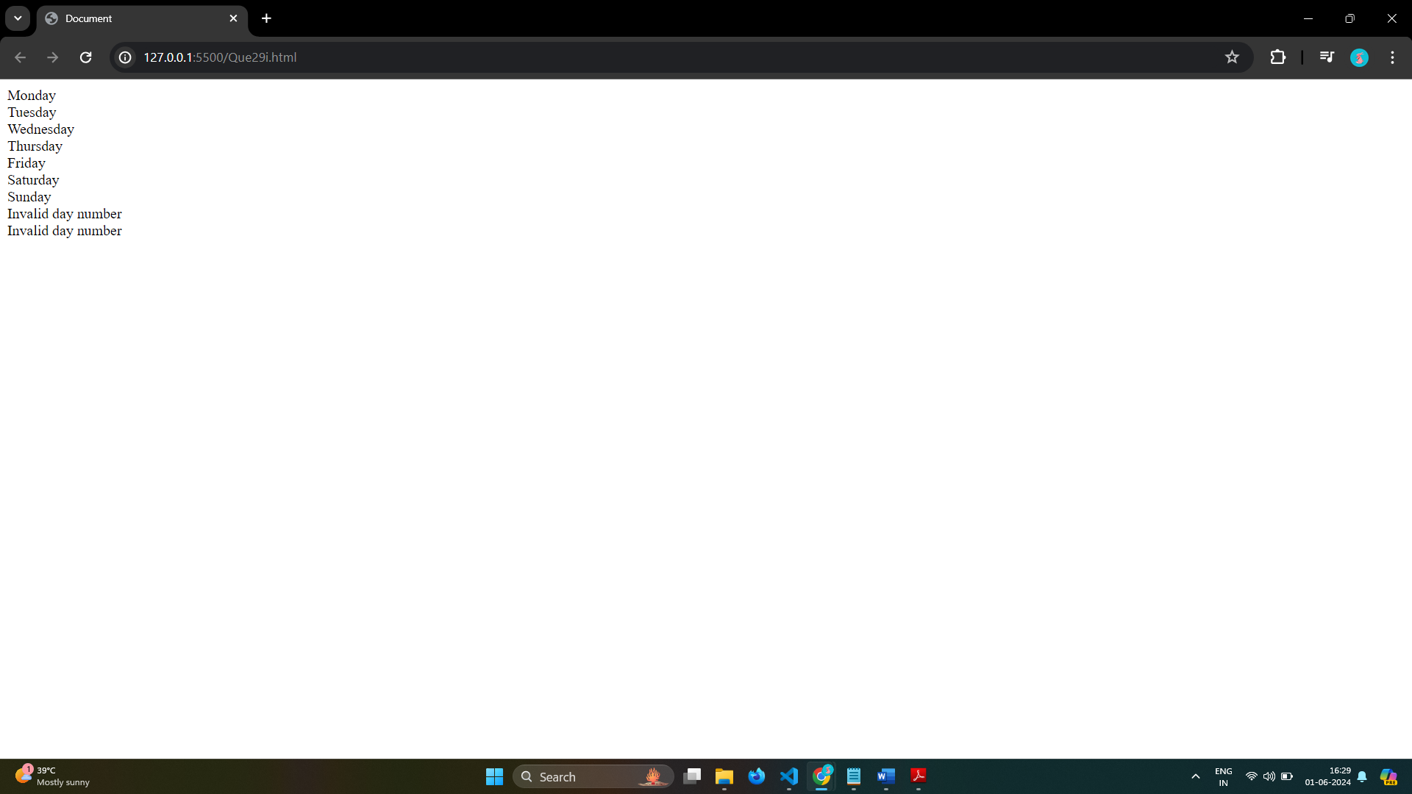

# ii. Vowel or Consonant using switch case in JS?

Ans:

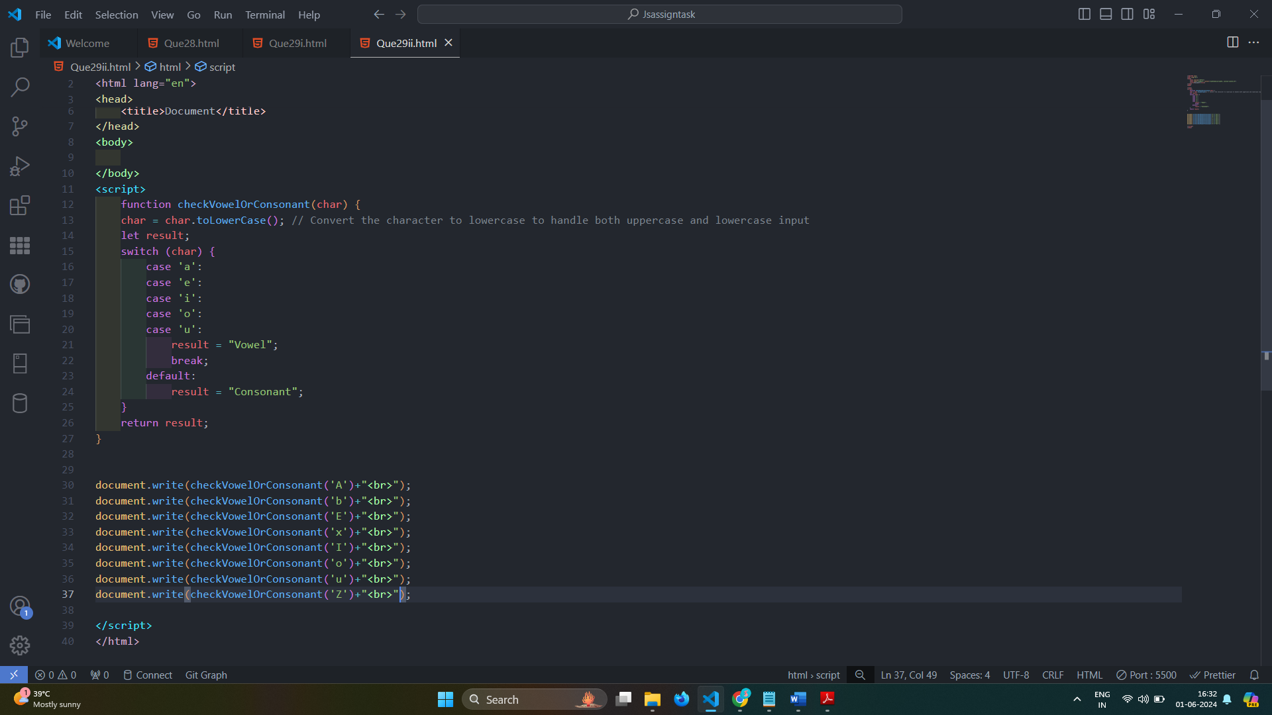

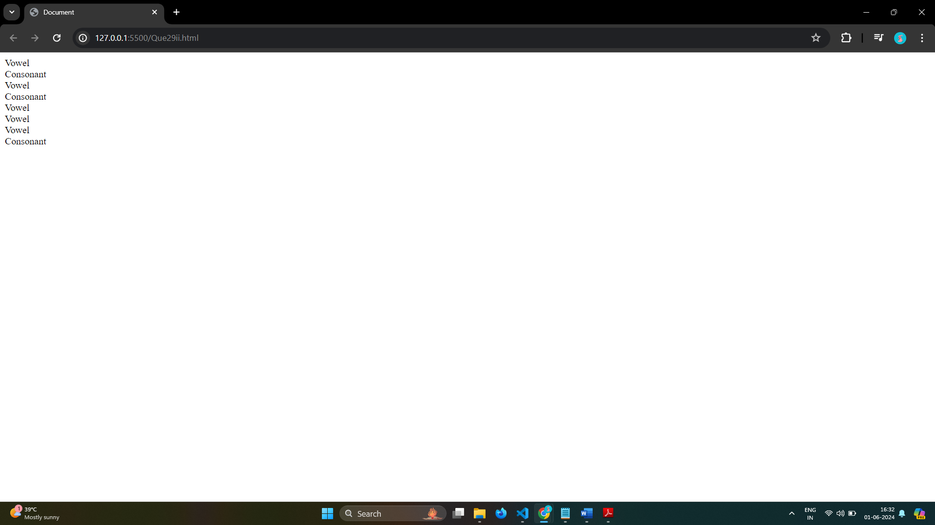

# (Conditional looping logic Question)

# Q.30 What are the looping structures in JavaScript? Any one Example?

Ans: Different Kinds of Loops

1.for = loops through a block of code a number of times

for (let i = 0; i < 5; i++) {

text += "The number is " + i + "<br>";

}

2.for/in = loops through the properties of an object

const person = {fname:"John", lname:"Doe", age:25};

let text = "";

for (let x in person) {

text += person[x];

}

3.for/of = loops through the values of an iterable object

const cars = ["BMW", "Volvo", "Mini"];

let text = "";

for (let x of cars) {

text += x;

}

4.while = loops through a block of code while a specified condition is true

while (i < 10) {

text += "The number is " + i;

i++;

}

5.do/while = - also loops through a block of code while a specified condition is true

do {

text += "The number is " + i;

i++;

}

while (i < 10);

# Q.31 Write a print 972 to 897 using for loop in JS?

Ans:

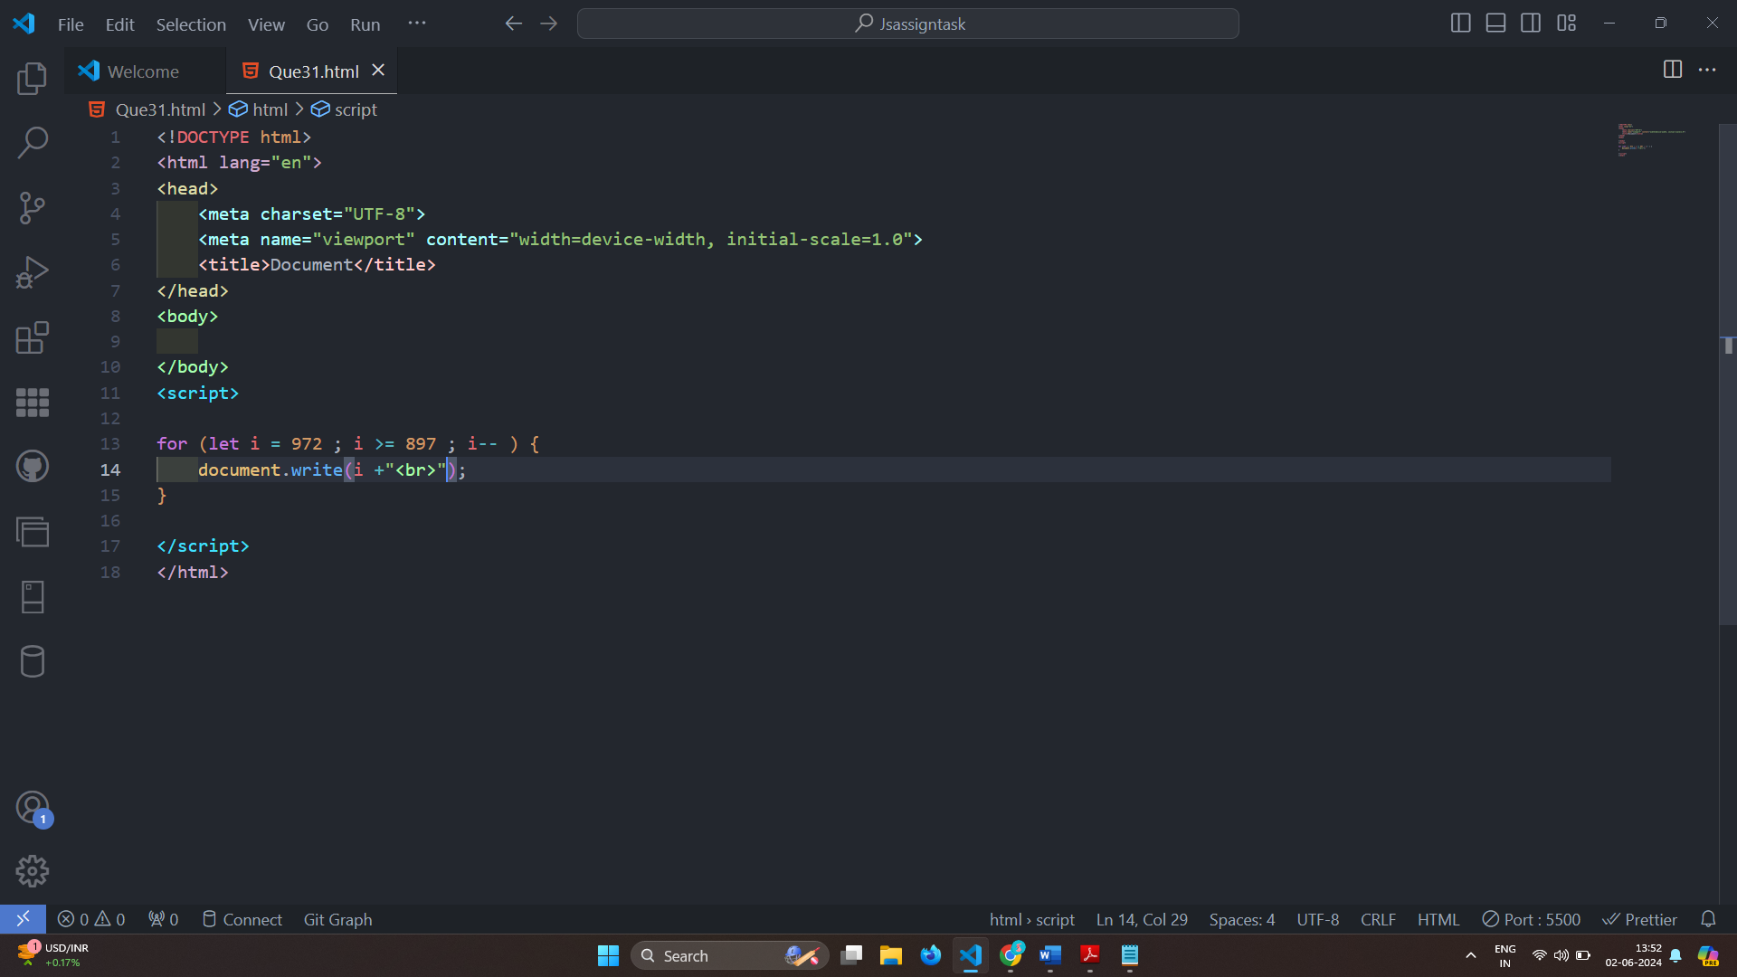

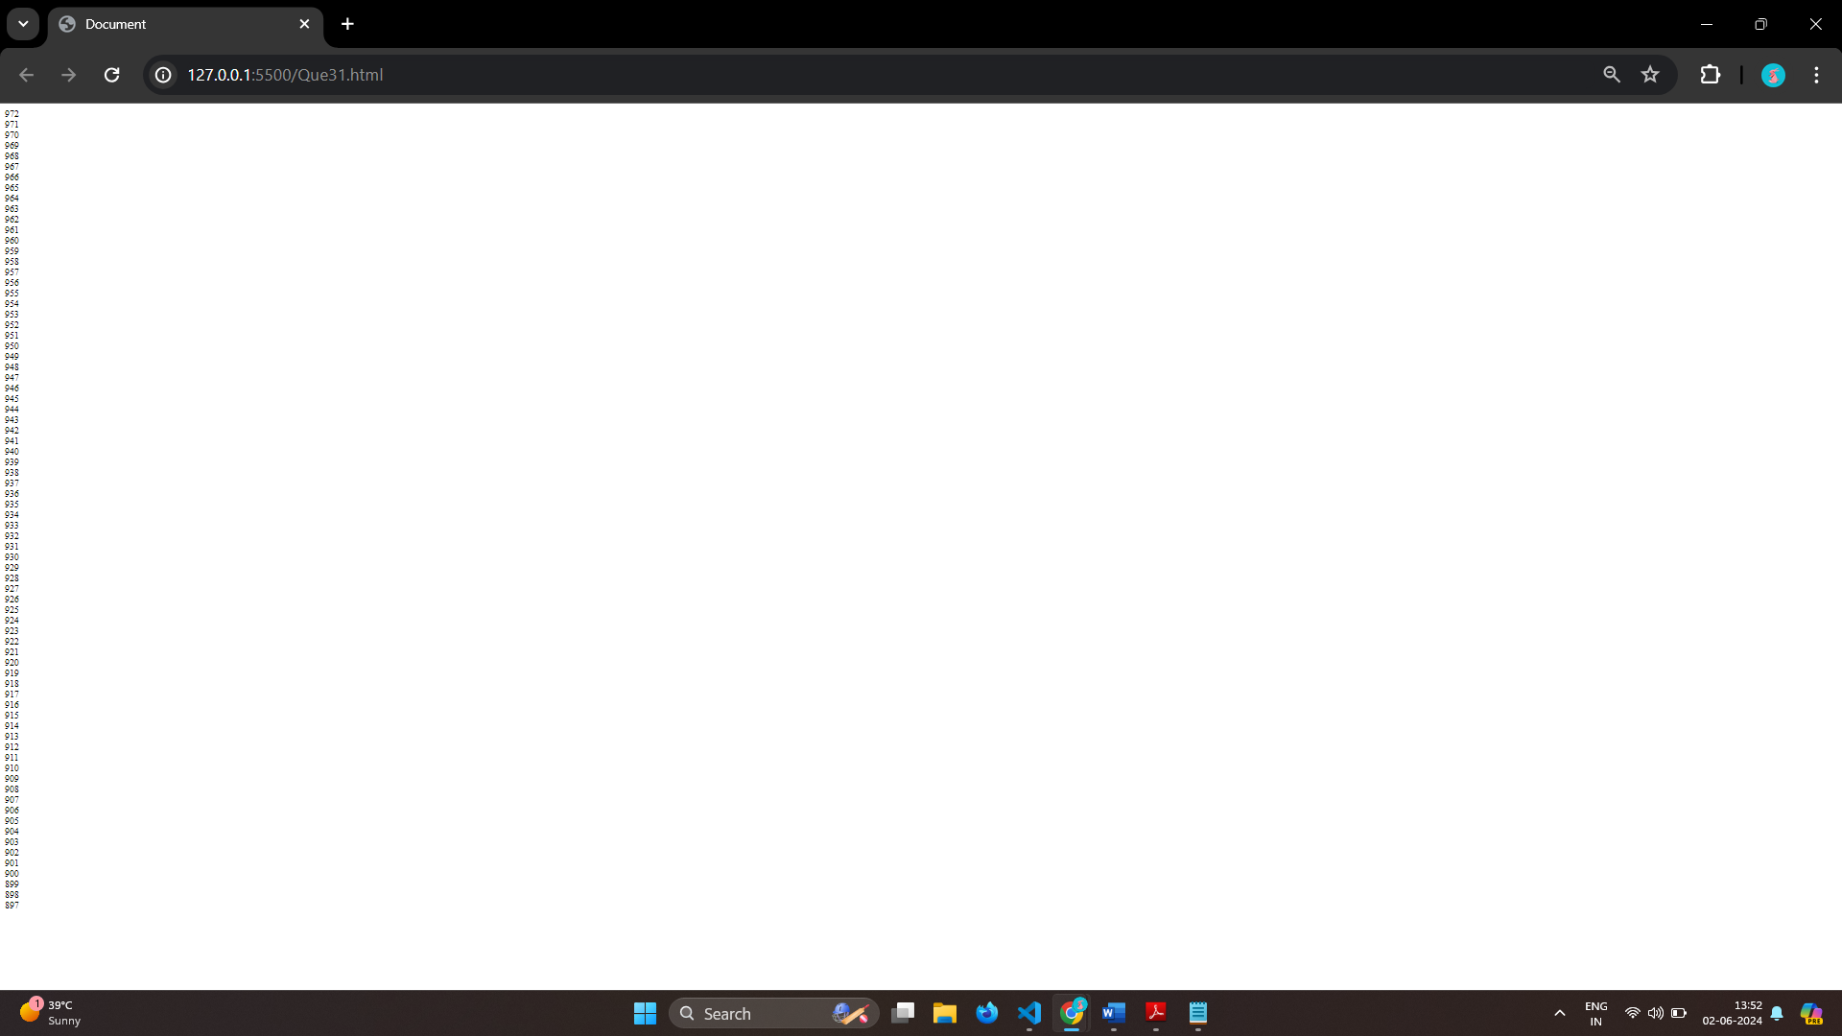

# Q.32 Write to print factorial of given number?

Ans: 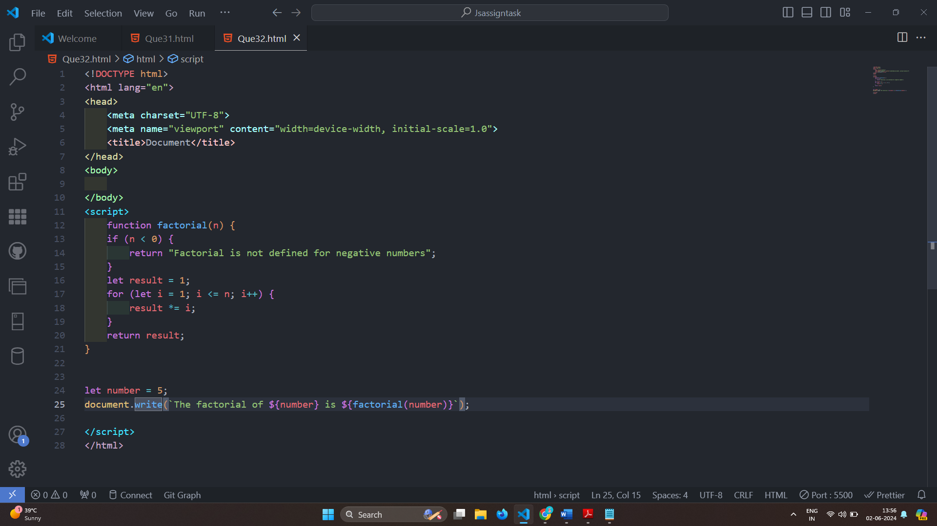

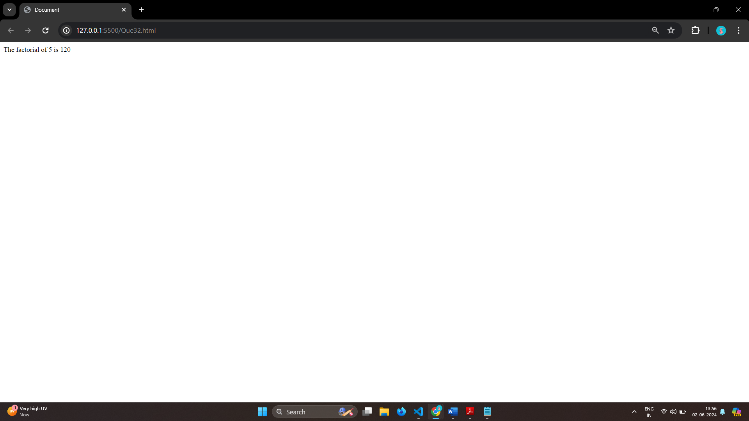

# Q.33 Write to print Fibonacci series up to given numbers?

Ans: 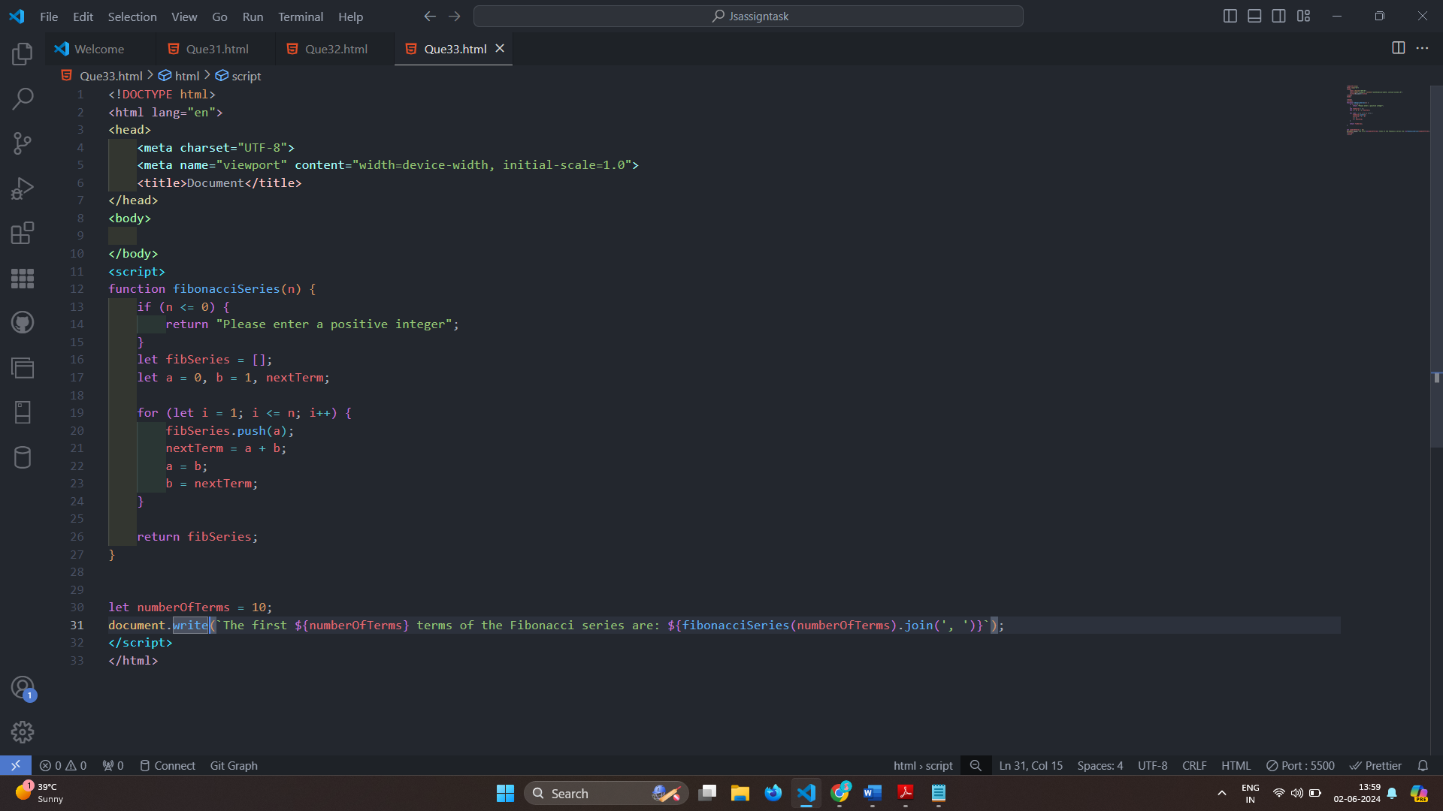

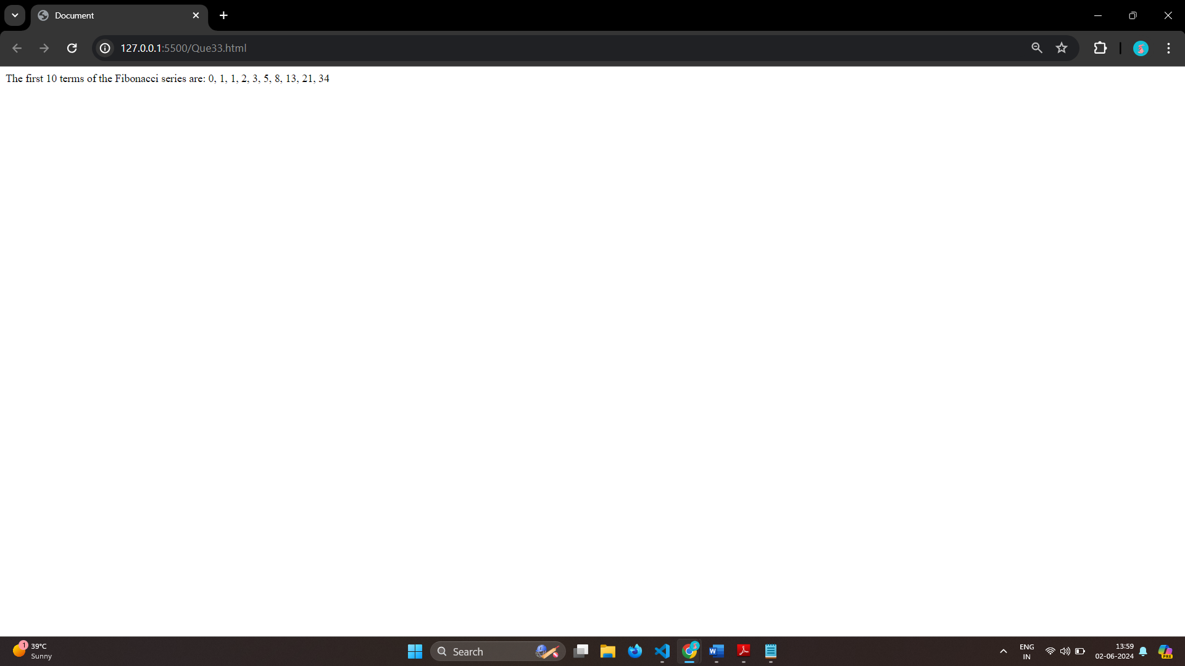

# Q.34 Write to print number in reverse order e.g.: number = 64728 ---> reverse =82746 in JS?

Ans: 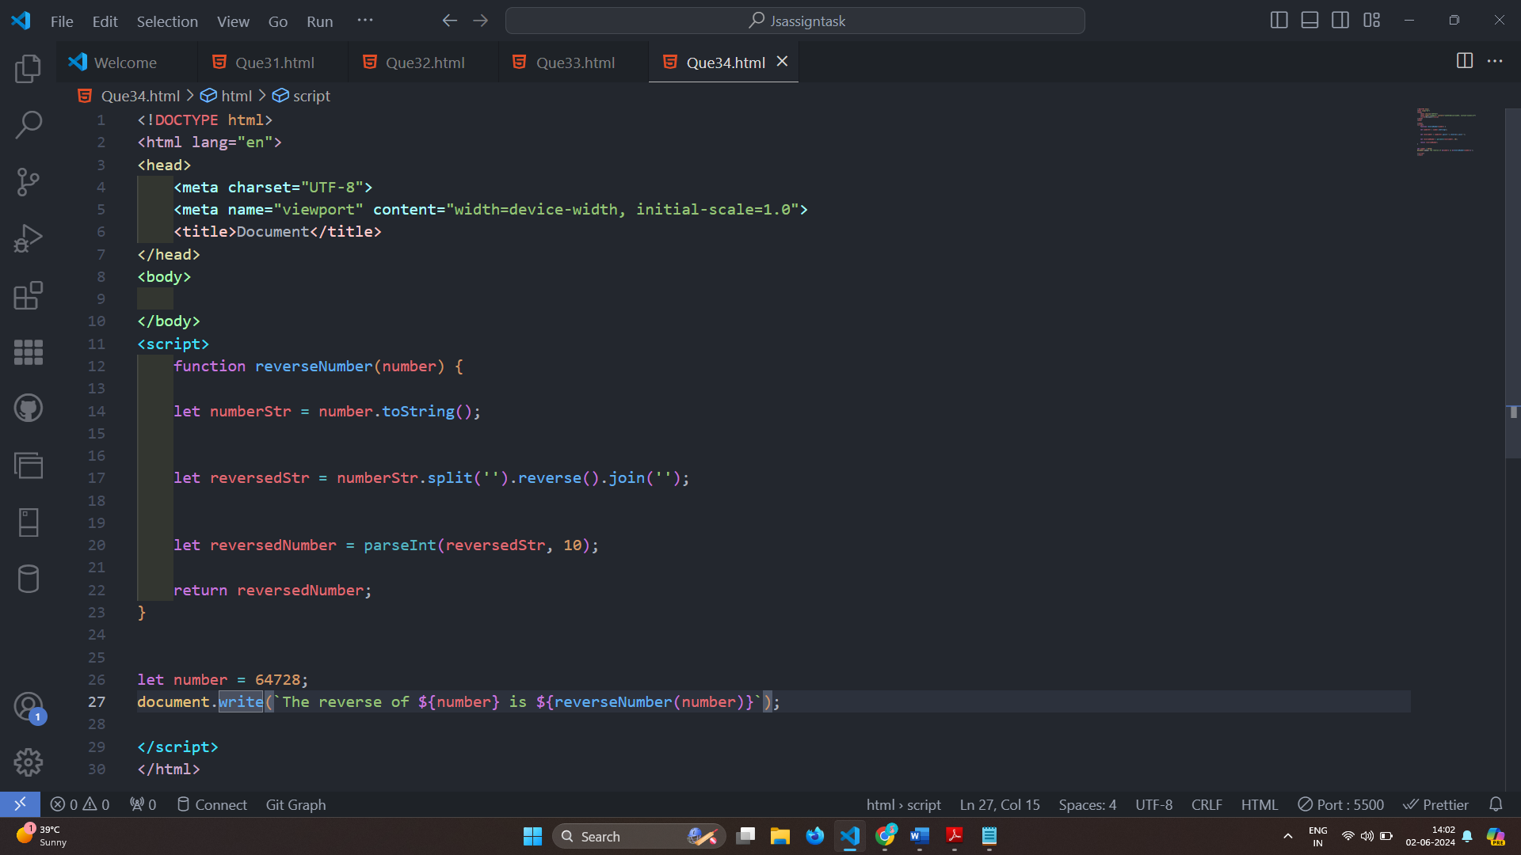

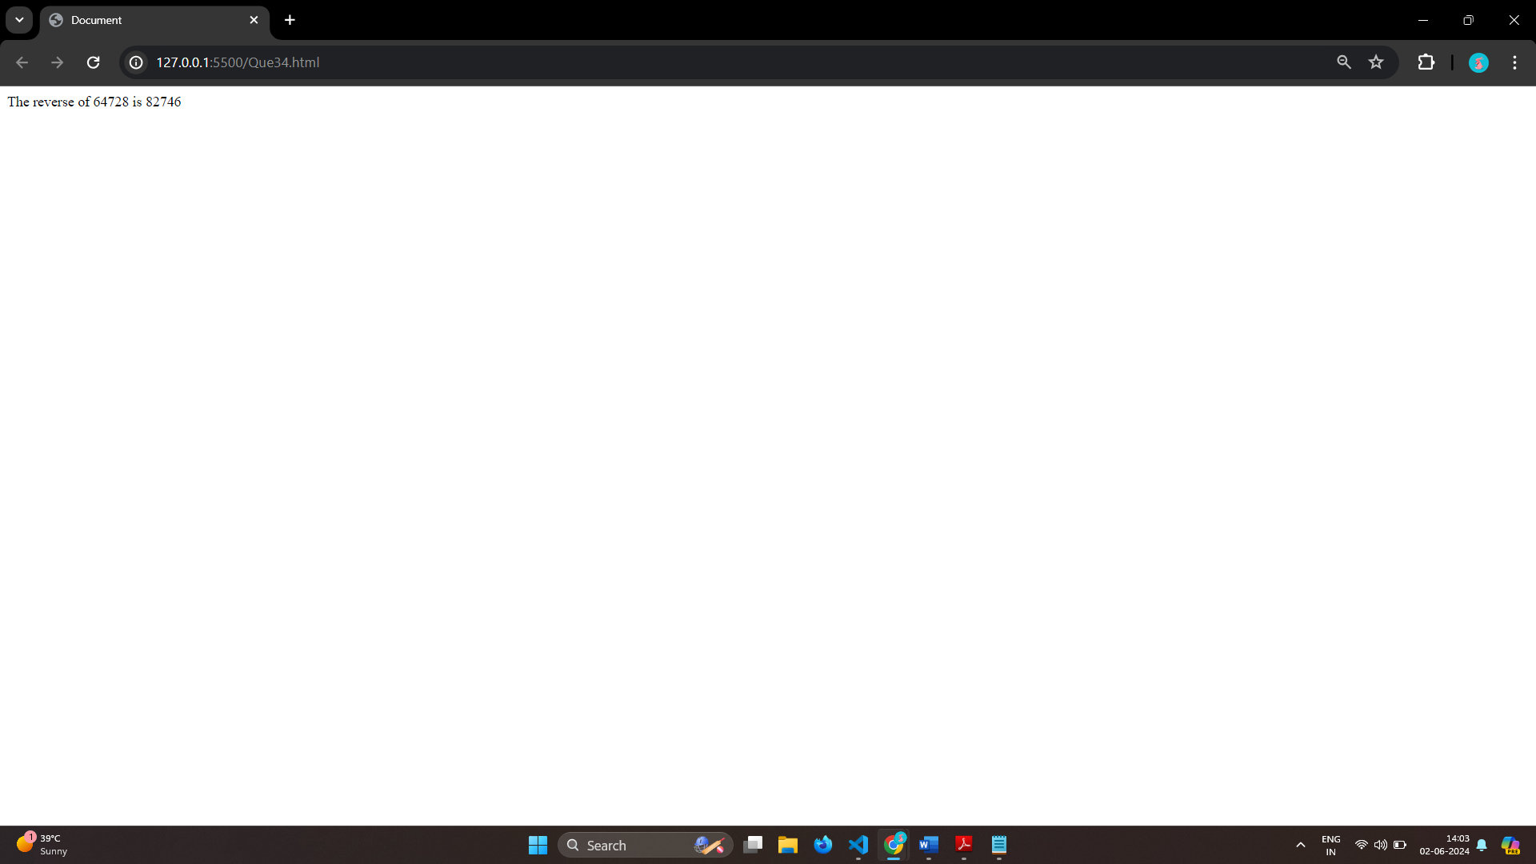

# Q.35 Write a program make a summation of given number (E.g., 1523 Ans: - 11) in JS?

Ans: 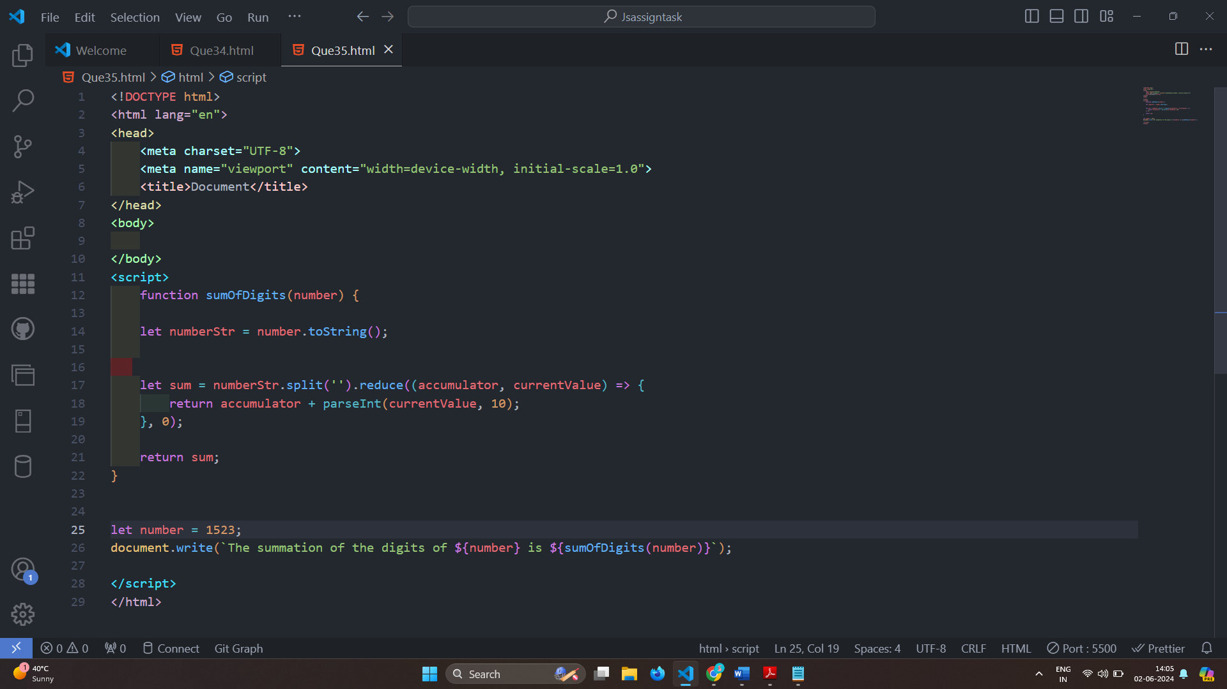

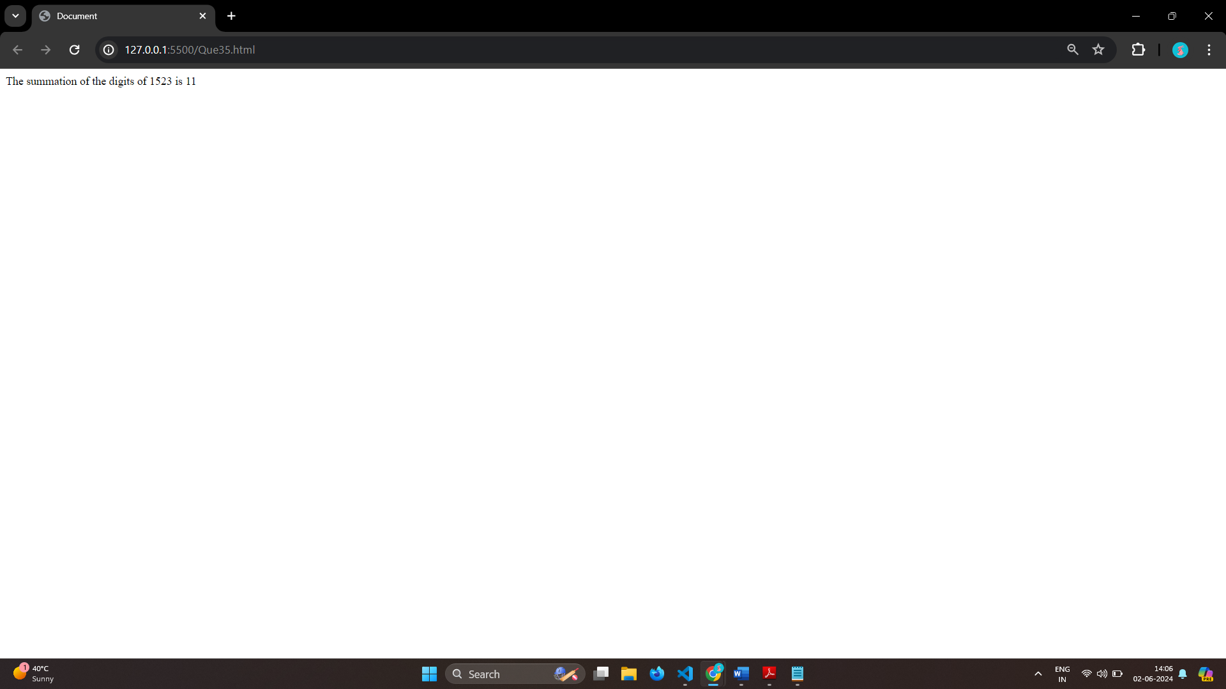

# Q.36 Write a program you have to make a summation of first and last Digit. (E.g., 1234 Ans: -5) in JS?

Ans:

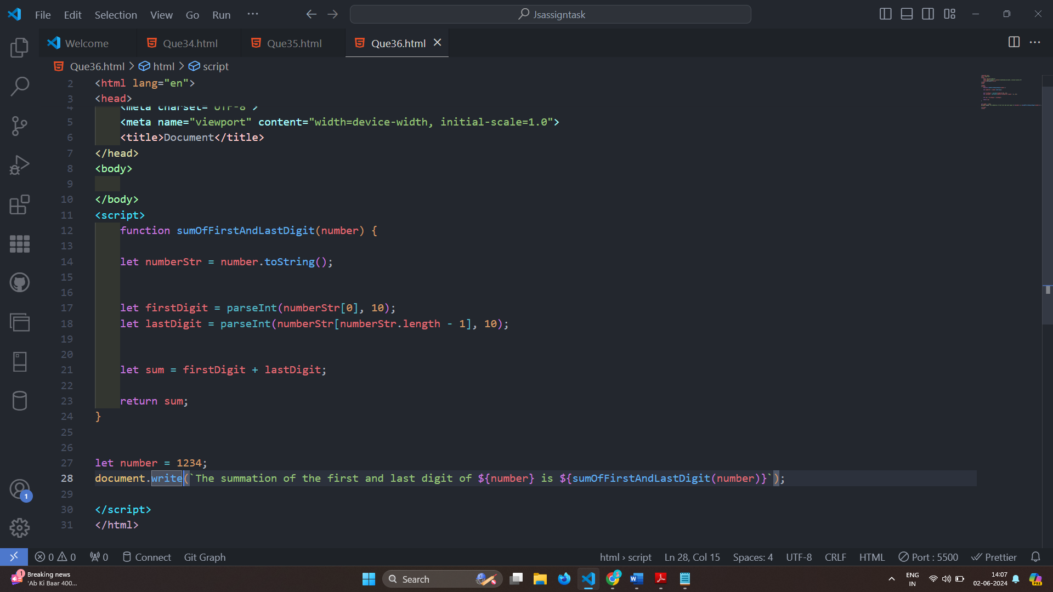

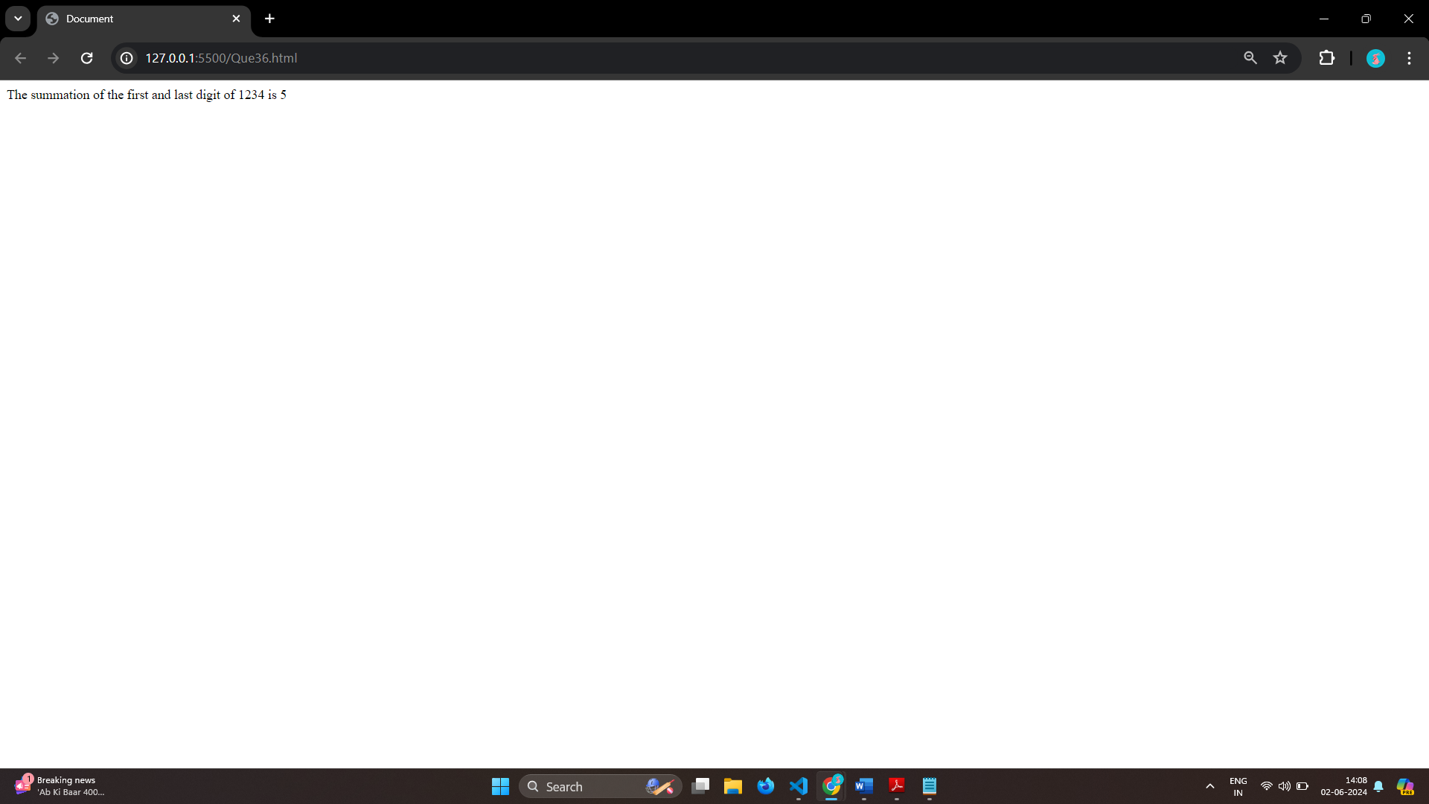

# Q.37 Use console.log() and escape characters to print the following pattern in JS?

# 1 1 1 1 1

# 2 1 2 4 8

# 3 1 3 9 27

# 4 1 4 16 64

# 5 1 5 25 125

Ans:

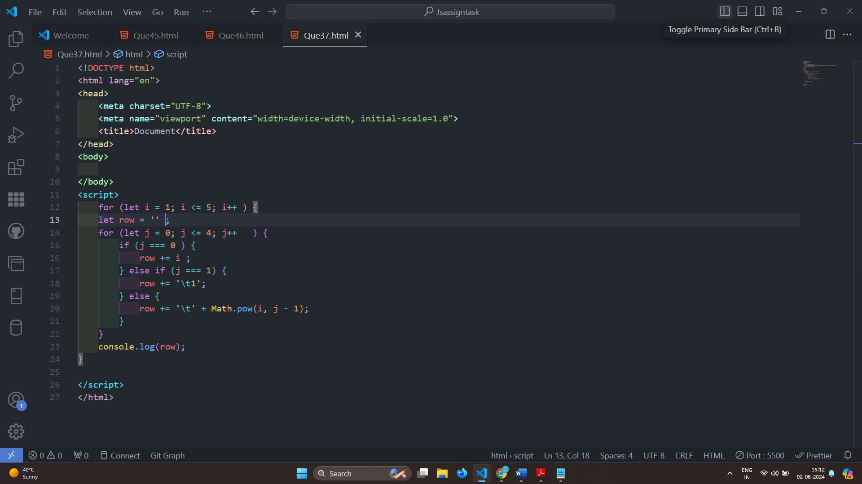

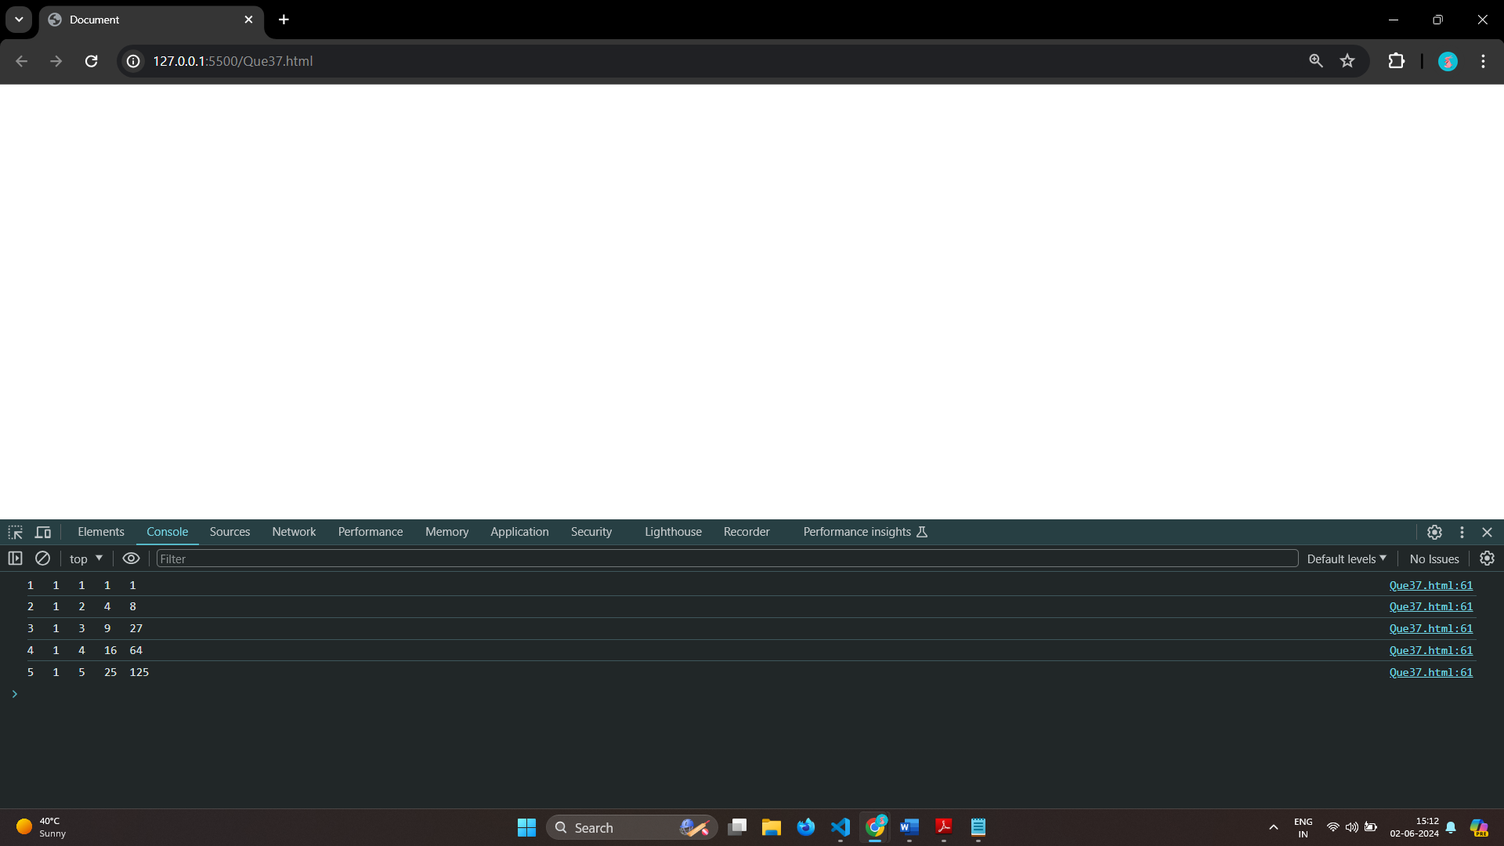

# Q.38 Use pattern in console.log in JS?

# 1) 1

# 1 0

# 1 0 1

# 1 0 1 0

# 1 0 1 0 1

Ans:

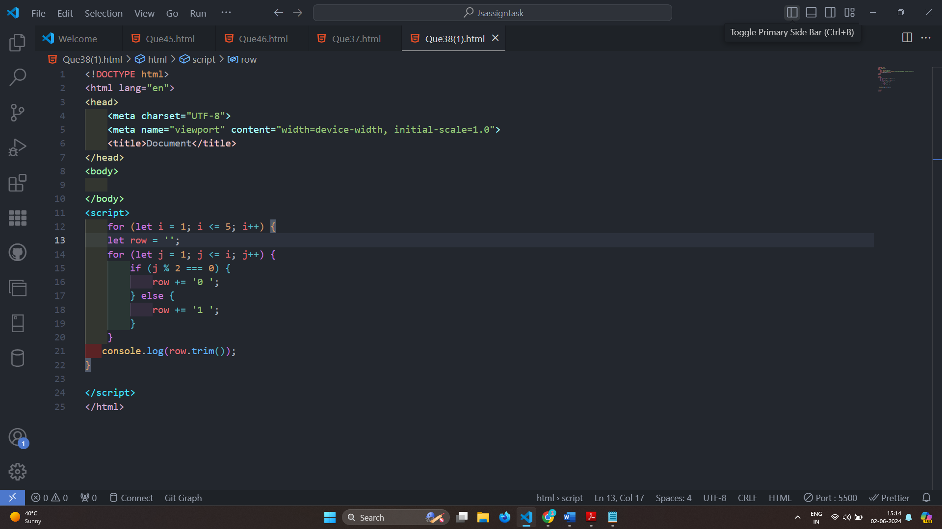

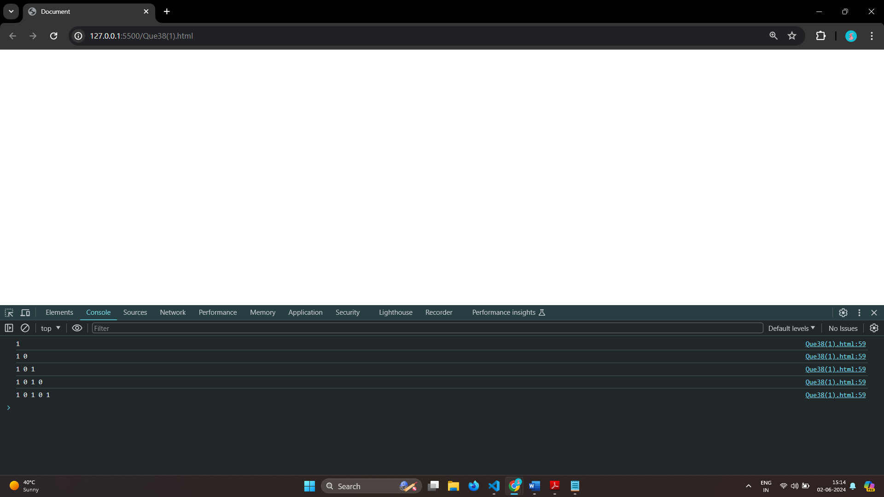

# 2) A

# B C

# D E F

# G H I J

# K L M N O

Ans:

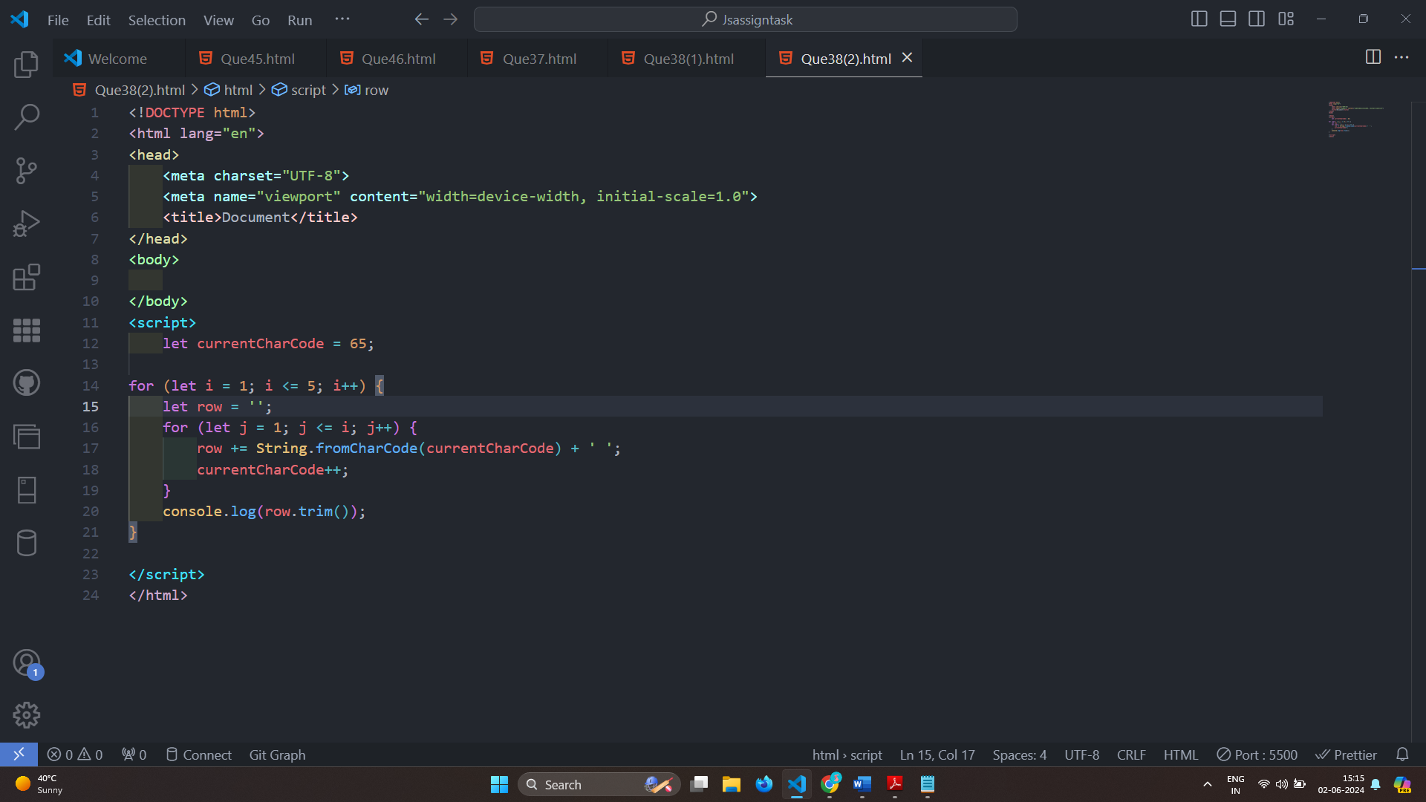

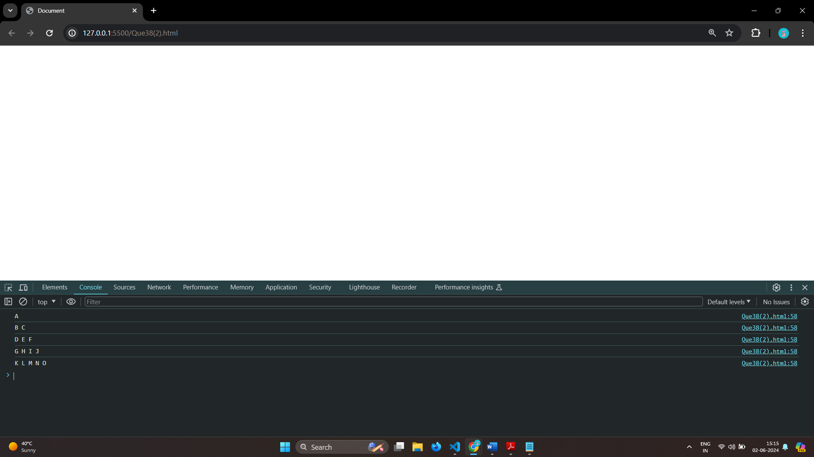

# 3) 1

# 2 3

# 4 5 6

# 7 8 9 10

# 11 12 13 14 15

Ans: 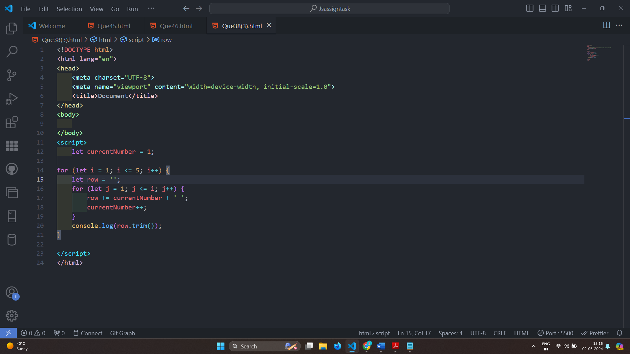

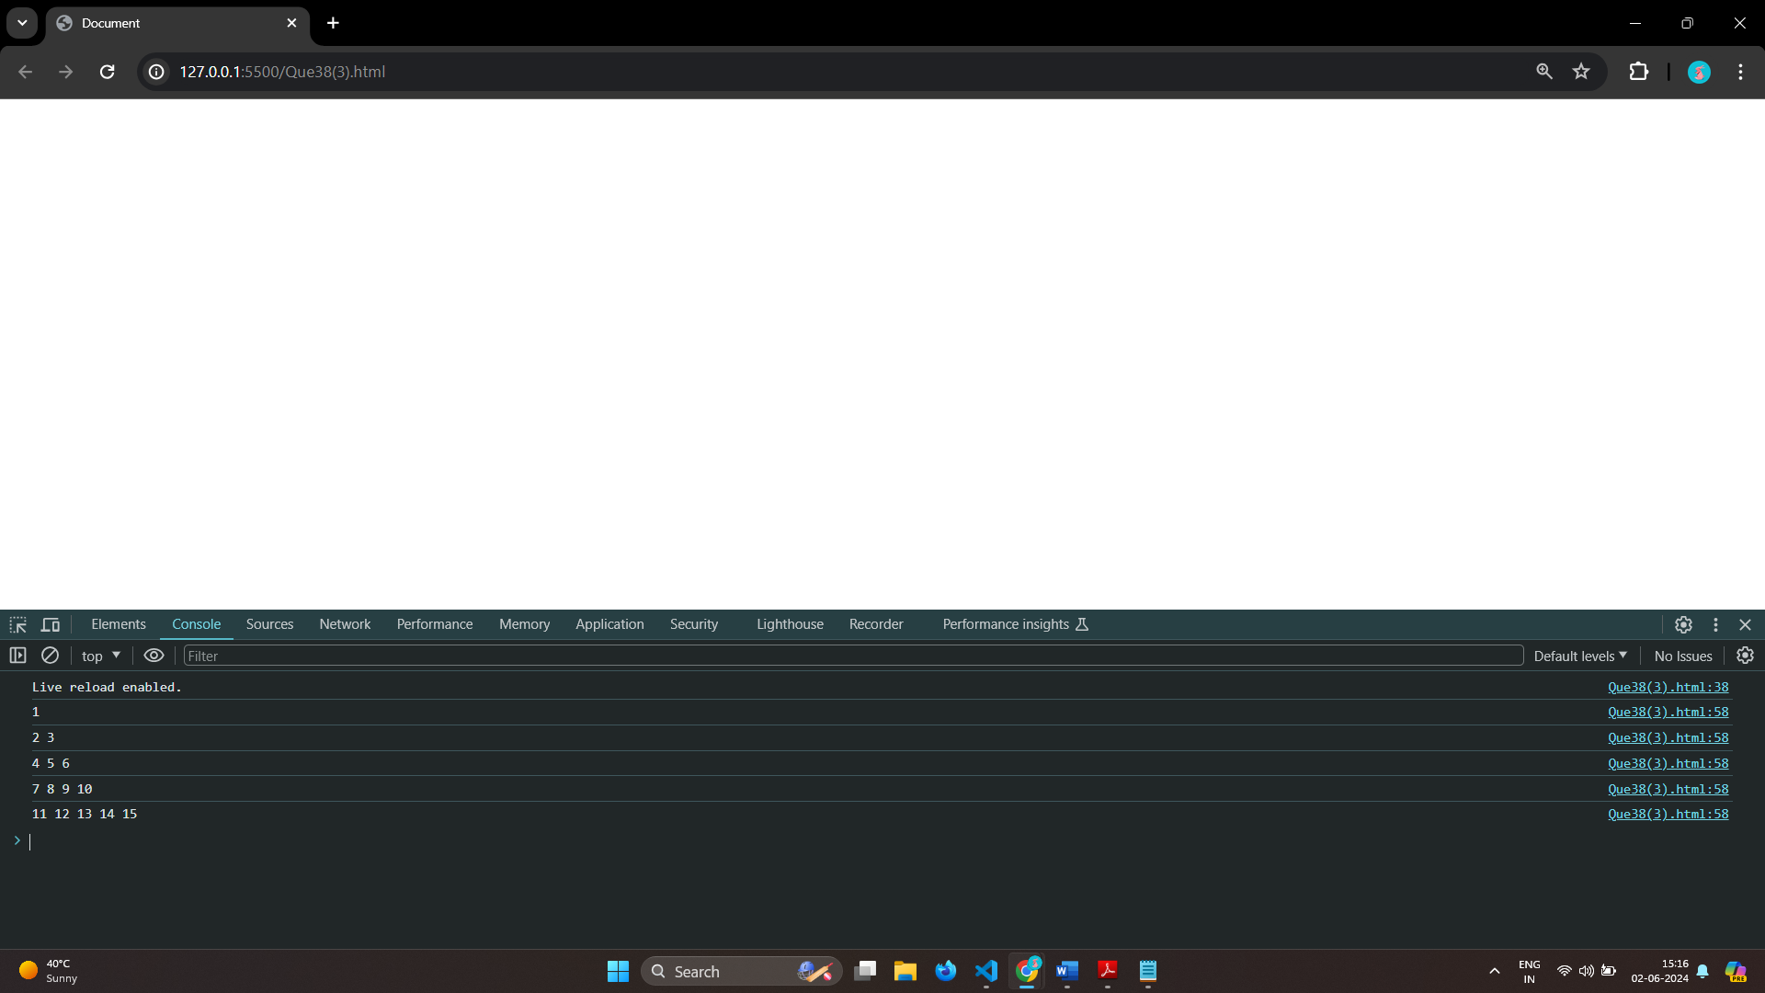

# 4) *

# * *

# * * *

# * * * *

# * * * * *

Ans: 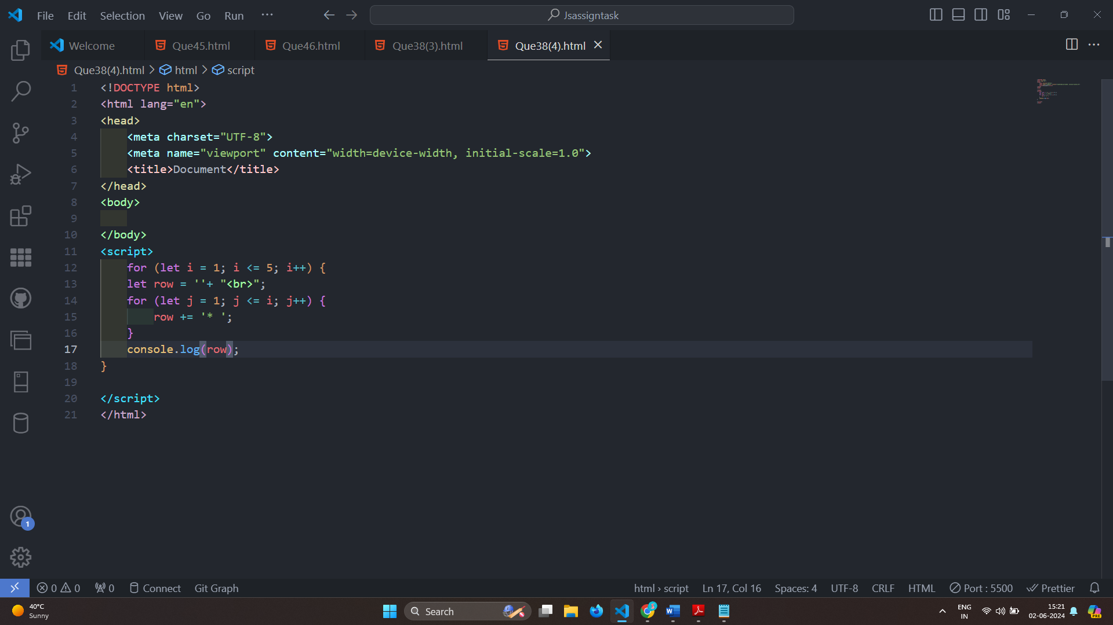

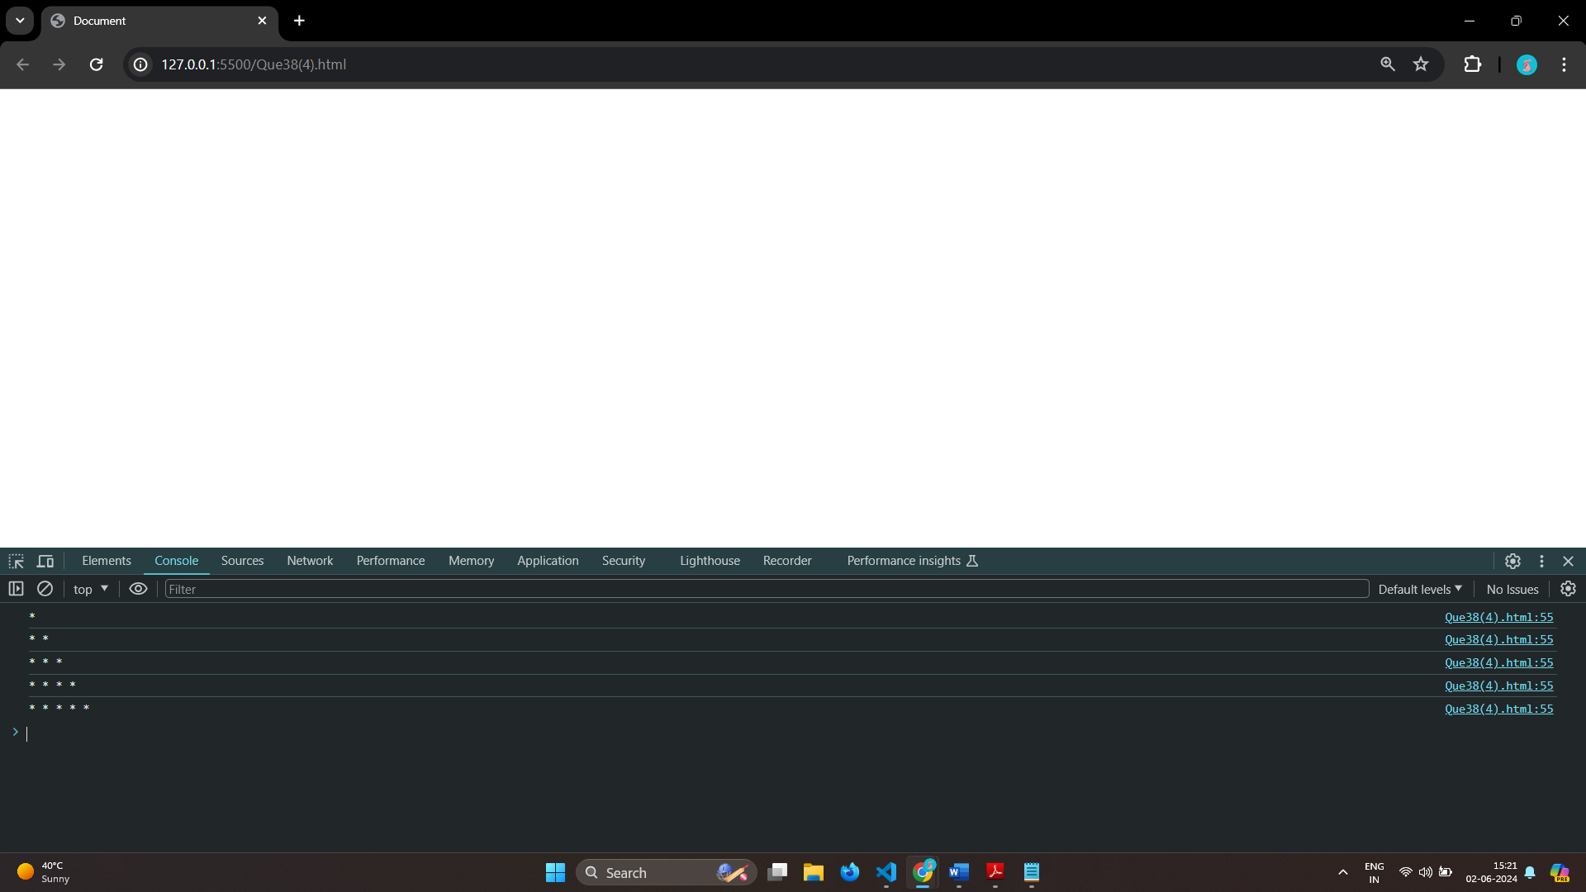

# Q.39 Accept 3 numbers from user using while loop and check each numbers palindrome?

Ans:

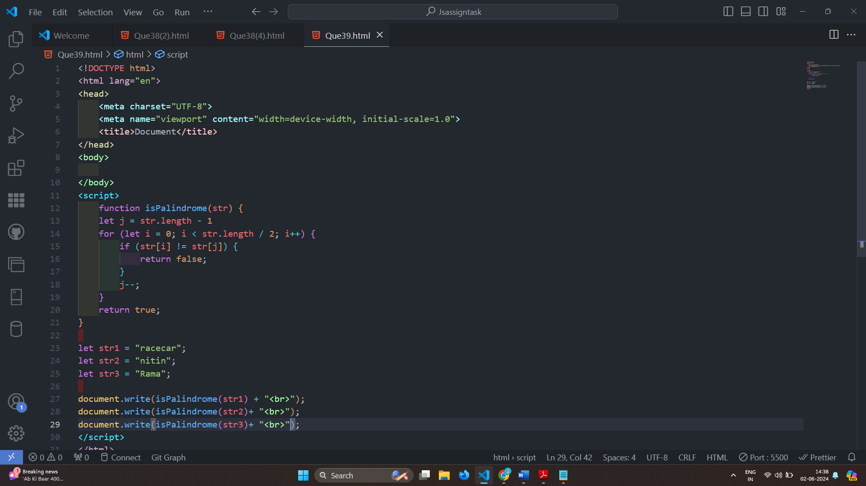

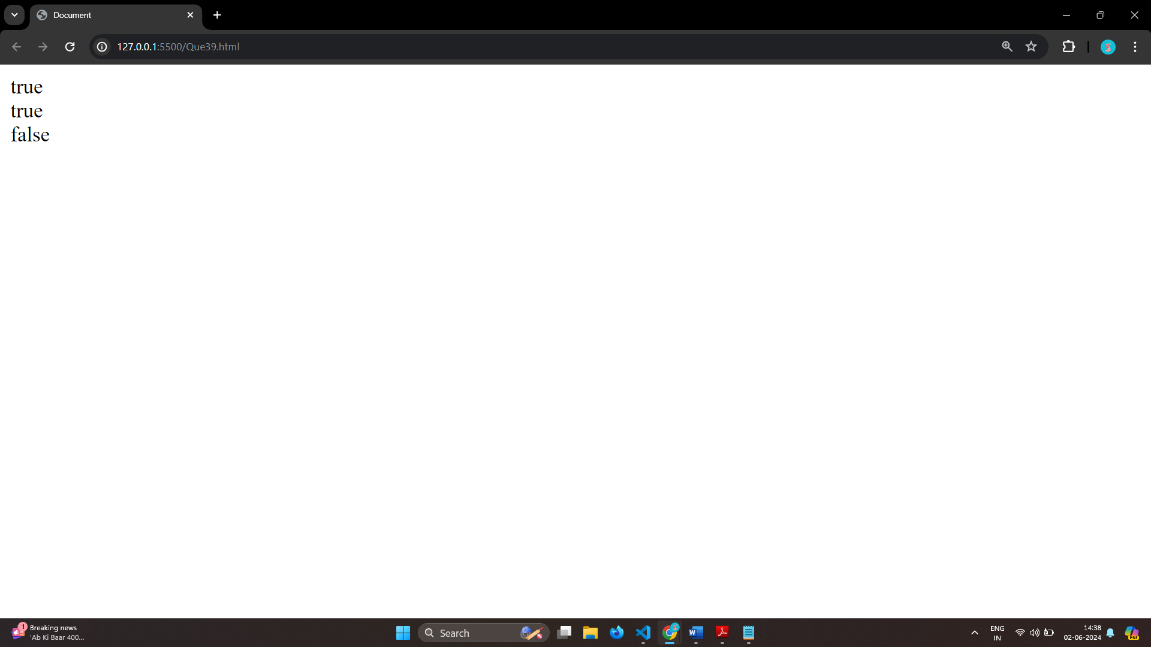

# (Array and object Question)

# Q.40 Write a JavaScript Program to display the current day and time in the following format. Sample Output: Today is Friday. Current Time is 12 PM: 12 : 22 2 ?

Ans:

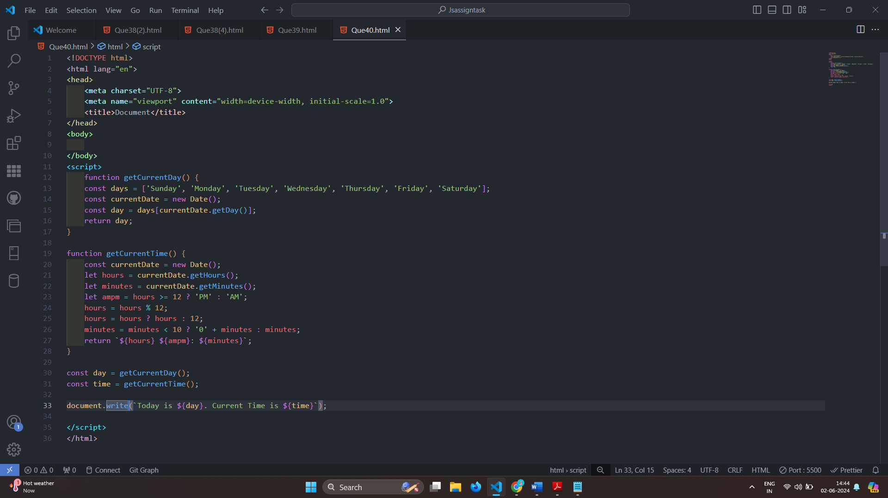

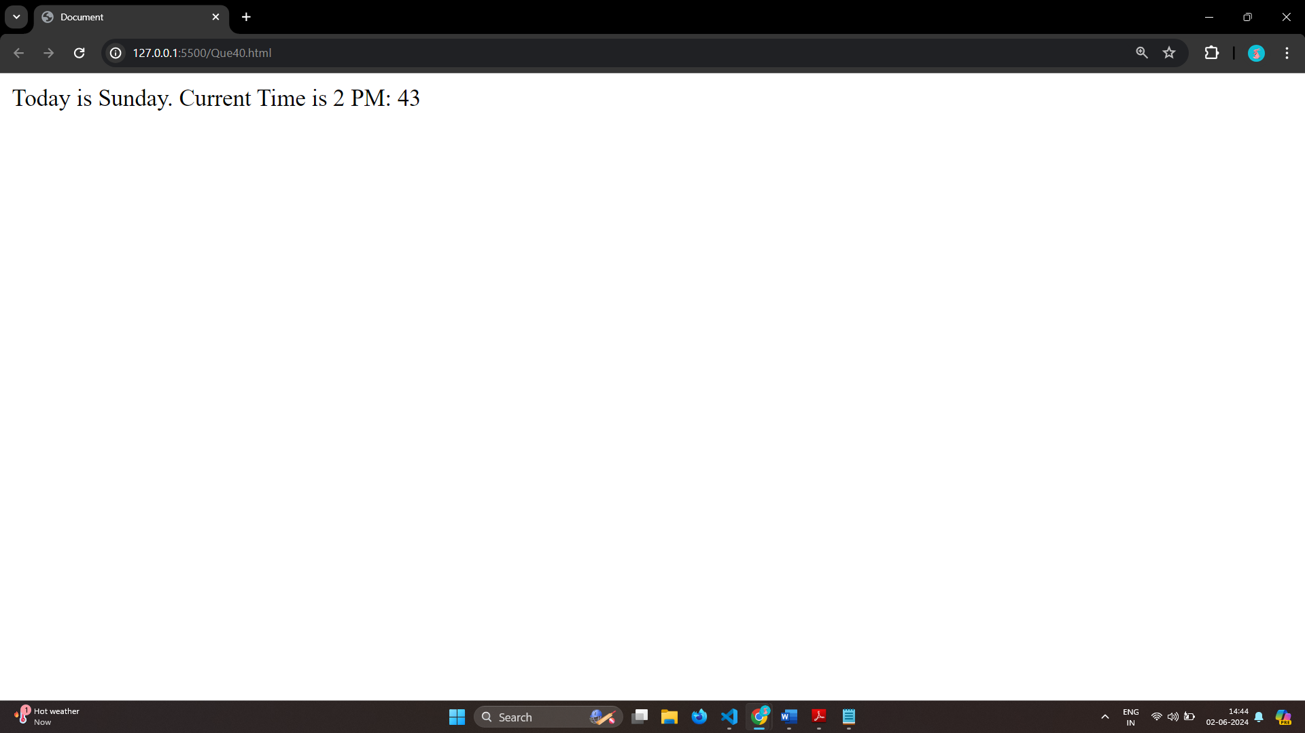

# Q.41 Write a JavaScript program to get the current date?

Ans: 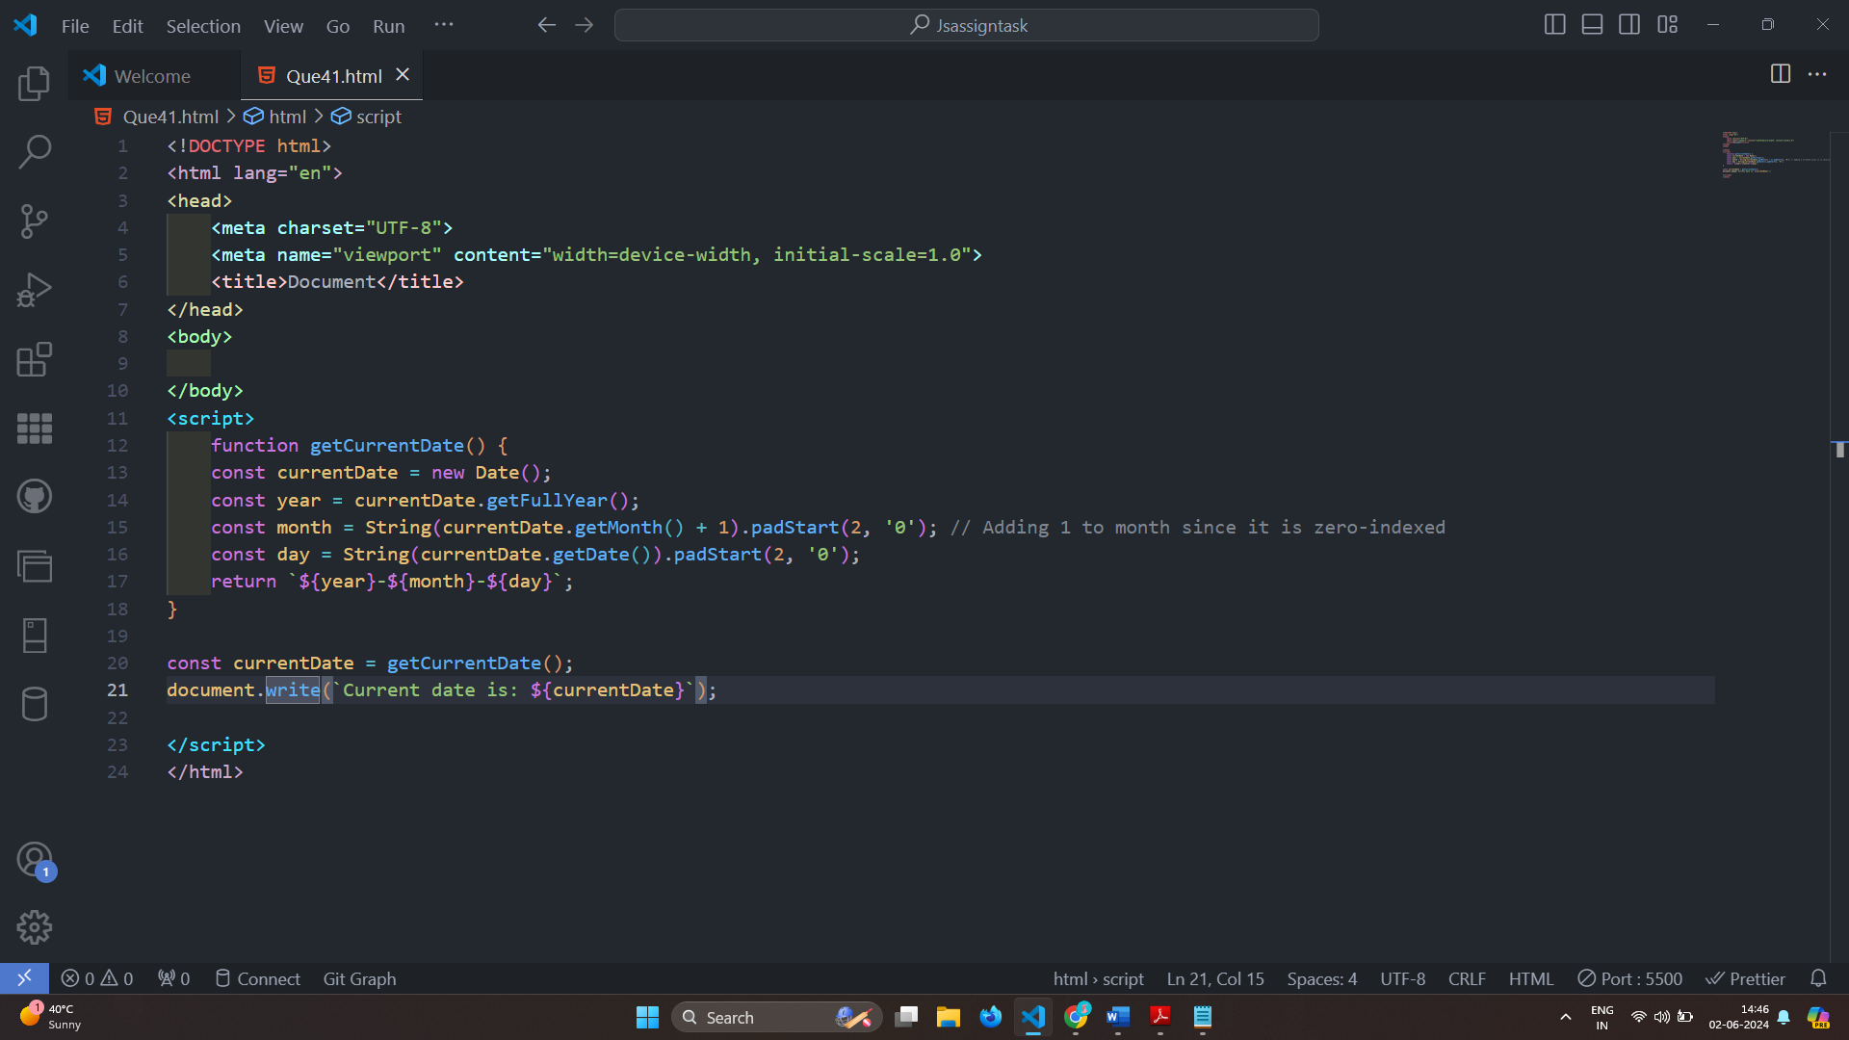

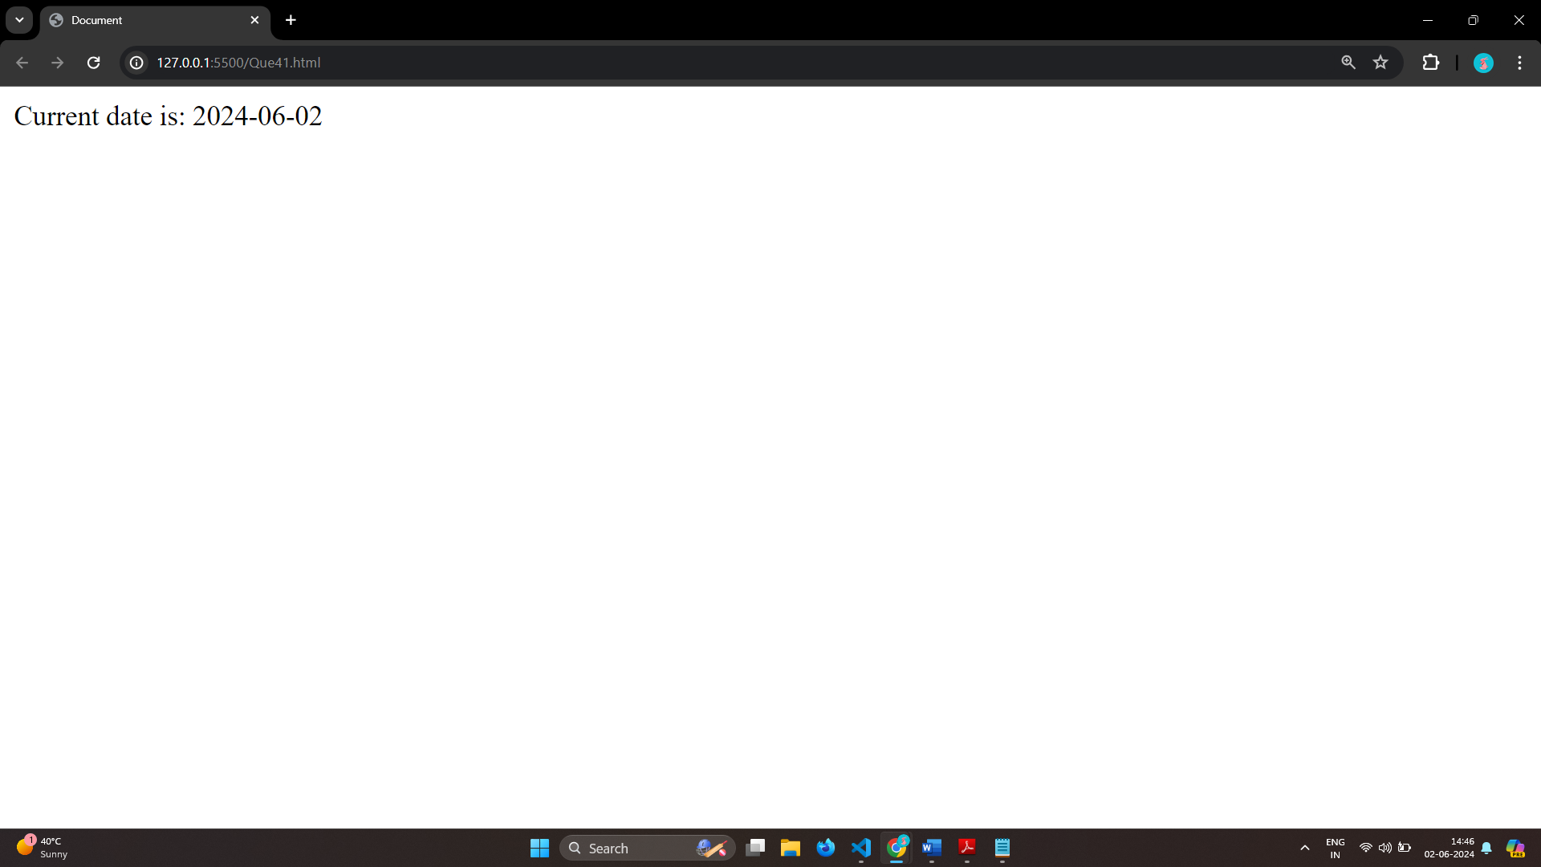

# Q.42 Write a JavaScript program to compare two objects?

Ans: 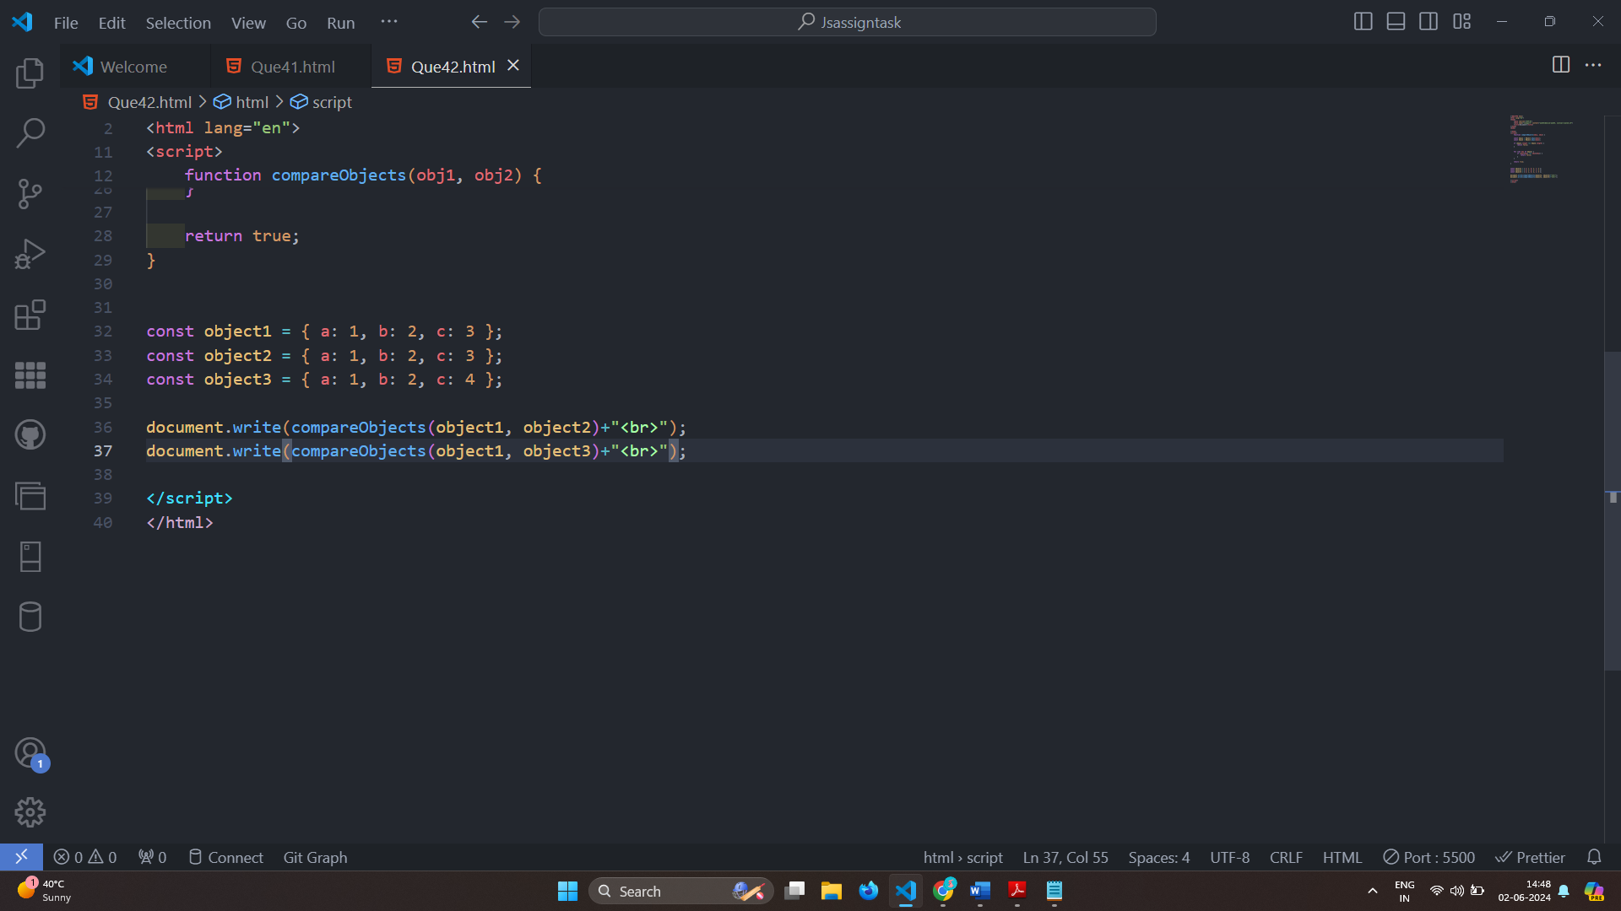

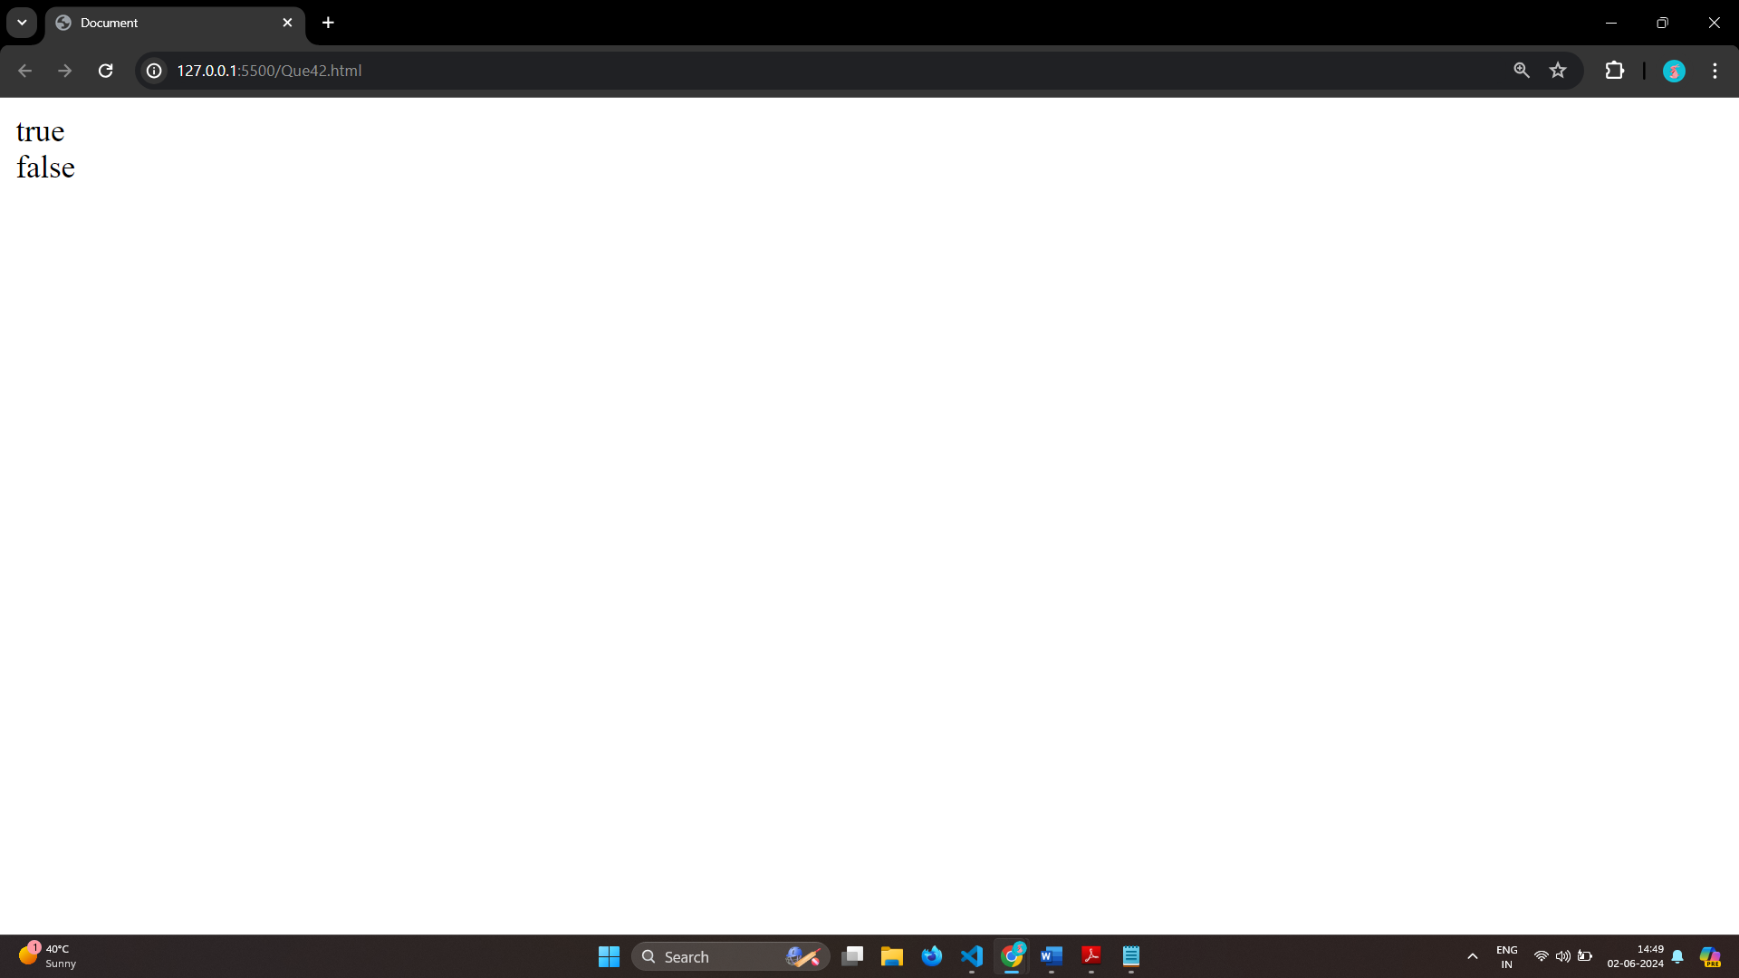

# Q.43 Write a JavaScript program to convert an array of objects into CSV string?

Ans: 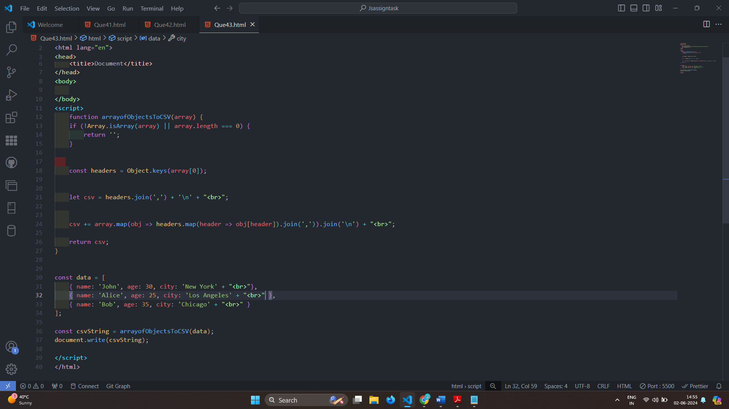

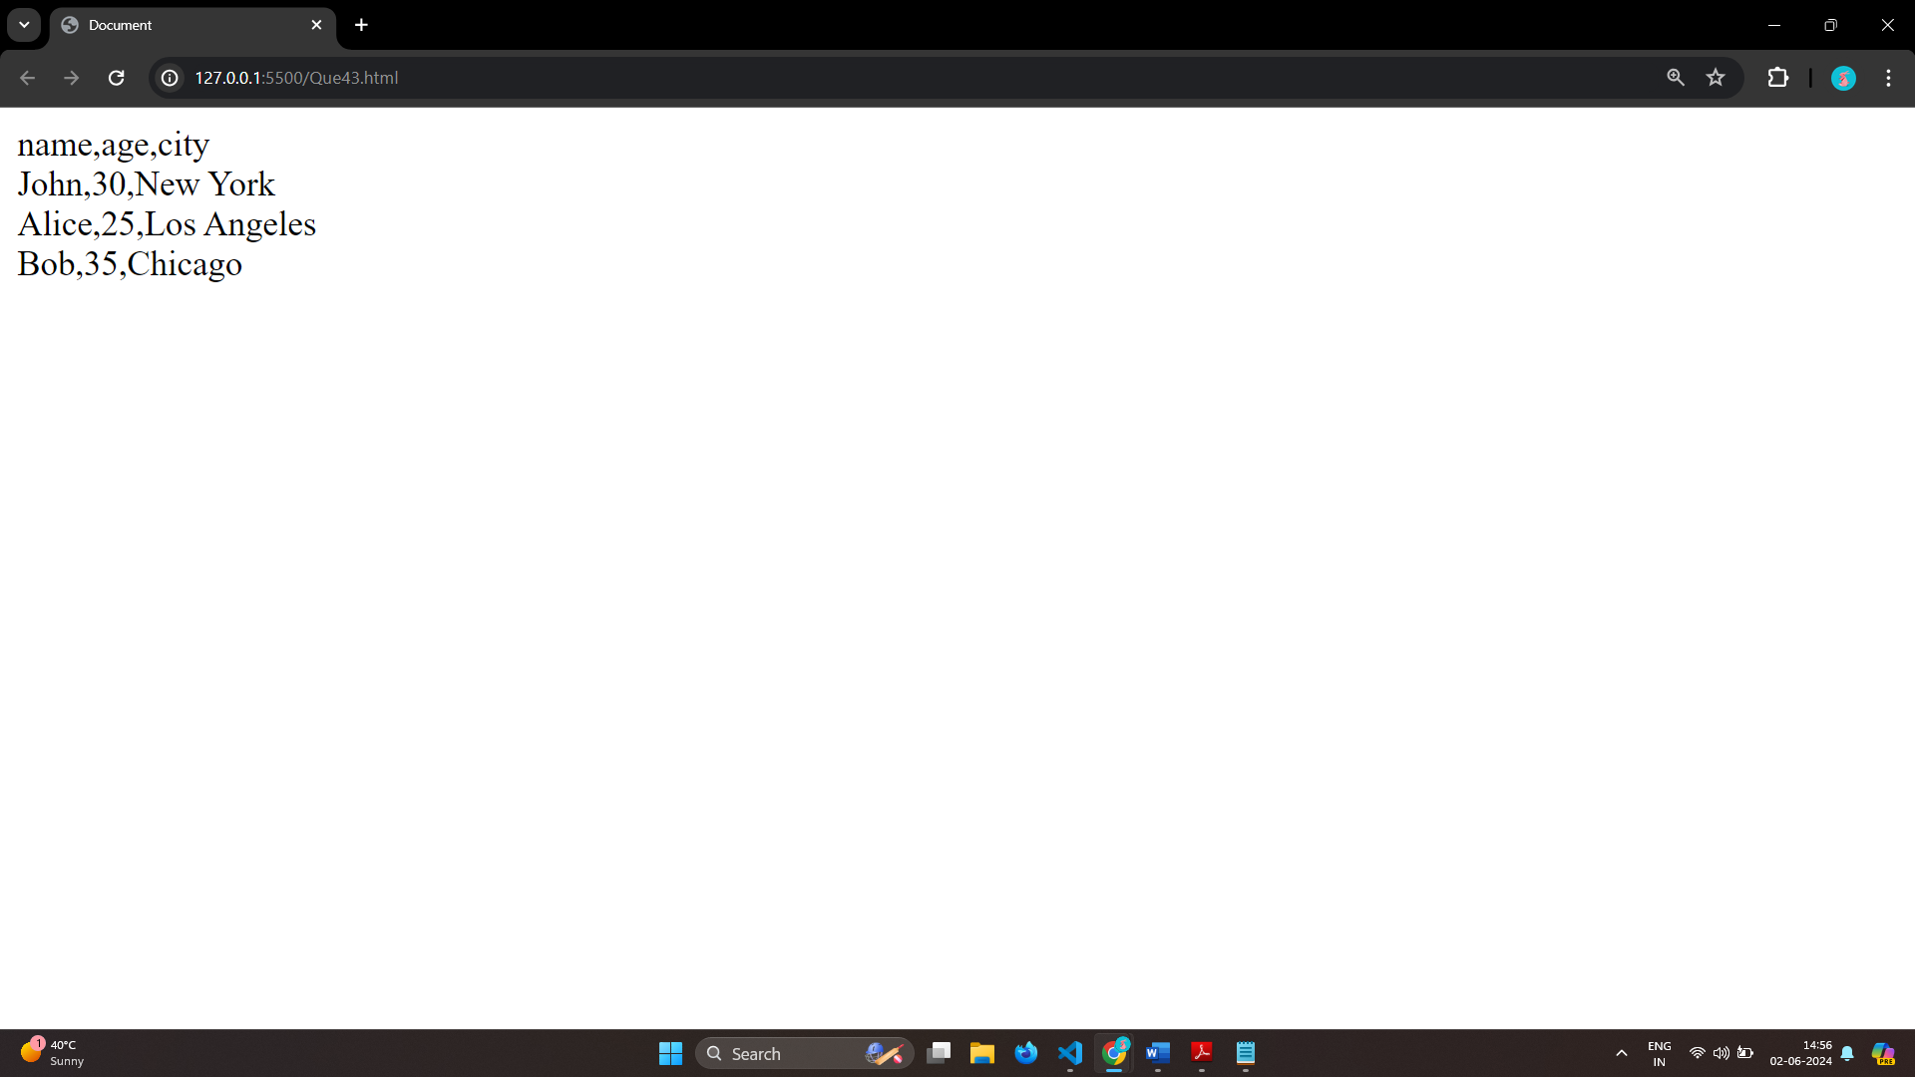

# Q.44 Write a JavaScript program to capitalize first letter of a string?

Ans: 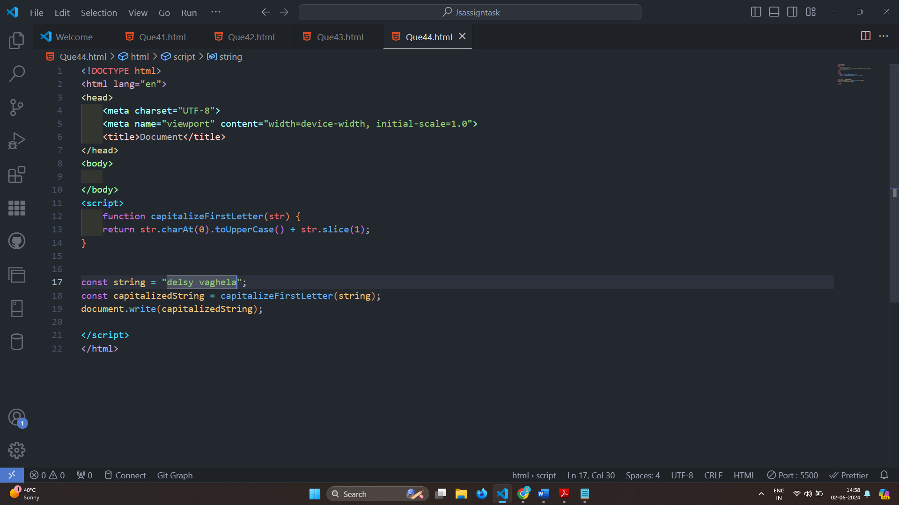

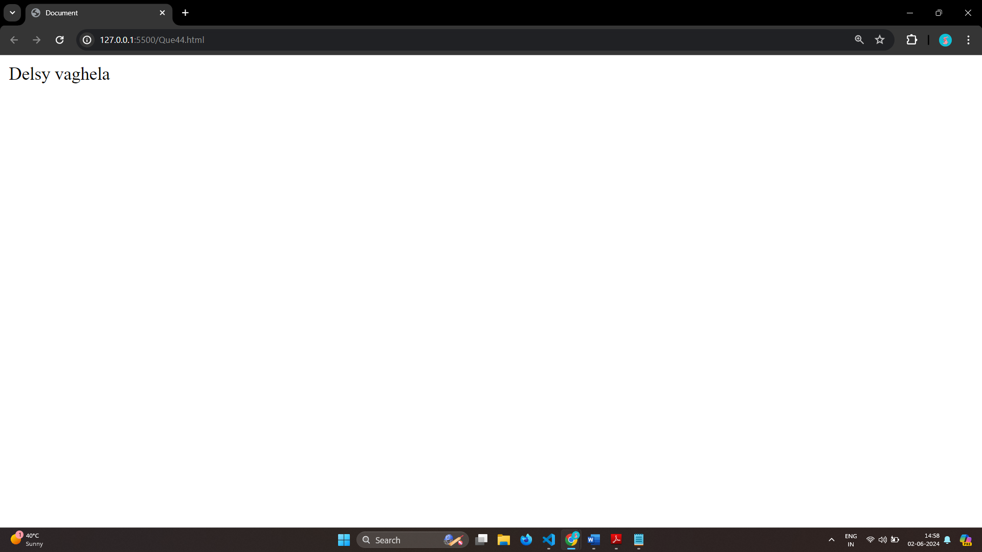

# Q. 45 Write a JavaScript program to determine if a variable is array?

Ans: 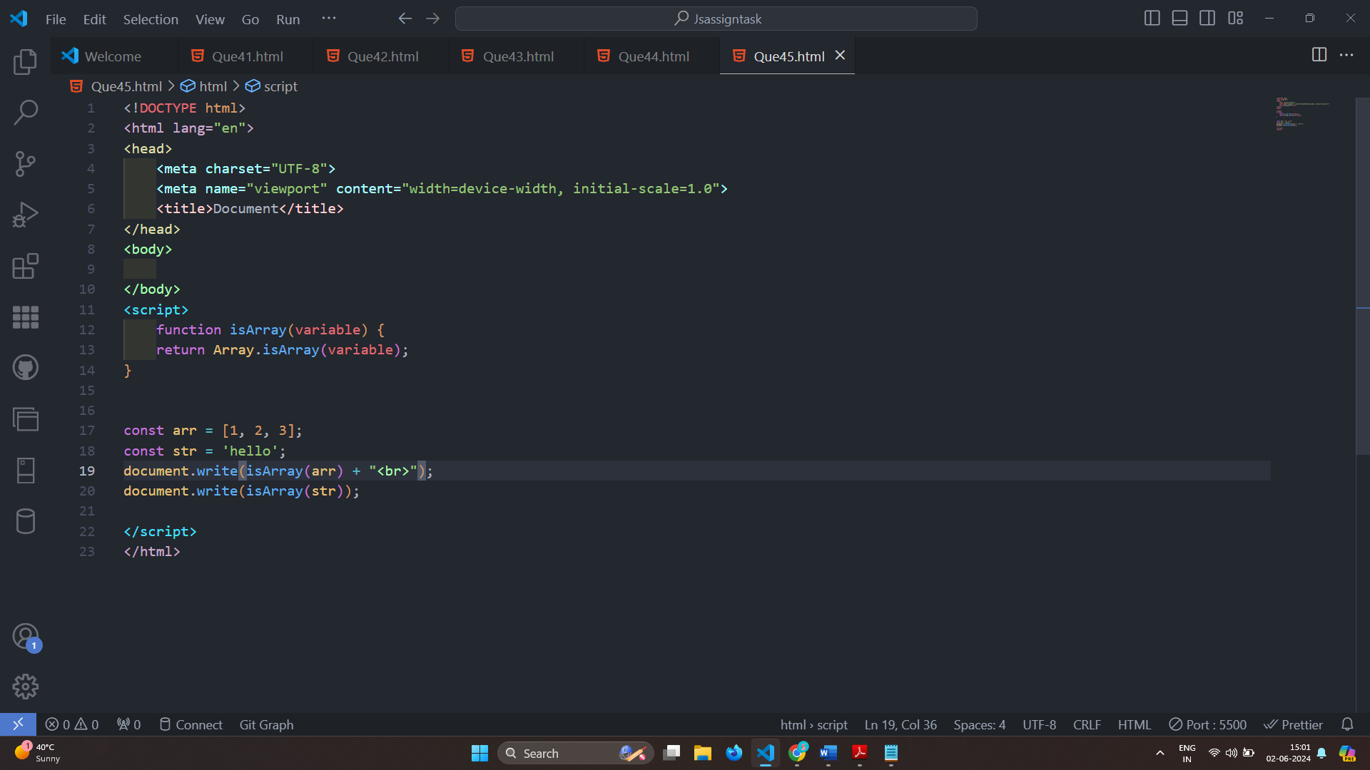

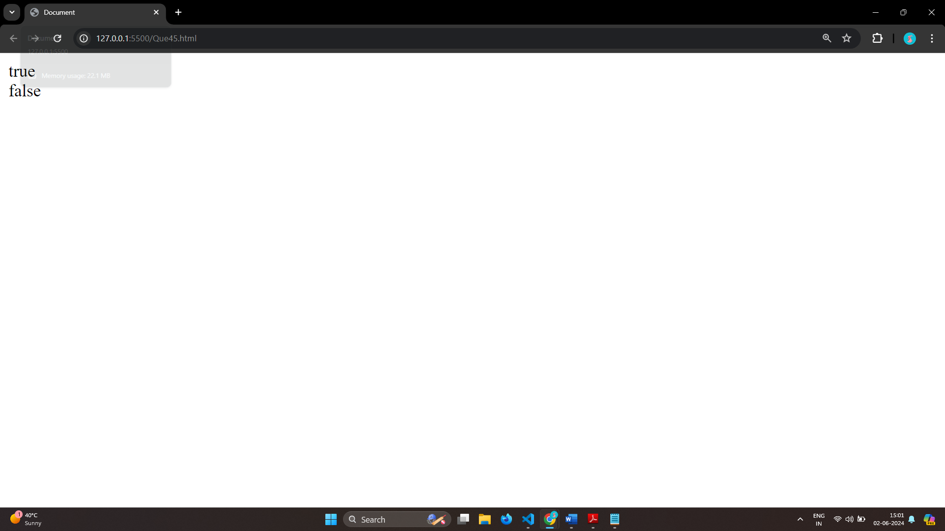

# Q.46 Write a JavaScript program to clone an array?

Ans: 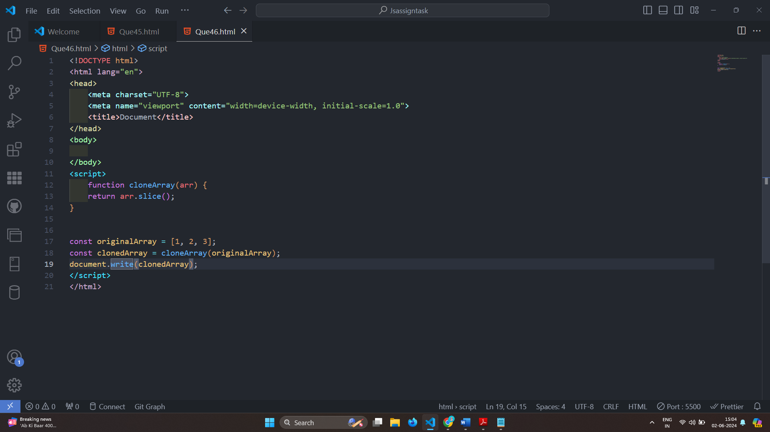

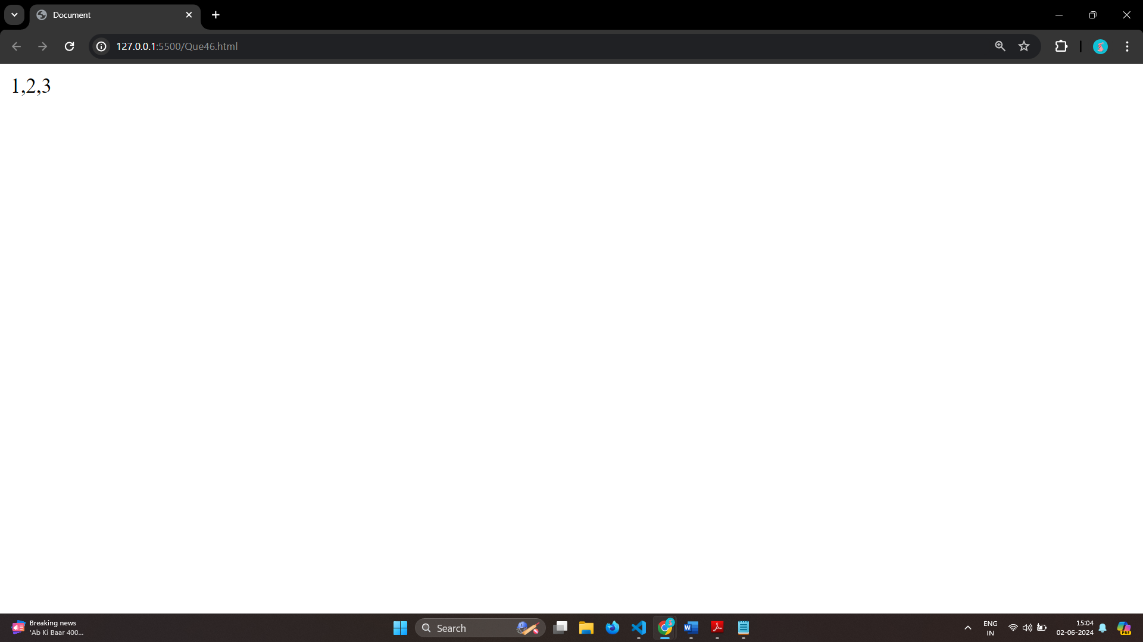

# Q.47 What is the drawback of declaring methods directly in JavaScript objects?

Ans: Drawback of declaring methods directly in JavaScript objects

Memory Consumption

Inefficiency

Difficulties with Inheritance

Encapsulation

# Q.48 Print the length of the string on the browser console using console.log()?

Ans: 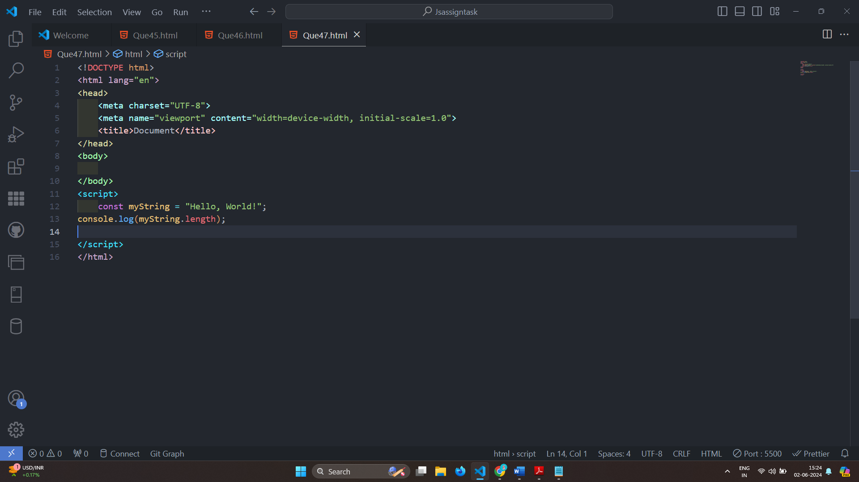

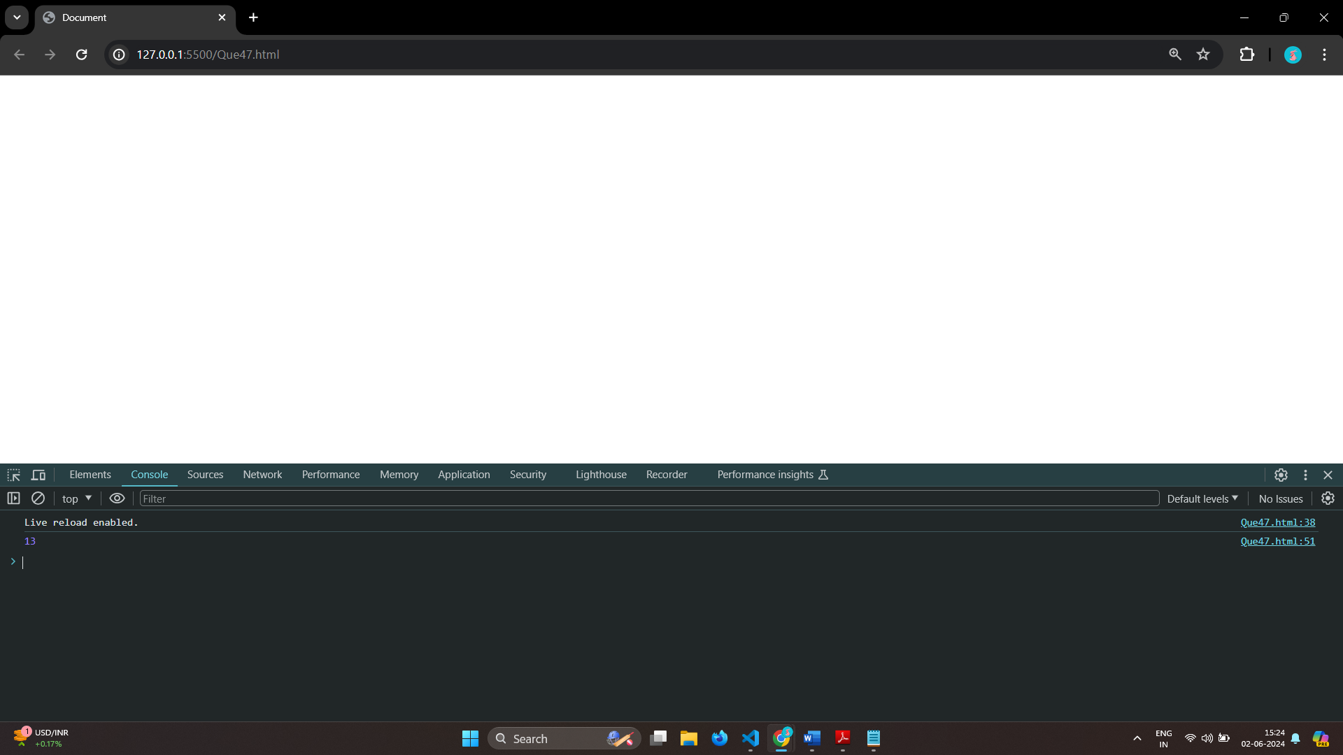

# Q.49 Change all the string characters to capital letters using toUpperCase() method?

Ans: 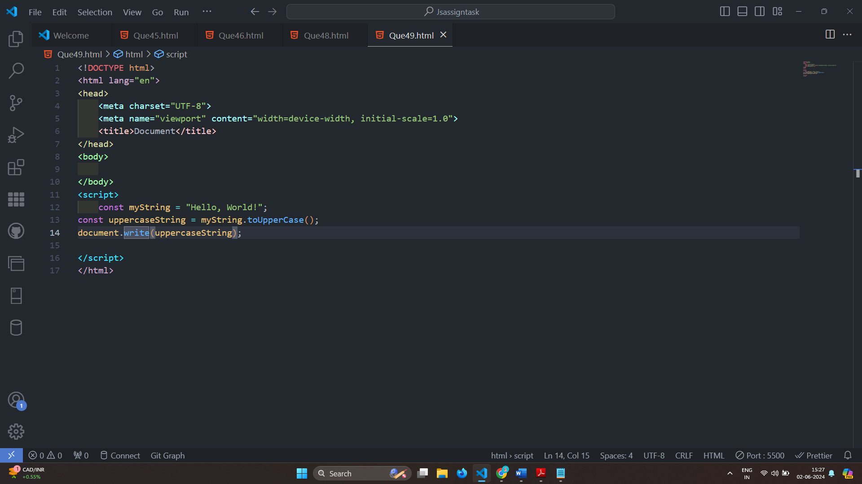

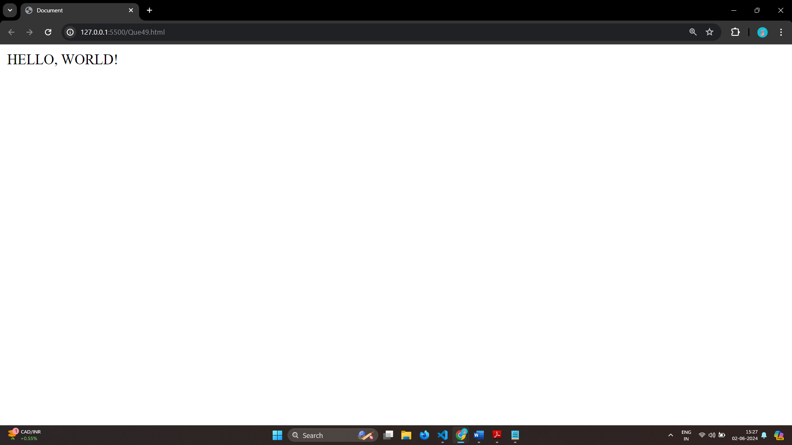

# Q.50 What is the drawback of declaring methods directly in JavaScript objects?

Ans: Ans: Drawback of declaring methods directly in JavaScript objects

Memory Consumption

Inefficiency

Difficulties with Inheritance

Encapsulation

# Q.51 Write a JavaScript program to get the current date. Expected Output : mm-dd-yyyy, mm/dd/yyyy or dd-mm-yyyy, dd/mm/yyyy?

Ans: 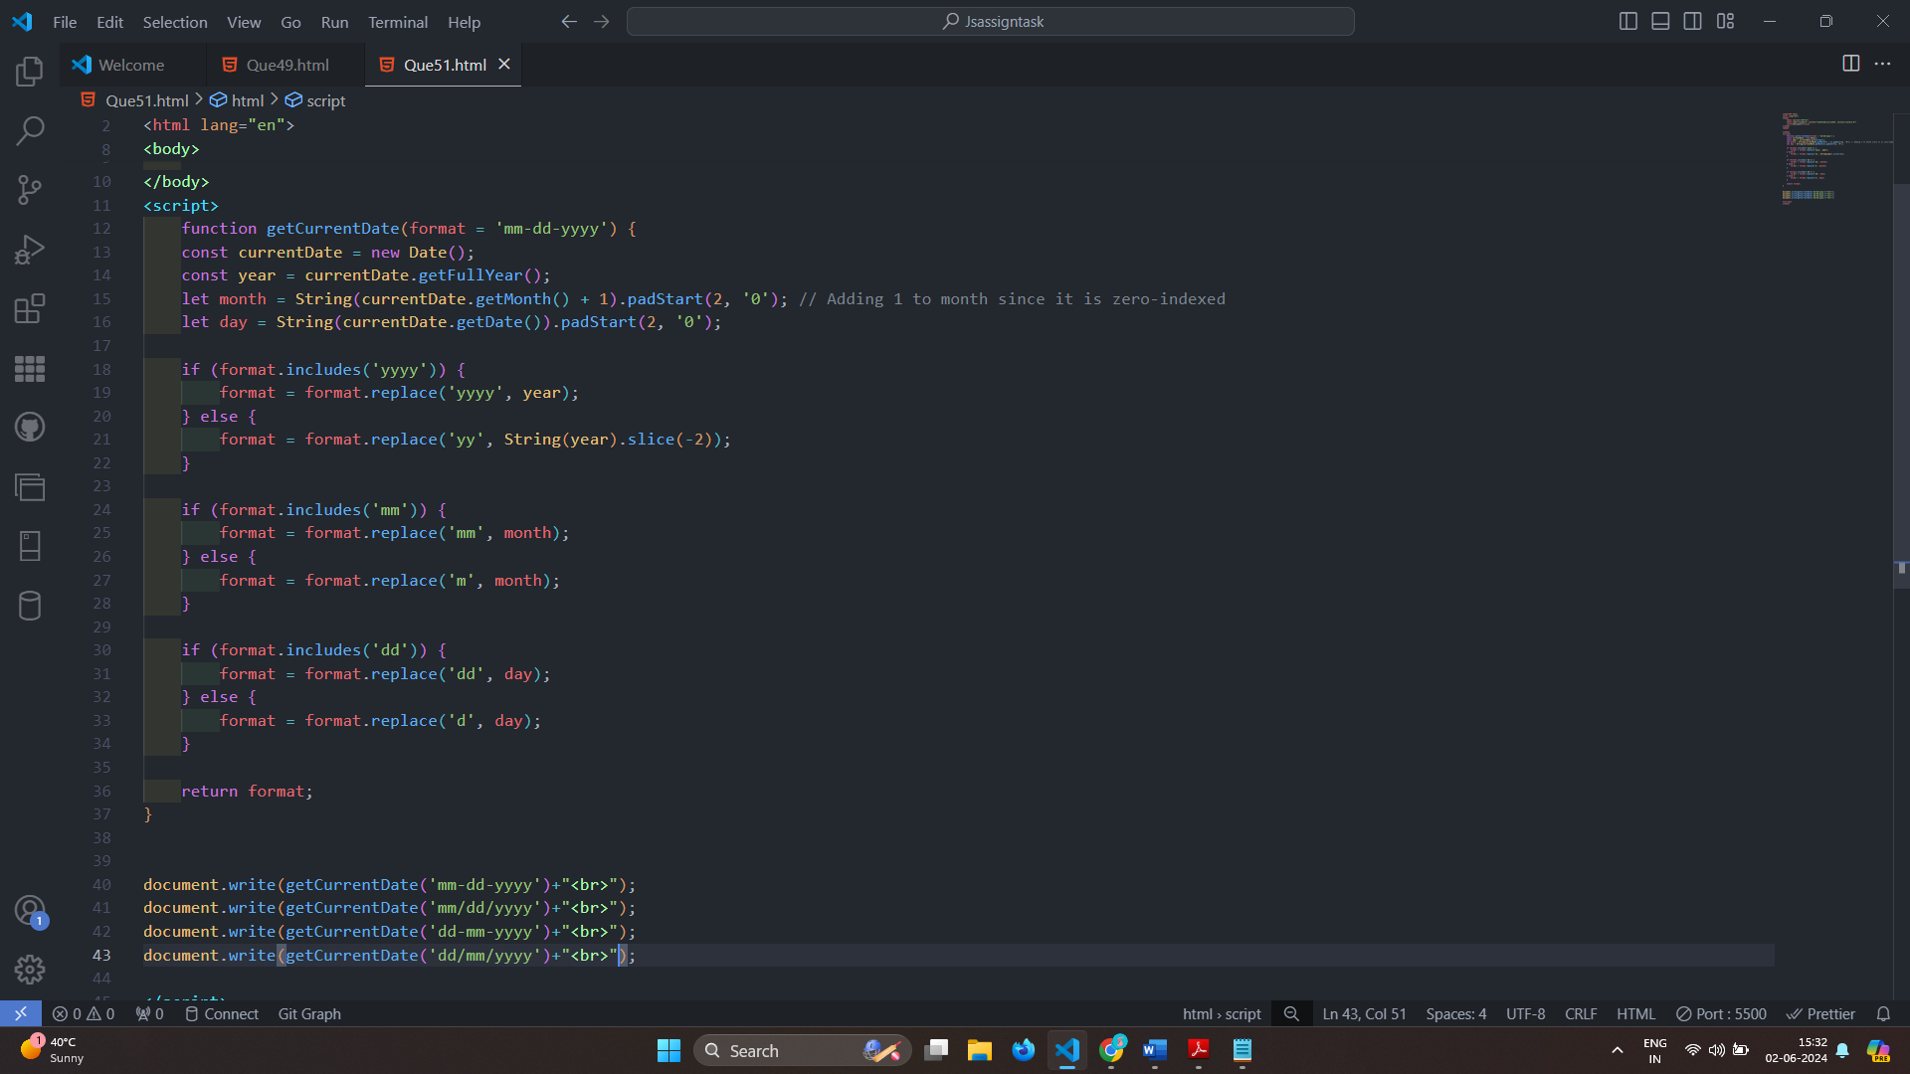

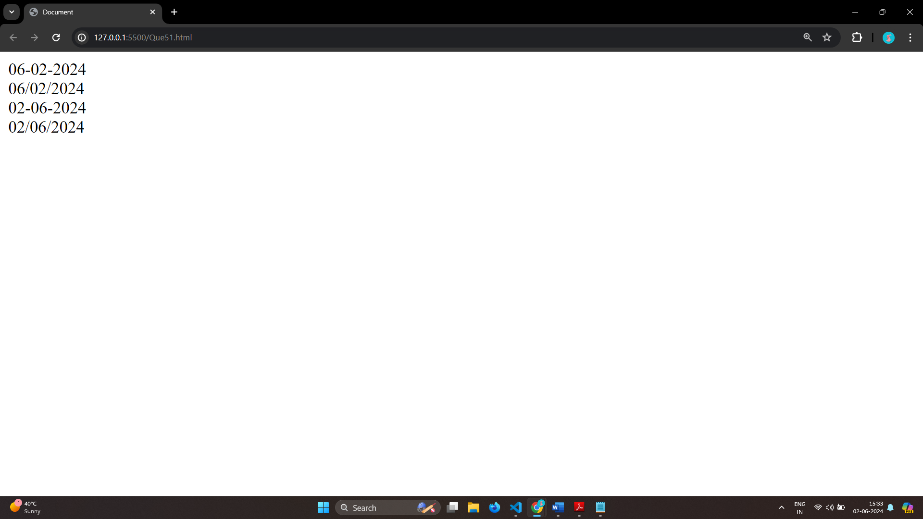

# Q.52 Use indexOf to determine the position of the first occurrence of a in 30 Days Of JavaScript?

Ans: 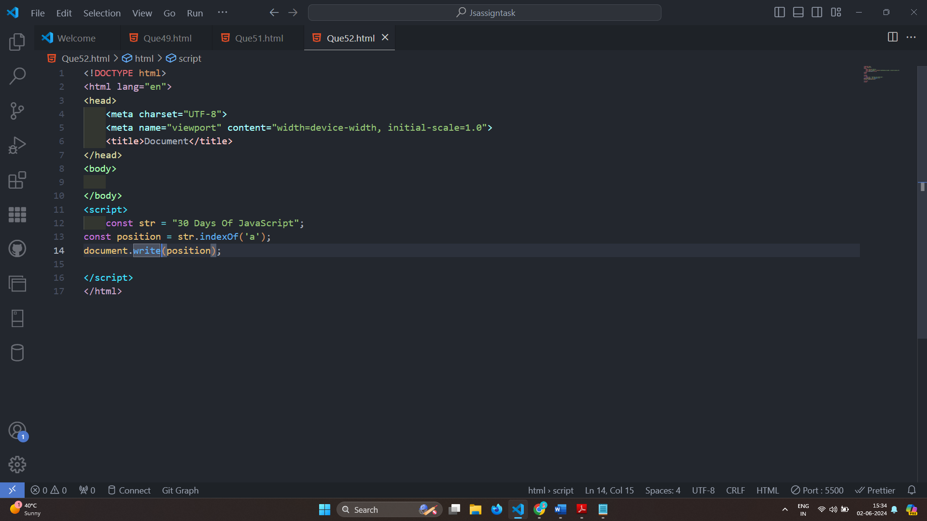

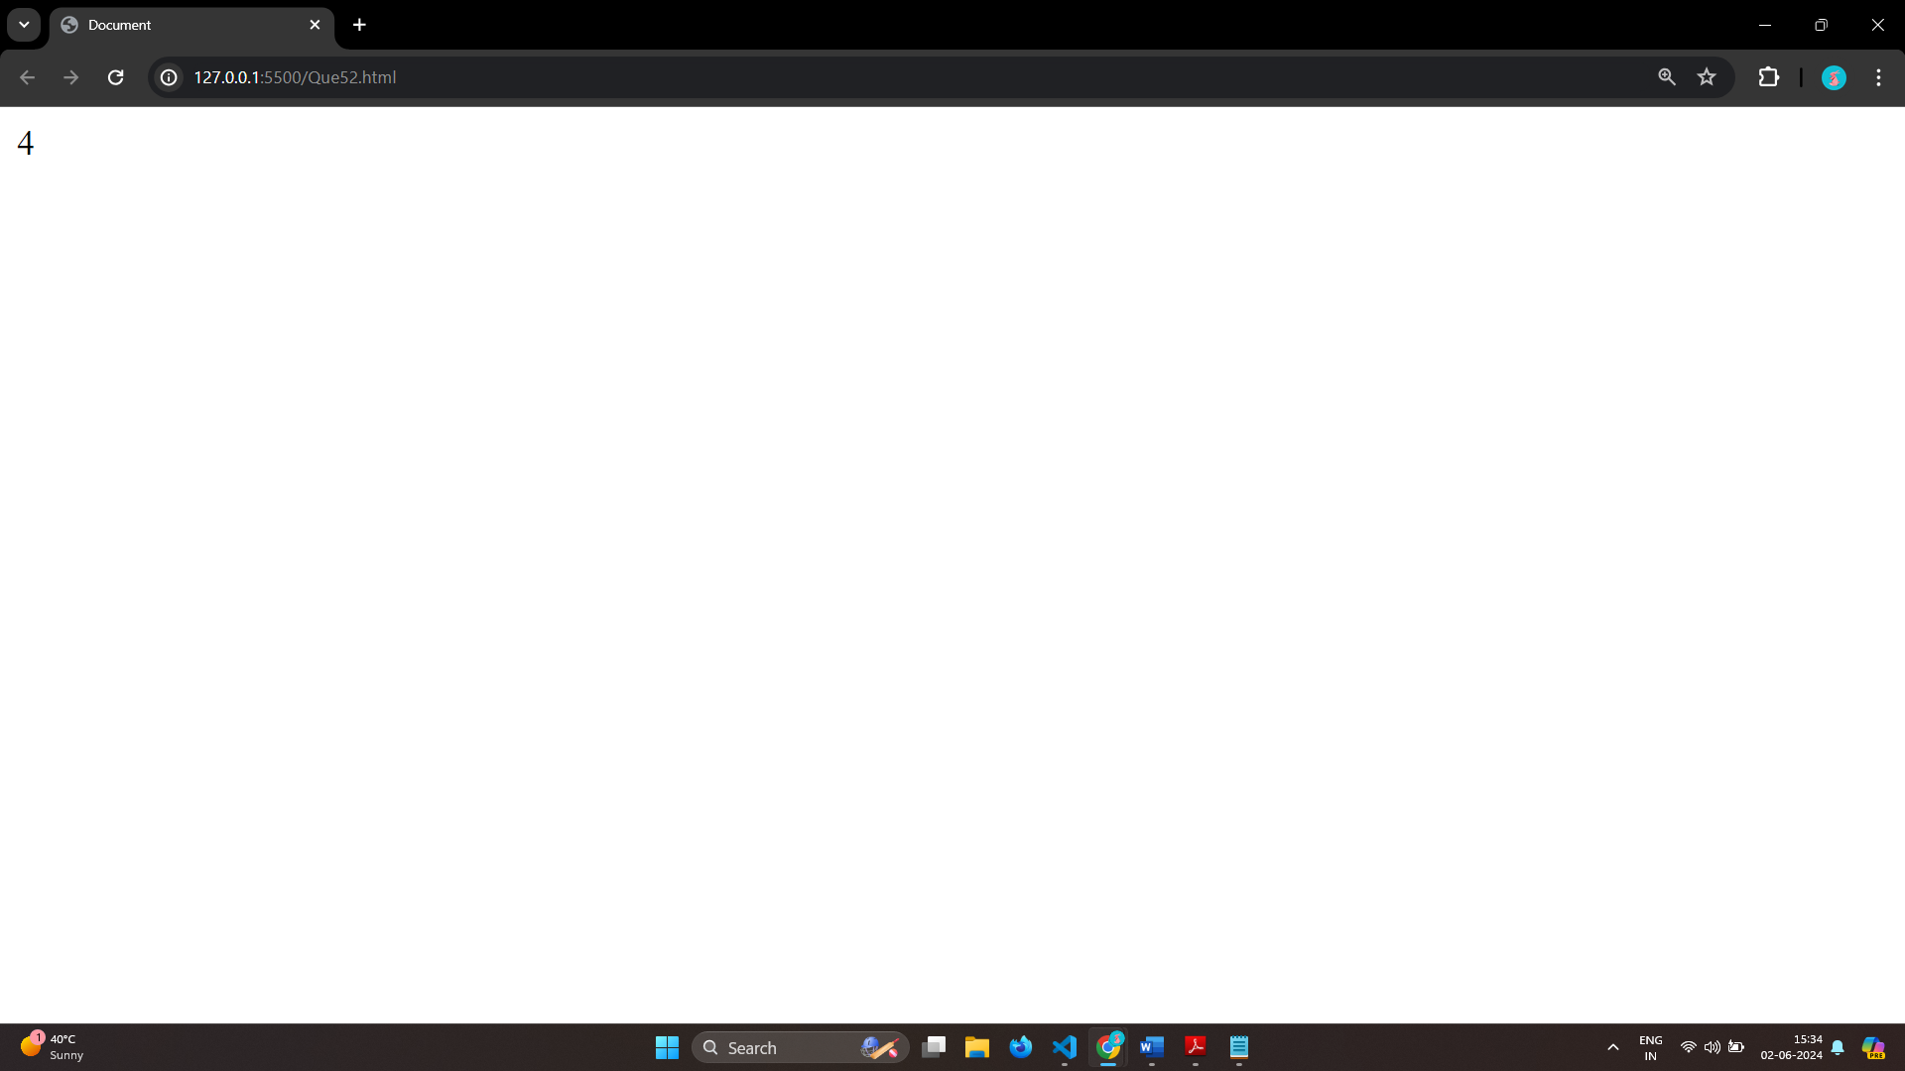

# Q.53 Use lastIndexOf to determine the position of the last occurrence of a in 30 Days Of JavaScript?

Ans: 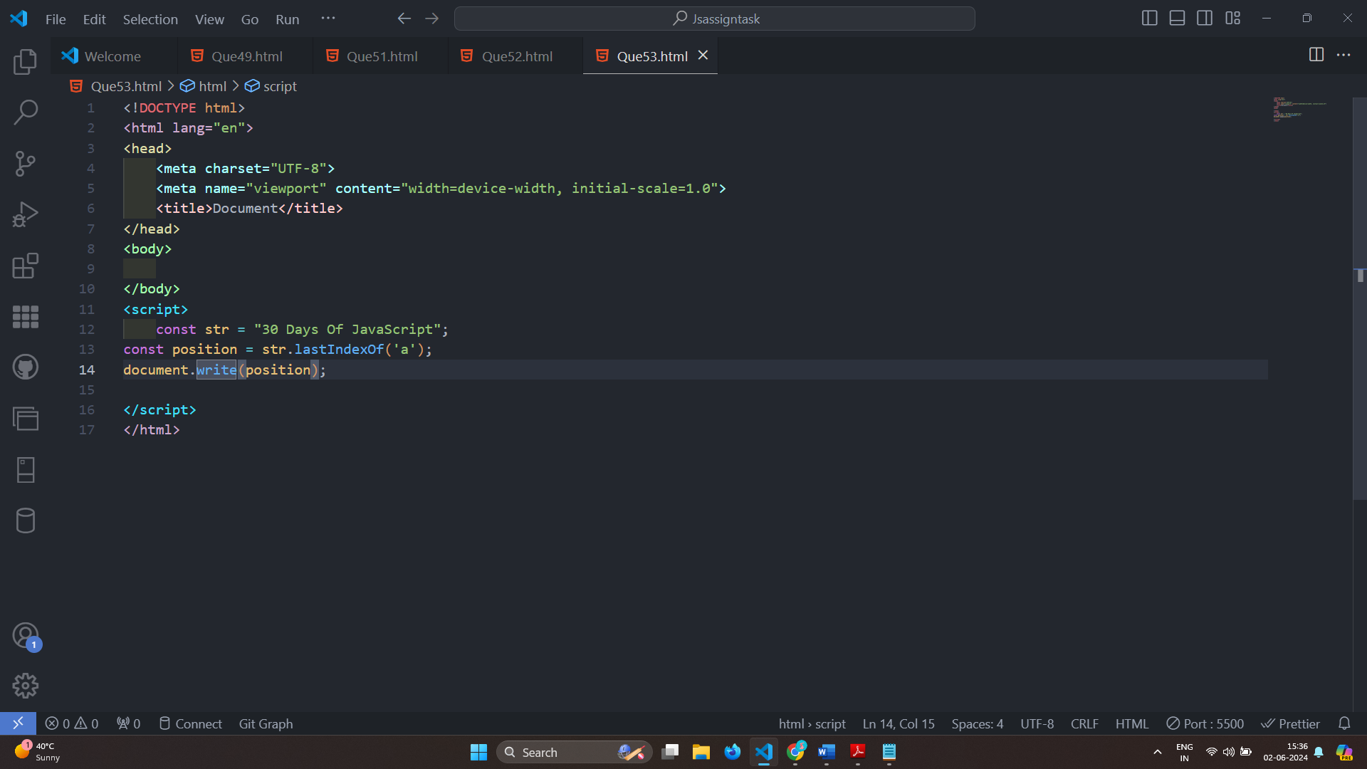

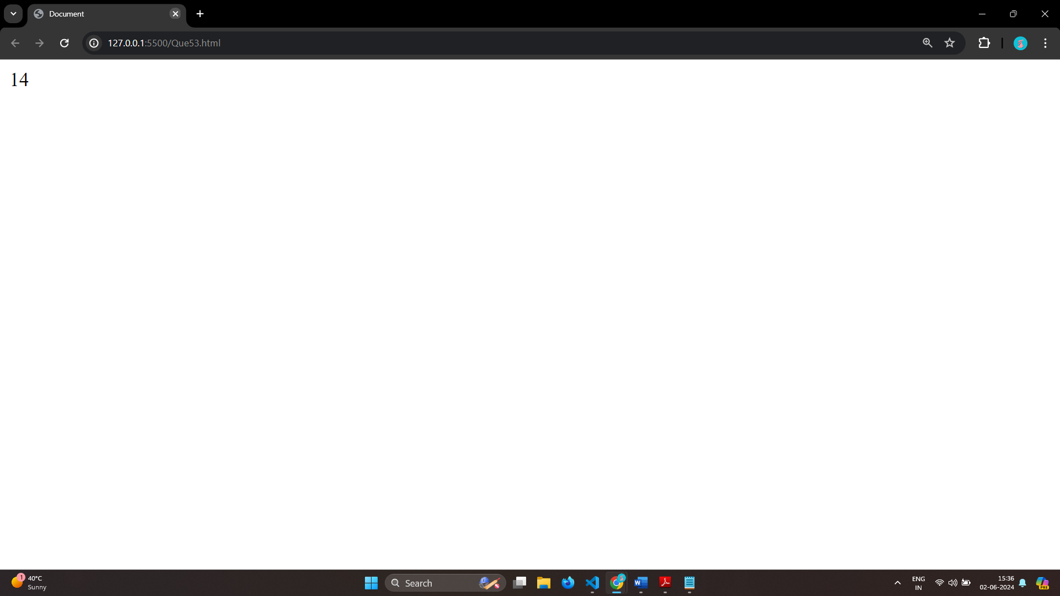

# Q.54 Form Validation in JS?

Ans: JavaScript Form Validation

HTML form validation can be done by JavaScript.

If a form field (fname) is empty, this function alerts a message, and returns false,

function validateForm() {

let x = document.forms["myForm"]["fname"].value;

if (x == "") {

alert("Name must be filled out");

return false;

}

}

<form name="myForm" action="/action_page.php" onsubmit="return validateForm()" method="post">

Name: <input type="text" name="fname">

<input type="submit" value="Submit">

</form>

# Q.55 Form in Email, number, Password, Validation?

Ans:

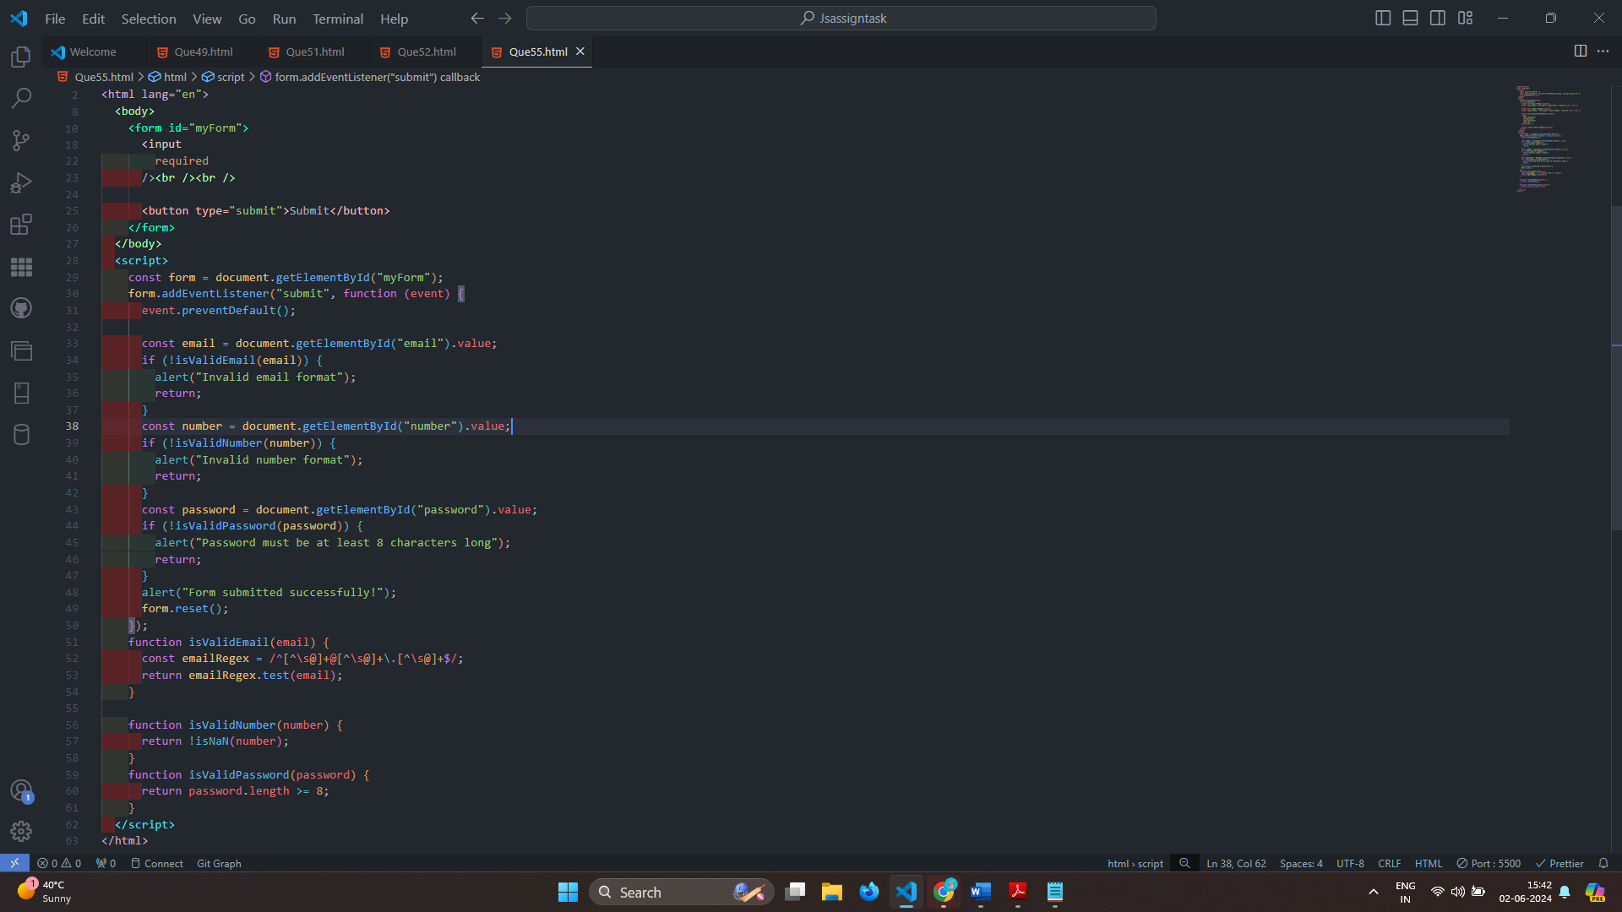

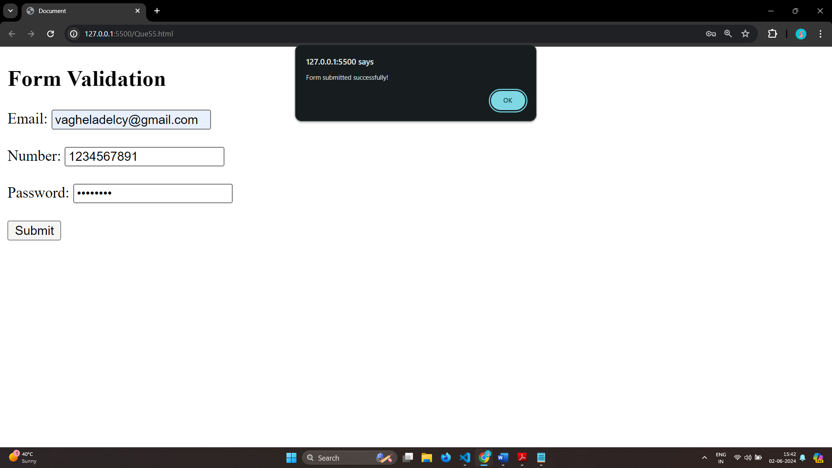

# Q.56 Dynamic Form Validation in JS?

Ans: Dynamic form validation in JavaScript is about providing real-time feedback to users as they interact with form fields.

This makes forms more user-friendly and helps prevent submission of invalid data.

# Q.57 how many type of JS Event? How to use it ?

Ans: 1.onchange =

An HTML element has been changed

<button onchange ="document.getElementById('demo').innerHTML = Date()">The time is?</button>

2.onclick =

The user clicks an HTML element

<button onclick="document.getElementById('demo').innerHTML = Date()">The time is?</button>

3.onmouseover =

The user moves the mouse over an HTML element

<button onmouseover ="document.getElementById('demo').innerHTML = Date()">The time is?</button>

4.onmouseout=

The user moves the mouse away from an HTML element

<button onmouseout ="document.getElementById('demo').innerHTML = Date()">The time is?</button>

5.onkeydown =

The user pushes a keyboard key

<button onkeydown ="document.getElementById('demo').innerHTML = Date()">The time is?</button>

6.onload=

The browser has finished loading the page

<button onload ="document.getElementById('demo').innerHTML = Date()">The time is?</button>

# Q.59 What is Bom vs Dom in JS?

Ans: Browser Object Model (BOM) is a browser-specific convention referring to all the objects exposed by the web browser.

The BOM allows JavaScript to “interact with” the browser.

The window object represents a browser window and all its corresponding features.

A window object is created automatically by the browser itself.

Java Script’s window.screen object contains information about the user’s screen.

It can also be written without the window prefix.

Document Object Model (DOM) is a programming interface for HTML and XML documents, that allows to create, manipulate, or delete the element from the document.

It defines the logical structure of documents and the way a document is accessed and manipulated.

With the help of DOM, the webpage can be represented in a structured hierarchy,

i.e., we can easily access and manipulate tags, IDs, classes, Attributes, or Elements of HTML using commands or methods provided by the Document object, that will guide the programmers and users to understand the document in an easier manner.

# Q.60 Array vs object defences in JS?

Ans: Arrays

Arrays are ordered collections of values, which can be accessed by their index

They are created using square brackets [] or the Array constructor.

Syntax:

let arr = [1, 2, 3, 4];

let arr2 = new Array(1, 2, 3, 4);

Each element in an array has a numerical index starting from 0.

Arrays have a length property that dynamically updates as elements are added or removed.

Objects

Objects are collections of key-value pairs, where keys (also called properties) are strings or symbols, and values can be of any data type.

They are created using curly braces {} or the Object constructor.

Syntax:

let obj = { name: "Alice", age: 25 };

let obj2 = new Object();

obj2.name = "Alice";

obj2.age = 25;

Each value is accessed using a unique key.

Properties can be added, modified, or deleted at runtime

# Q.61 Split the string into an array using split() Method?

Ans: In JavaScript, the split() method is used to divide a string into an array of substrings based on a specified separator. The separator can be a string or a regular expression. Here’s how to use the split() method:

let array = string.split(separator, limit);

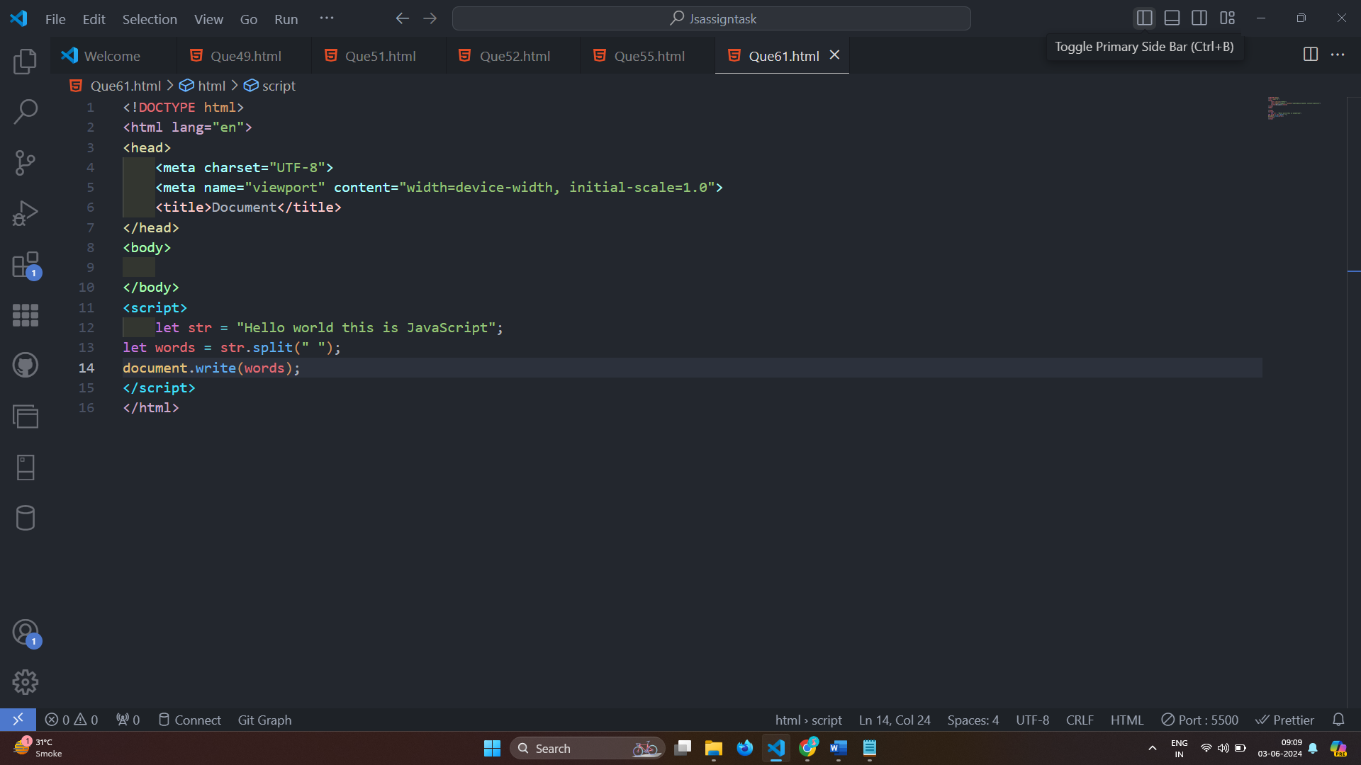

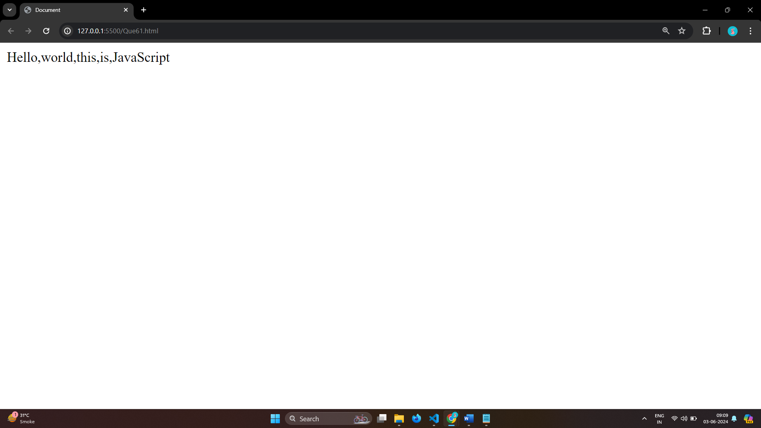

# Q.62 Check if the string contains a word Script using includes() method?

Ans: In JavaScript, the includes() method can be used to check if a string contains a specific substring or word. This method returns true if the substring is found and false otherwise.

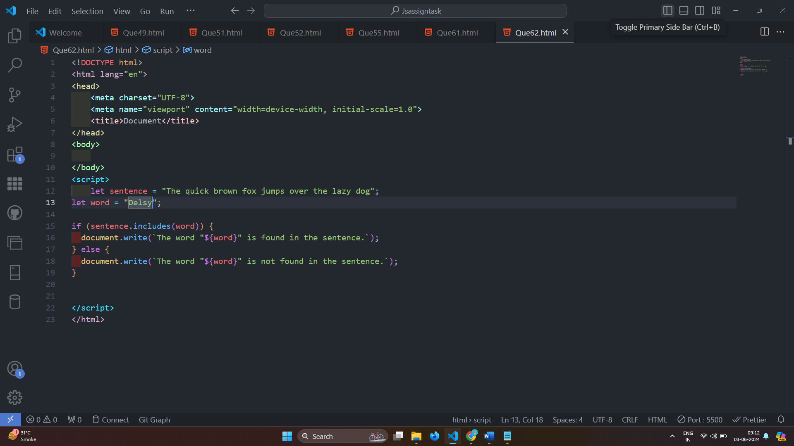

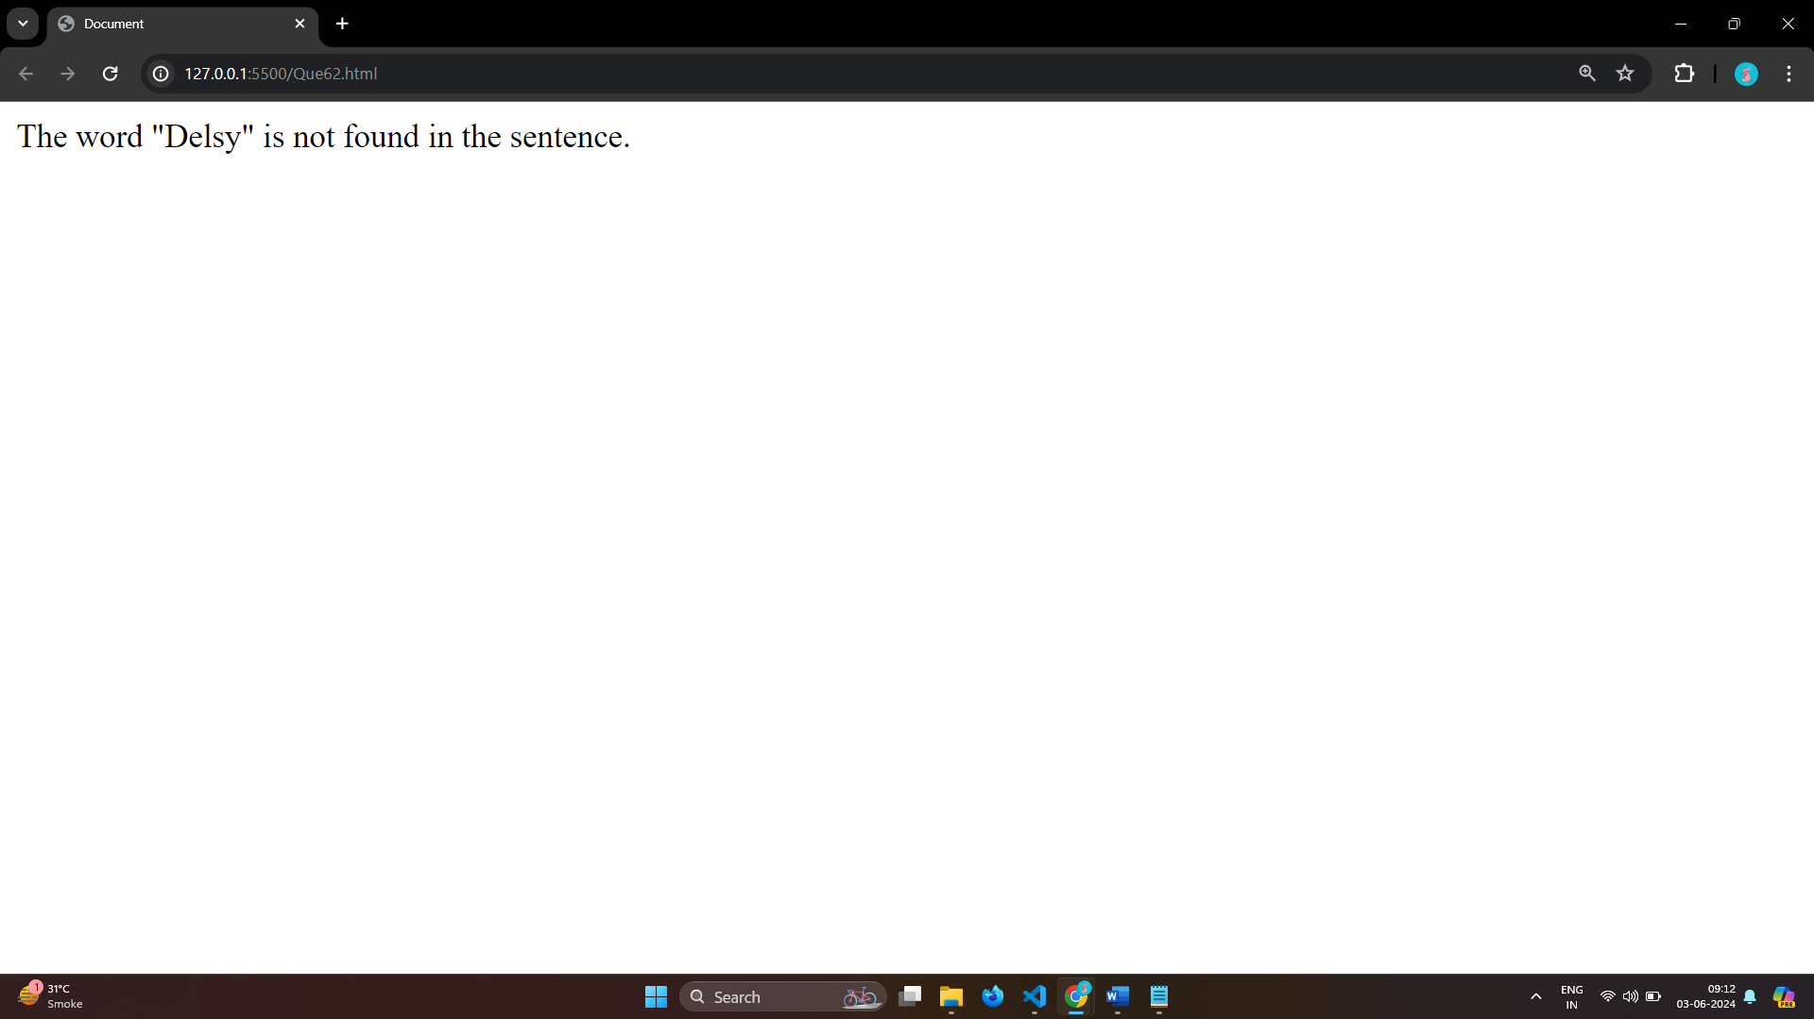

# Q.63 Change all the string characters to lowercase letters using toLowerCase() Method.

Ans: 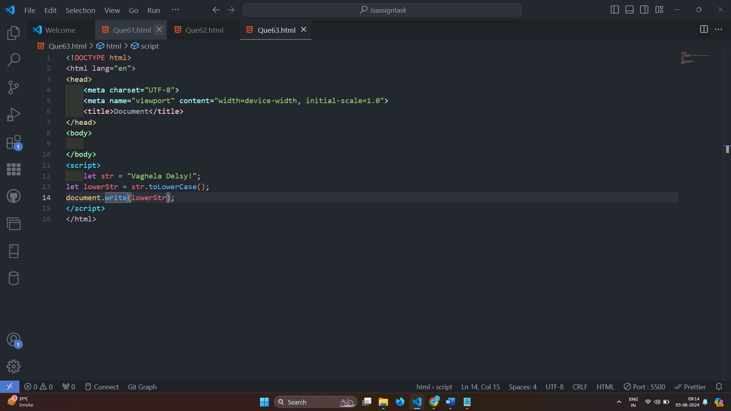

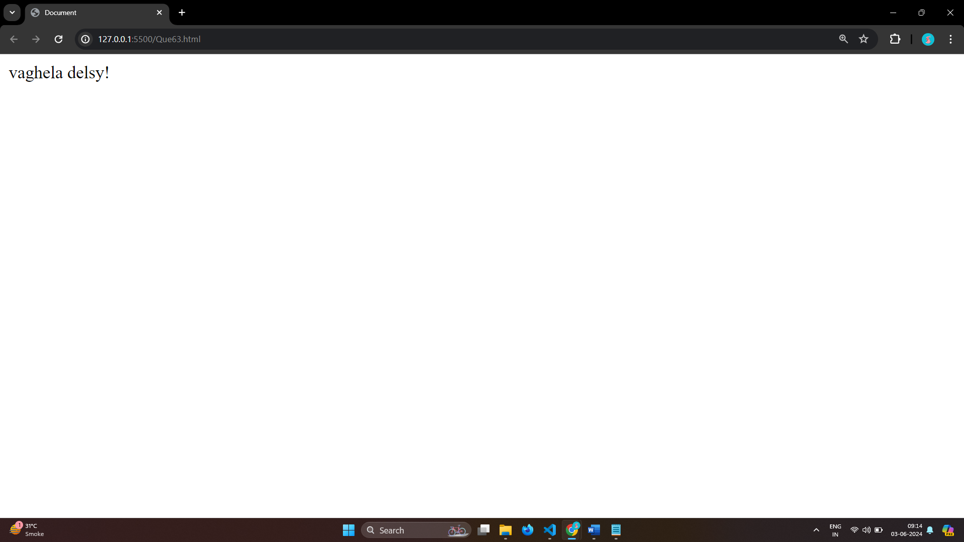

# Q.64 What is Character at index 15 in ’30 Days of JavaScript’ string? Use charAt() method.

Ans: 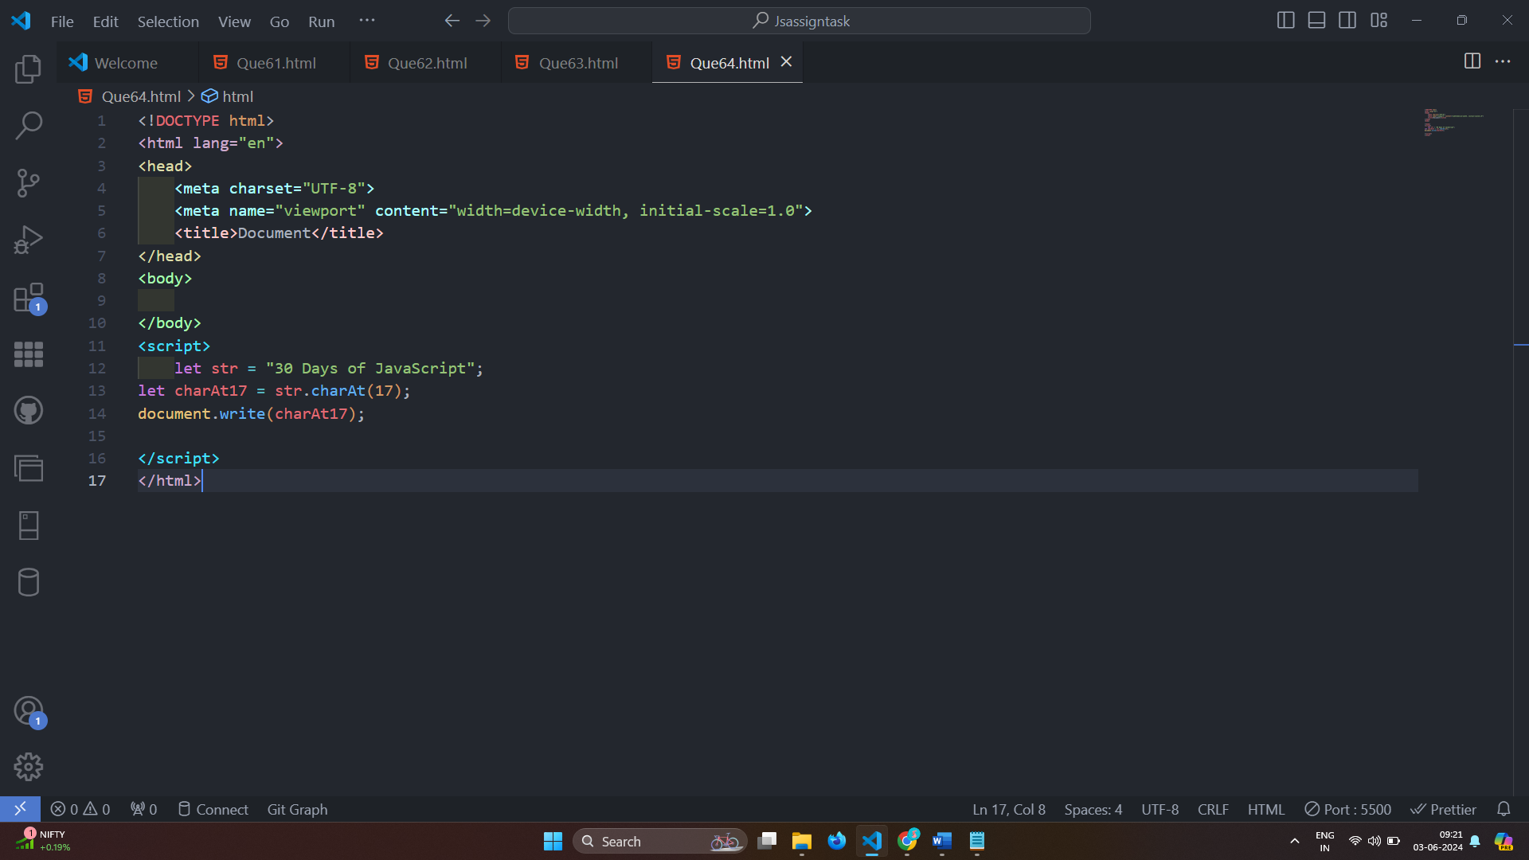

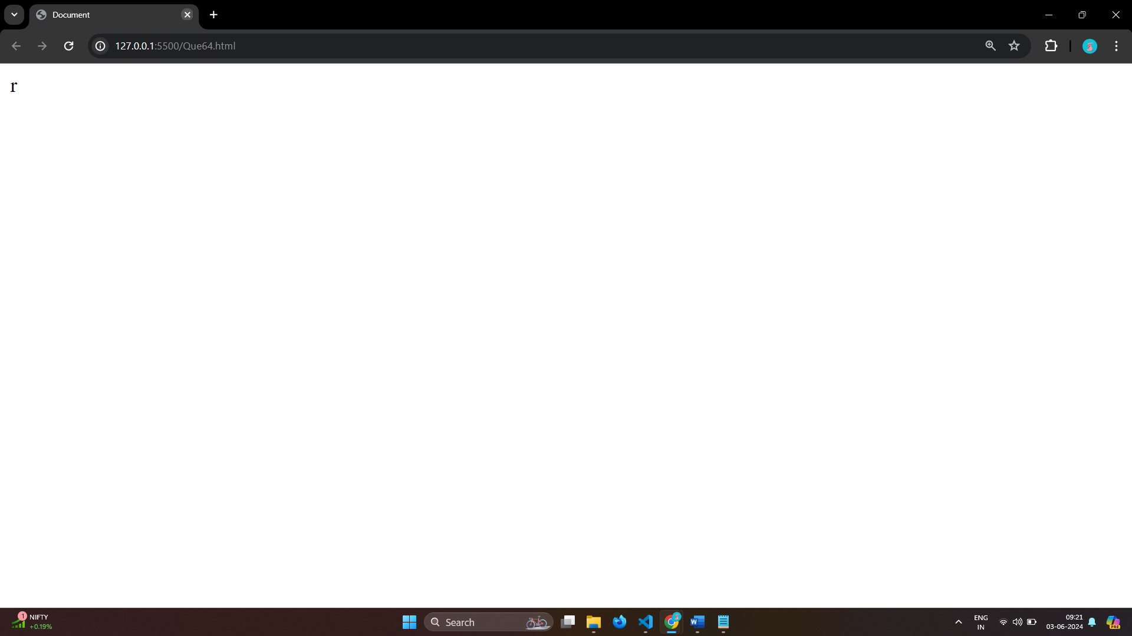

# Q.65 copy to one string to another string in JS?

Ans:

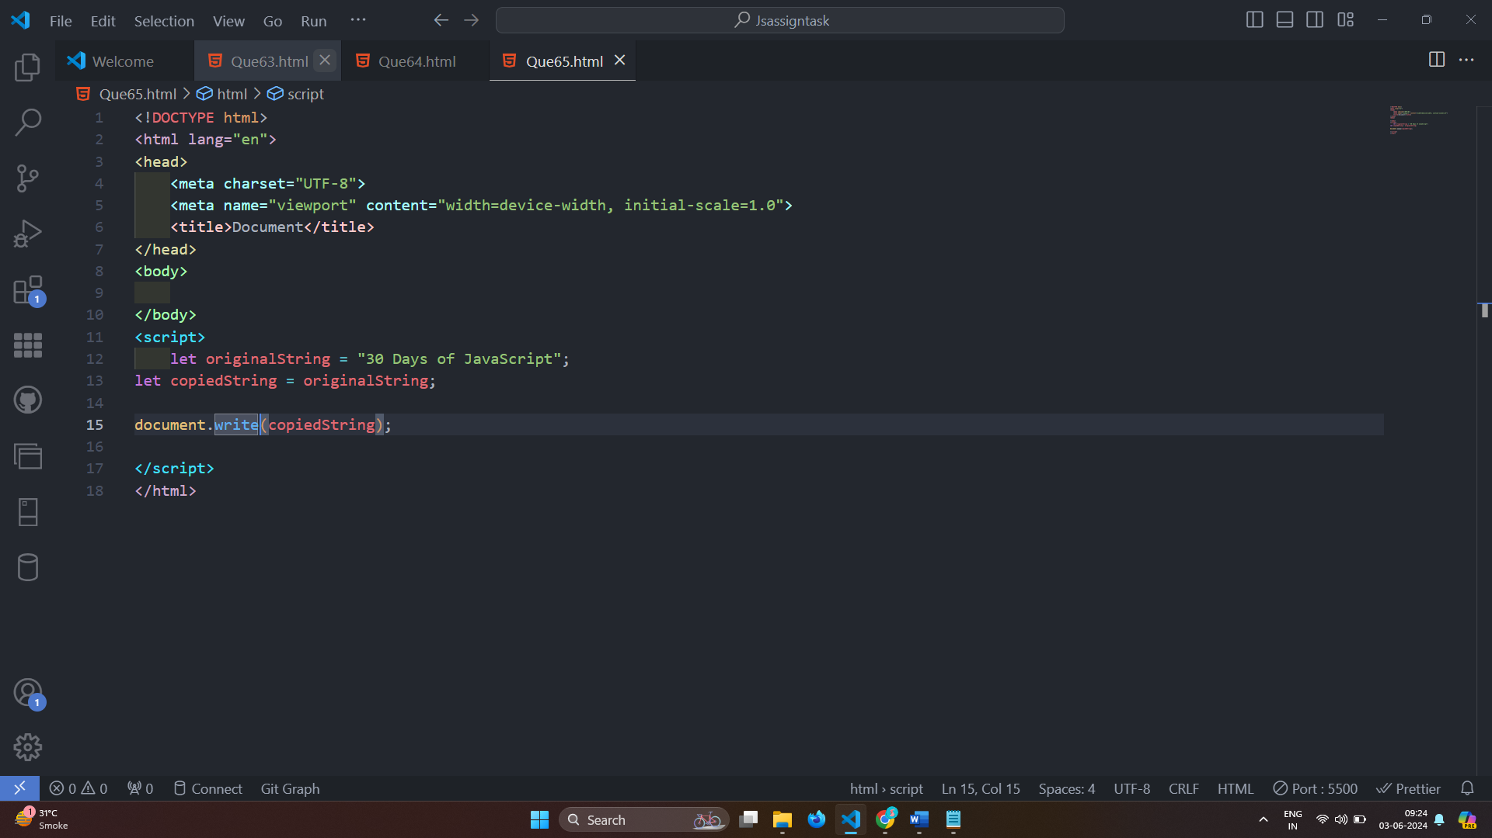

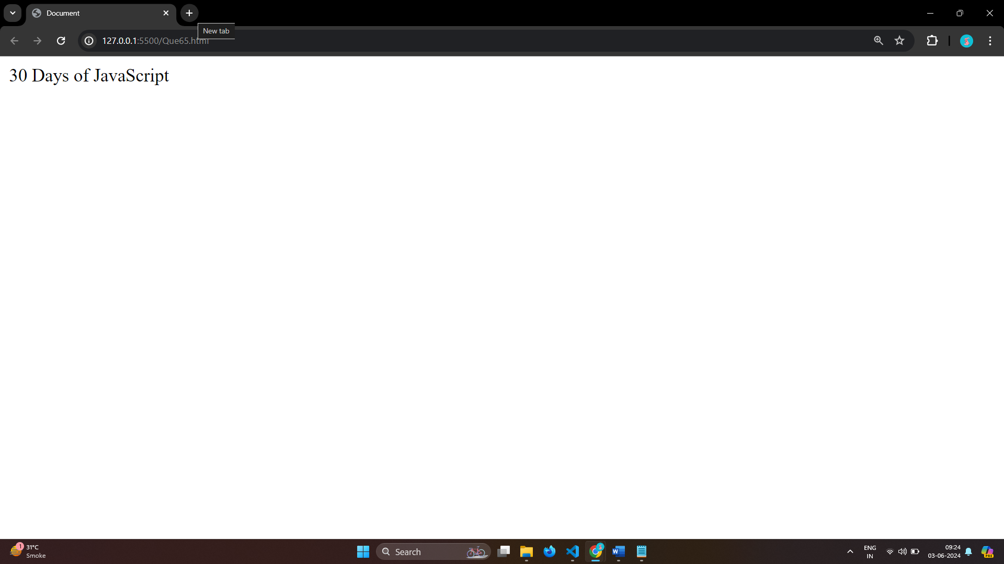

# Q.66 Find the length of a string without using libraryFunction?

Ans: 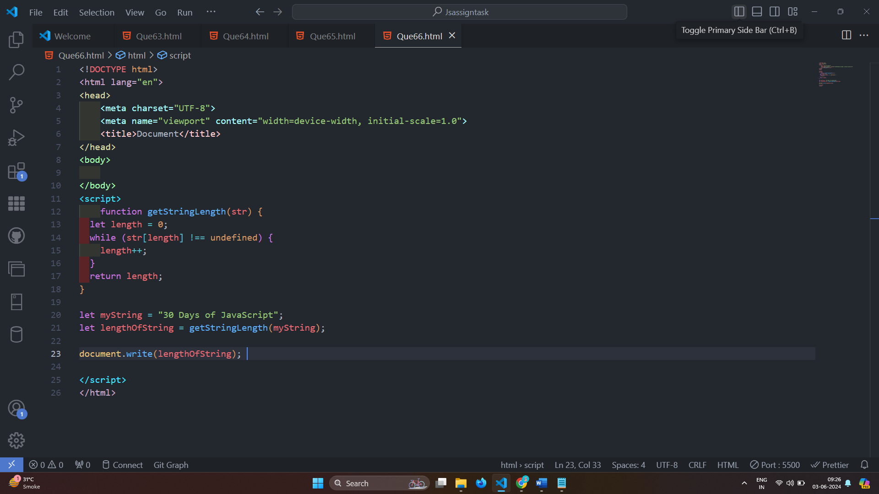

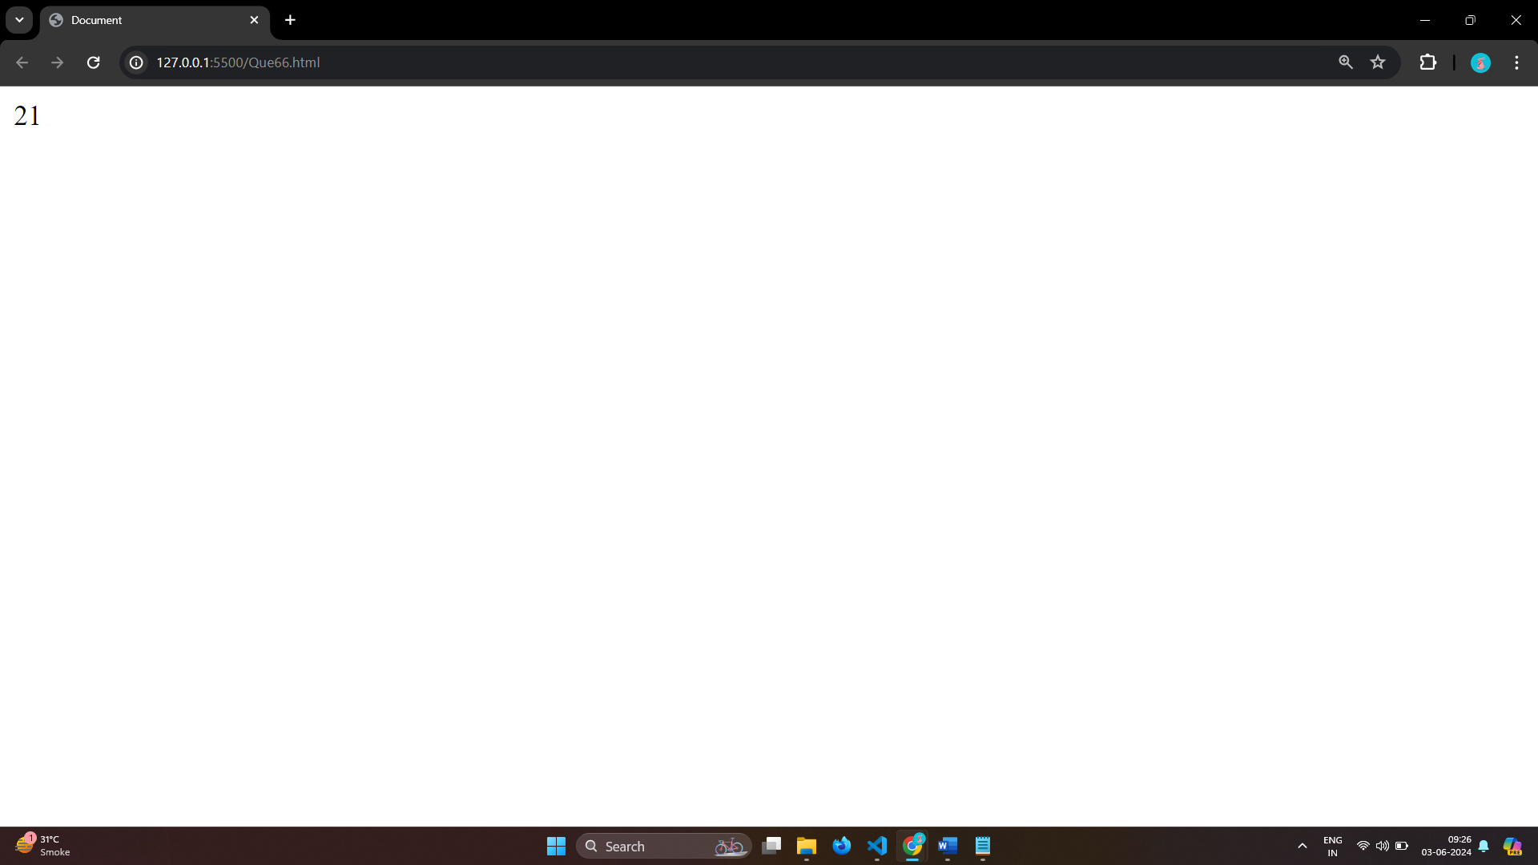

# • What is JavaScript?

Ans: JavaScript is the Programming Language.

JavaScript can update and change both HTML and CSS.

JavaScript can calculate, manipulate and validate data.

JavaScript variables:-

1.Numbers

2.Strings

3.Objects

4.Arrays

5.Functions

Syntax of Javascript:-

<script>

// JavaScript Code

</script>

# • What is the use of isNaN function?

Ans: : isNaN() method returns true if a value is Not-a-Number.

Number.isNaN() returns true if a number is Not-a-Number.

isNaN() converts the value to a number before testing it.

# • What is negative Infinity?

Ans: The negative infinity in JavaScript is a constant value that is used to represent a value that is the lowest available.

This means that no other number is lesser than this value.

It can be generated using a self-made function or by an arithmetic operation.

Negative infinity results in -0(different from 0 ) when divided by any other number.

When divided by itself or positive infinity, negative infinity return NaN

Negative infinity, when divided by any positive number (apart from positive infinity) is negative infinity.

Negative infinity, divided by any negative number (apart from negative infinity) is positive infinity.

# • Which company developed JavaScript?

Ans: JavaScript was invented by Brendan Eich in 1995.

It was developed for Netscape 2, and became the ECMA-262 standard in 1997.

After Netscape handed JavaScript over to ECMA, the Mozilla foundation continued to develop JavaScript for the Firefox browser.

Mozilla's latest version was 1.8.5. (Identical to ES5).

Internet Explorer (IE4) was the first browser to support ECMA-262 Edition 1 (ES1).

# • What are undeclared and undefined variables?

Ans: Undefined: It occurs when a variable has been declared but has not been assigned any value. Undefined is not a keyword.

let delsy;

undefined

console.log(delsy)

Undeclared: It occurs when we try to access any variable that is not initialized or declared earlier using the var or const keyword.

console.log(myVariable)

If we use ‘typeof’ operator to get the value of an undeclared variable, we will face the runtime error with the return value as “undefined”. The scope of the undeclared variables is always global.

# • Write the code for adding new elements dynamically?

Ans: 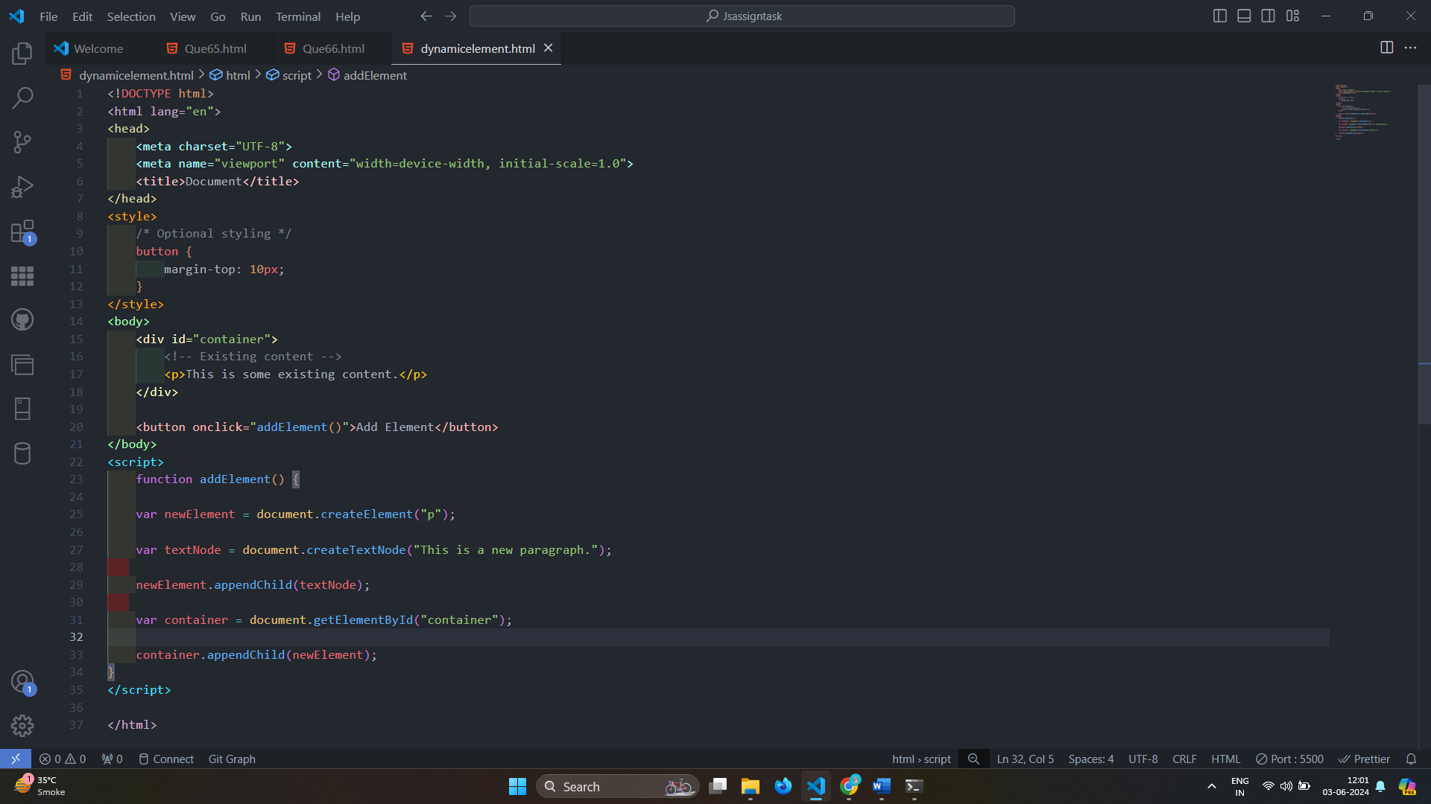

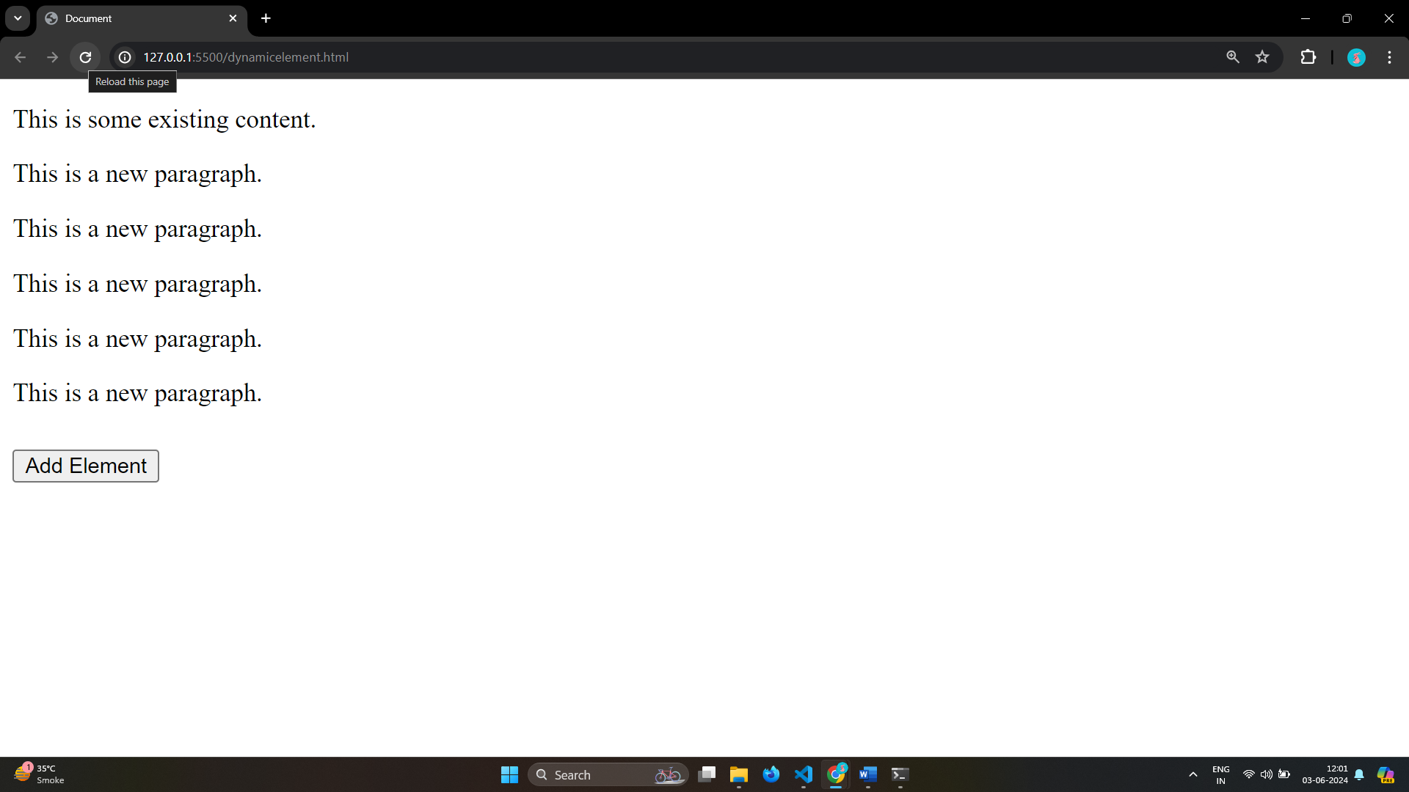

# • What is the difference between ViewState and SessionState?

Ans: ViewState-

Maintained at page level only.

View state can only be visible from a single page and not multiple pages.

It will retain values in the event of a postback operation occurring.

Information is stored on the client’s end only.

used to allow the persistence of page-instance-specific data.

ViewState values are lost/cleared when new page is loaded.

SessionState-

Maintained at session level.

Session state value availability is across all pages available in a user session.

In session state, user data remains in the server. Data is available to user until the browser is closed or there is session expiration.

Information is stored on the server.

used for the persistence of user-specific data on the server’s end.

SessionState can be cleared by programmer or user or in case of timeouts.

# • What is === operator?

Ans: (===) Comparison Operator in JavaScript.

It is used to compare that both value and type are same or not .

If both value and type are not same then it is show false if value and type of are same it is show true.

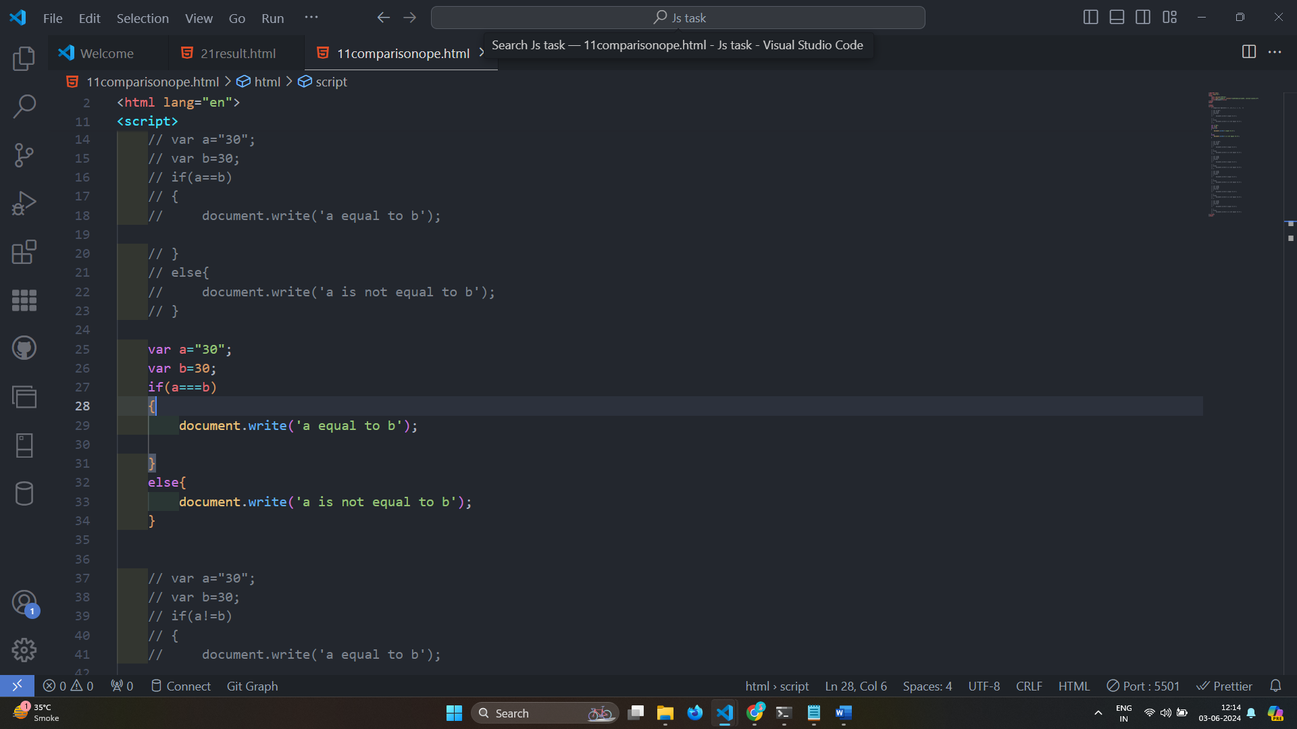

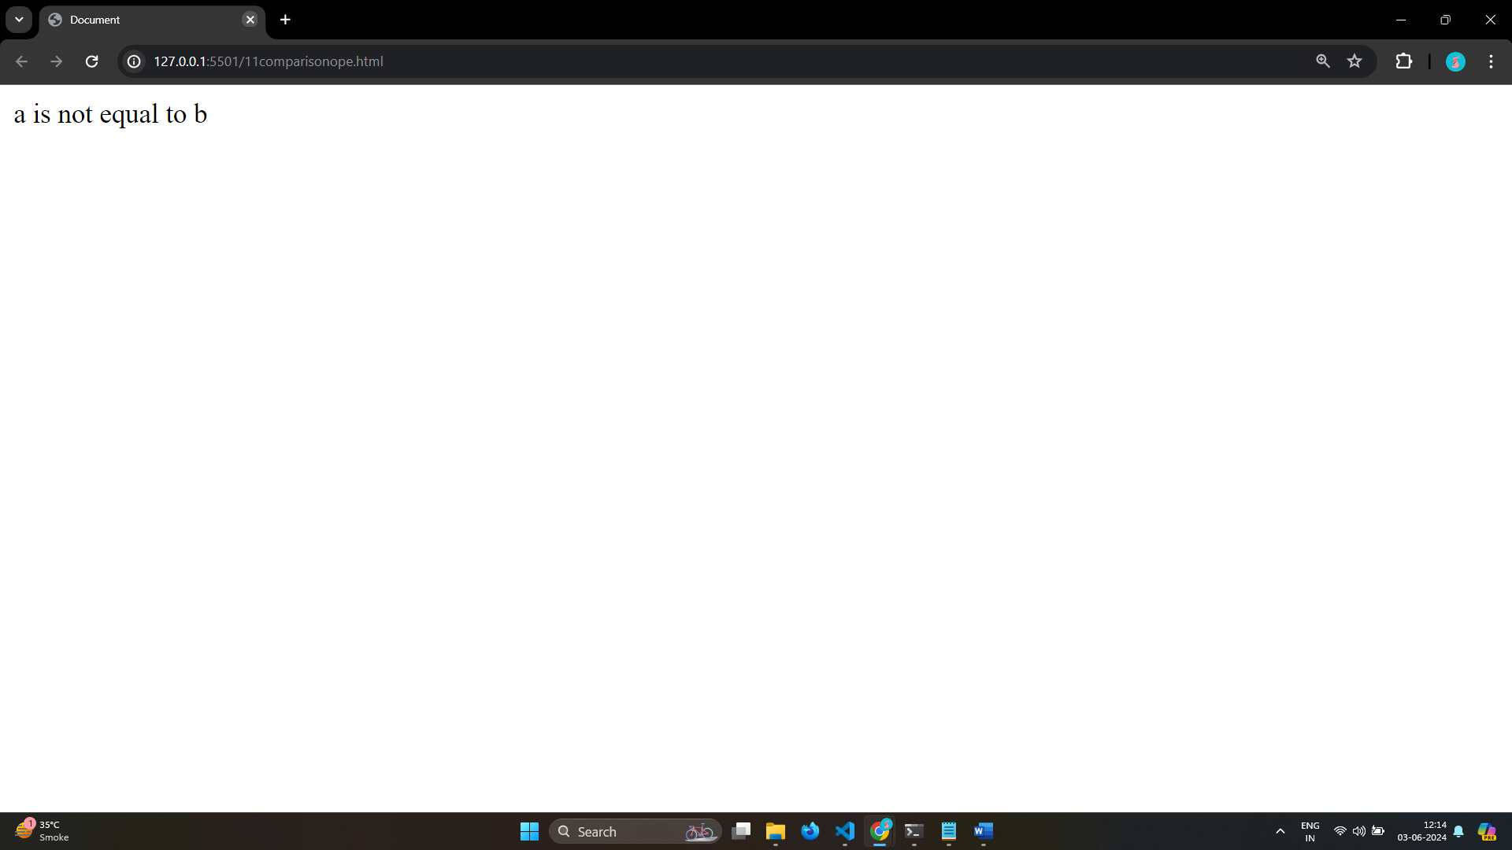

# • How can the style/class of an element be changed?

Ans: 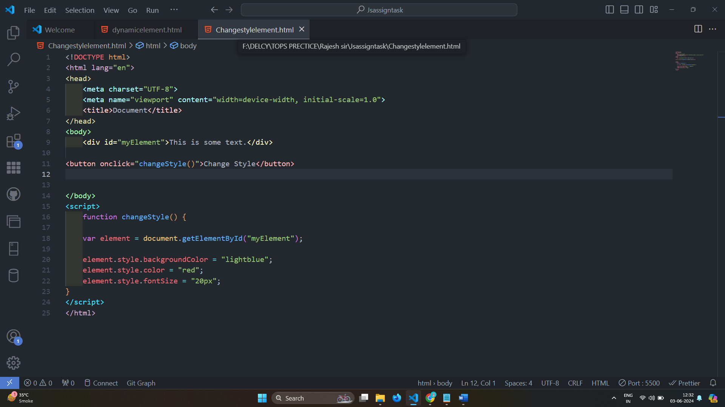

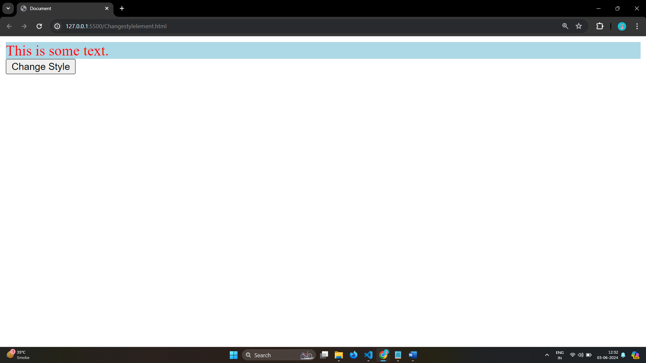

# • How to read and write a file using JavaScript?

Ans: On the client side, you can’t read or write files in JavaScript browsers.

read-

Syntax:

fs.readFile( file_name, encoding, callback_function )

write-

Syntax:

fs.writeFile( file_name, data, options, callback )

The fs.writeFile() function is used to write data to a file in an asynchronous manner. If the file already exists, it will be replaced.

# • What are all the looping structures in JavaScript?

Ans: Loop in Javascript:-

Loops in JavaScript execute a block of code again and again while the condition is true.

suppose we want to print “Hello World” 5 times. This can be done using JS Loop easily. In Loop, the statement needs to be written only once and the loop will be executed 5 times.

Types of loop:-

1.For loop

2.While loop

3.do-while loop

4.Break Statement

5.Continue Statement

# • How can you convert the string of any base to an integer in JavaScript?

Ans: 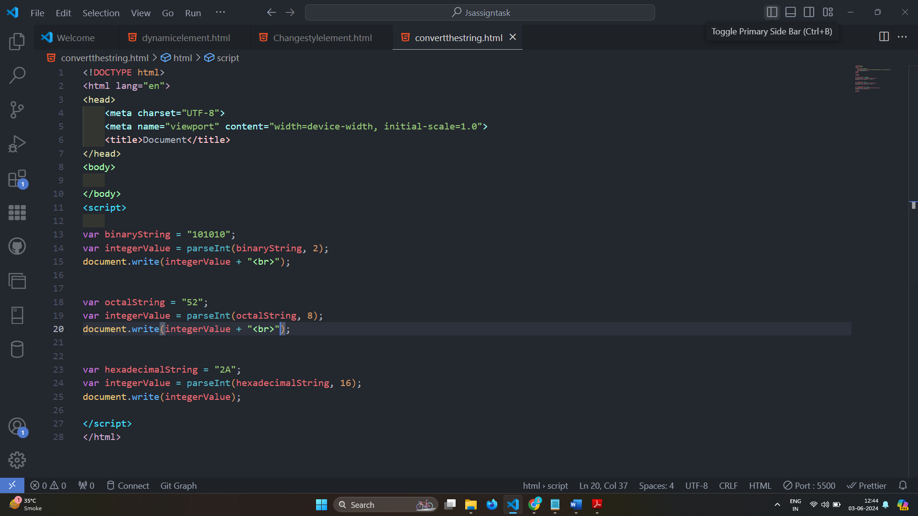

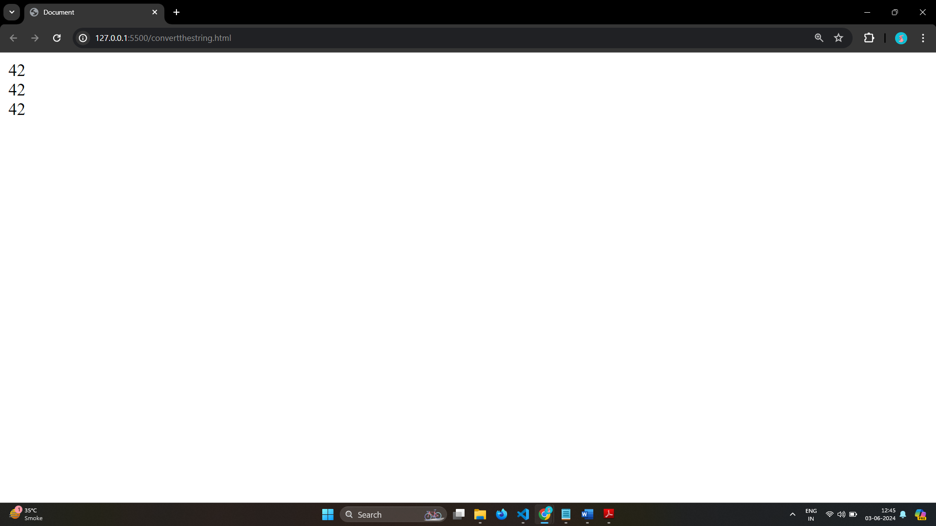

# • What is the function of the delete operator?

Ans: 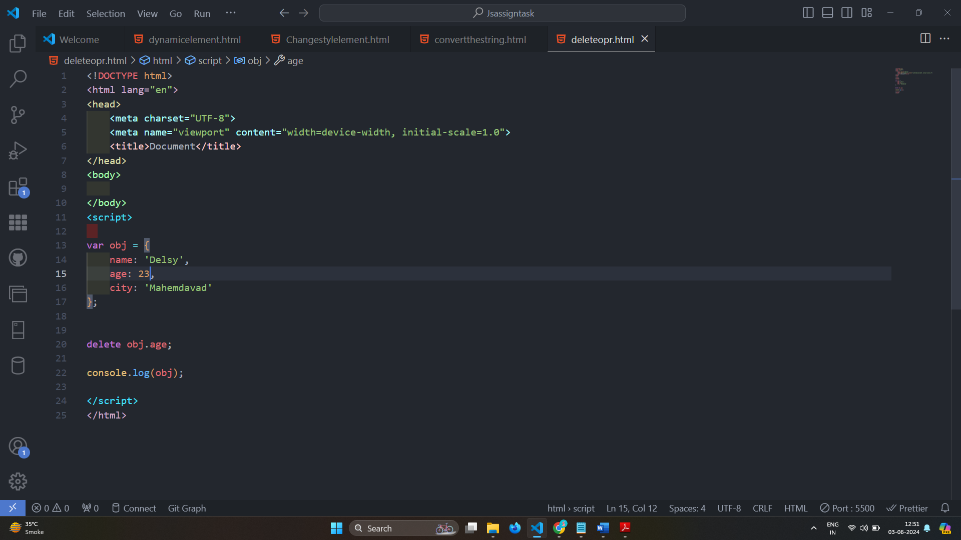

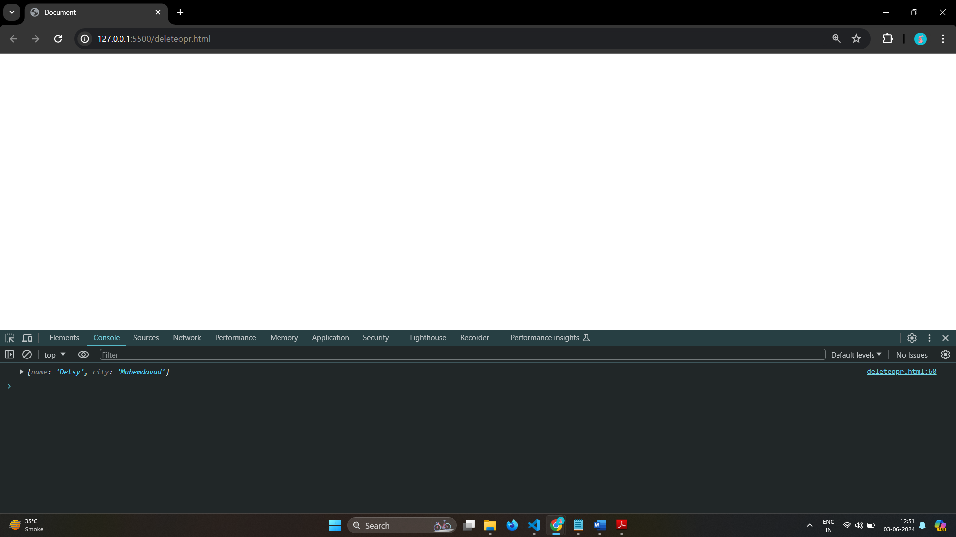

# • What are all the types of Pop up boxes available in JavaScript?

Ans: JavaScript has three kind of popup boxes:

1. Alert box
2. Confirm box
3. Prompt box.

Alert Box

Syntax

window.alert("sometext");

Confirm Box

Syntax

window.confirm("sometext");

Prompt Box

Syntax

window.prompt("sometext","defaultText");

# • What is the use of Void (0)?

Ans: The void operator is used to evaluate an expression and returns the undefined.

This operator is used for obtaining the undefined primitive value.

It is often used with hyperlinks.

Usually the browser refreshes the page or loads a new page on clicking a link.

The javascript:void(0) can be used when we don't want to refresh or load a new page in the browser on clicking a hyperlink.

Syntax

void expression;

# • How can a page be forced to load another page in JavaScript?

Ans: The first way is to use the window.location.href property.

This property contains information about the current URL of the page, and it can be used to redirect the user to a new page.

Syntax

window.location.href = "new_url";

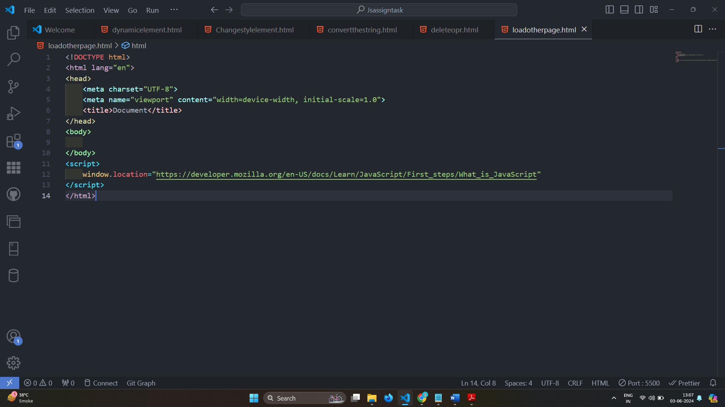

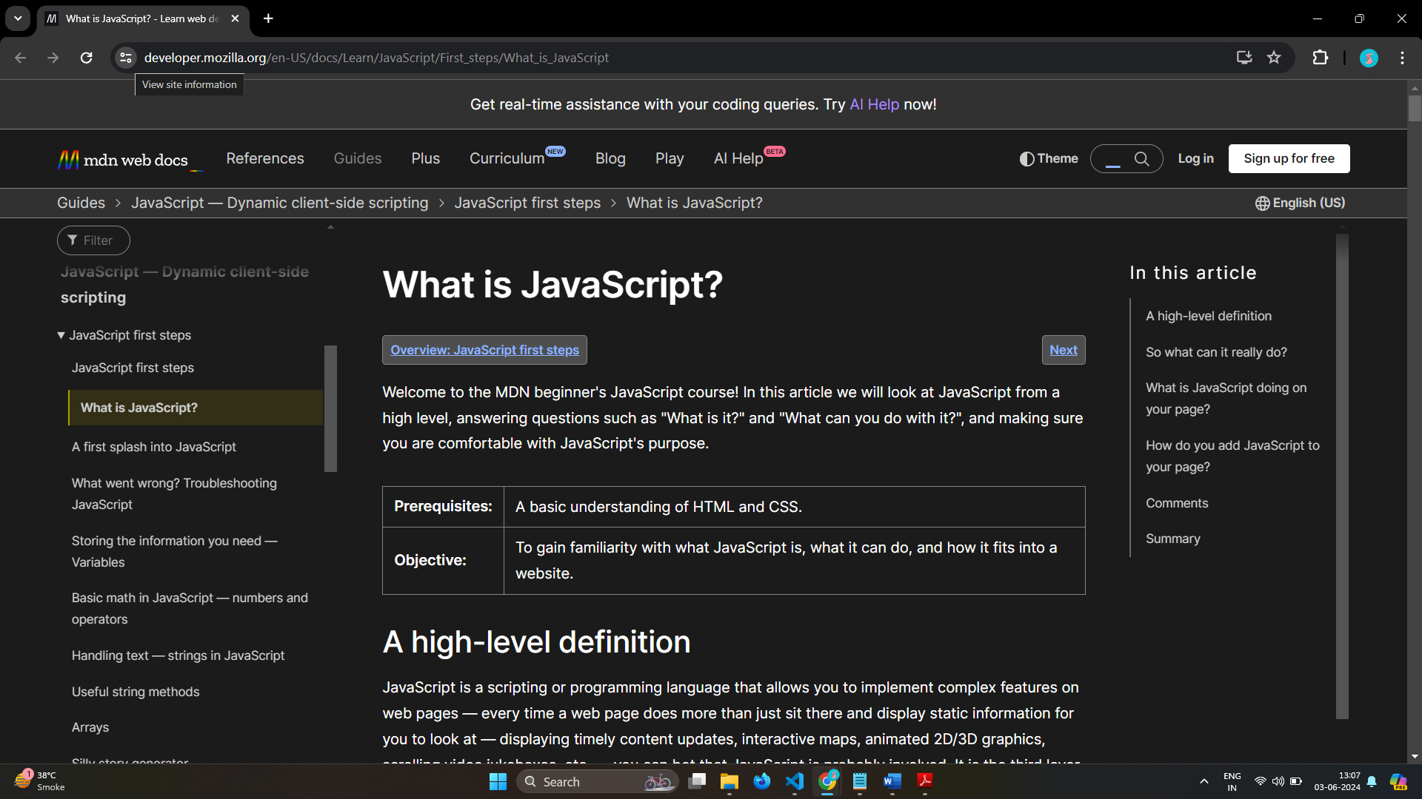

# • What are the disadvantages of using innerHTML in JavaScript?

Ans: innerHTML is very slow.

The event handlers do not get attached to the new elements created by setting innerHTML automatically.

Content is replaced everywhere.

Appending to innerHTML is not supported.

Old content replaced issue.

Can break the document.

Can also be used for Cross-site Scripting(XSS).

# • Create password field with show hide functionalities

Ans: 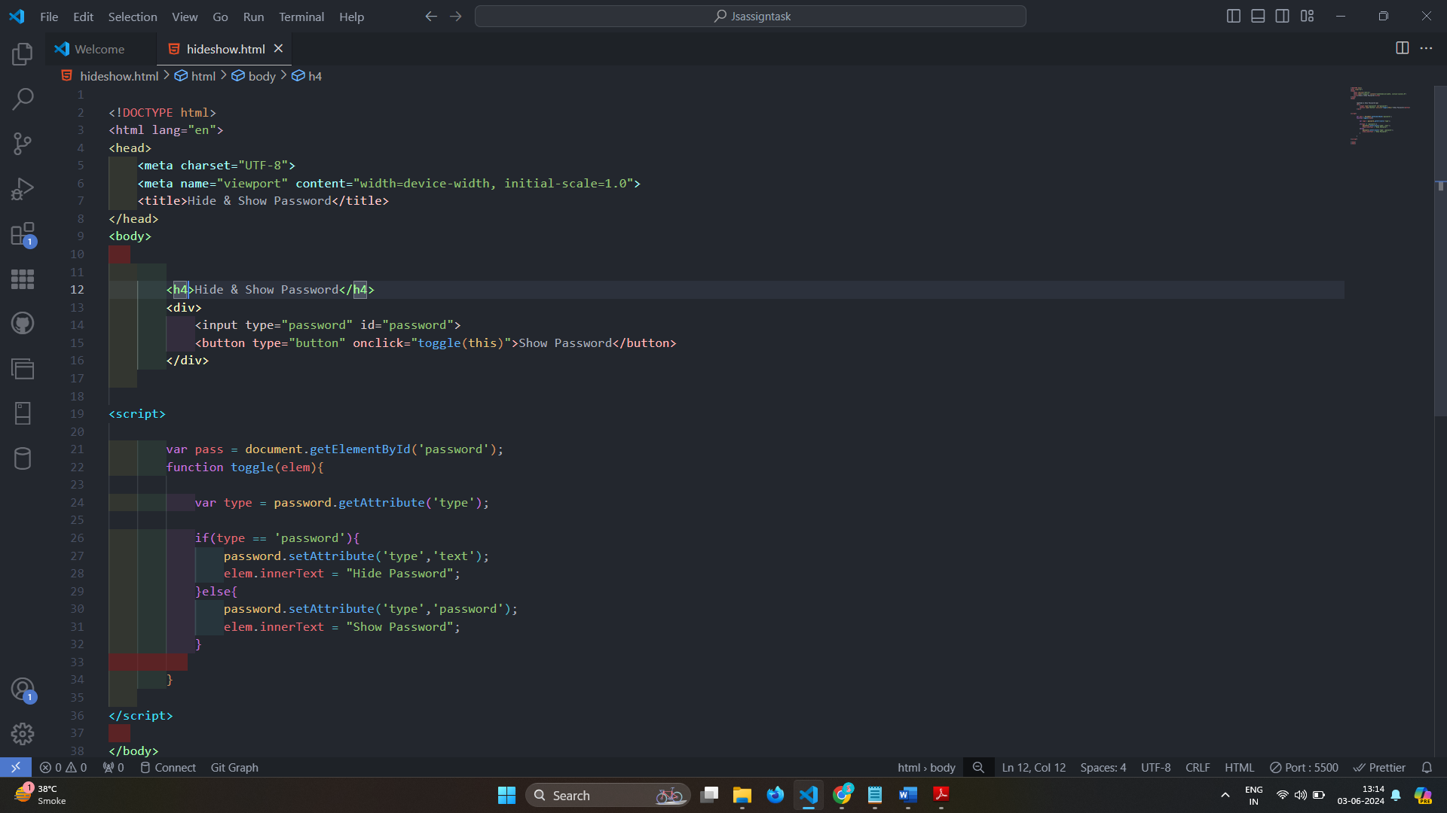

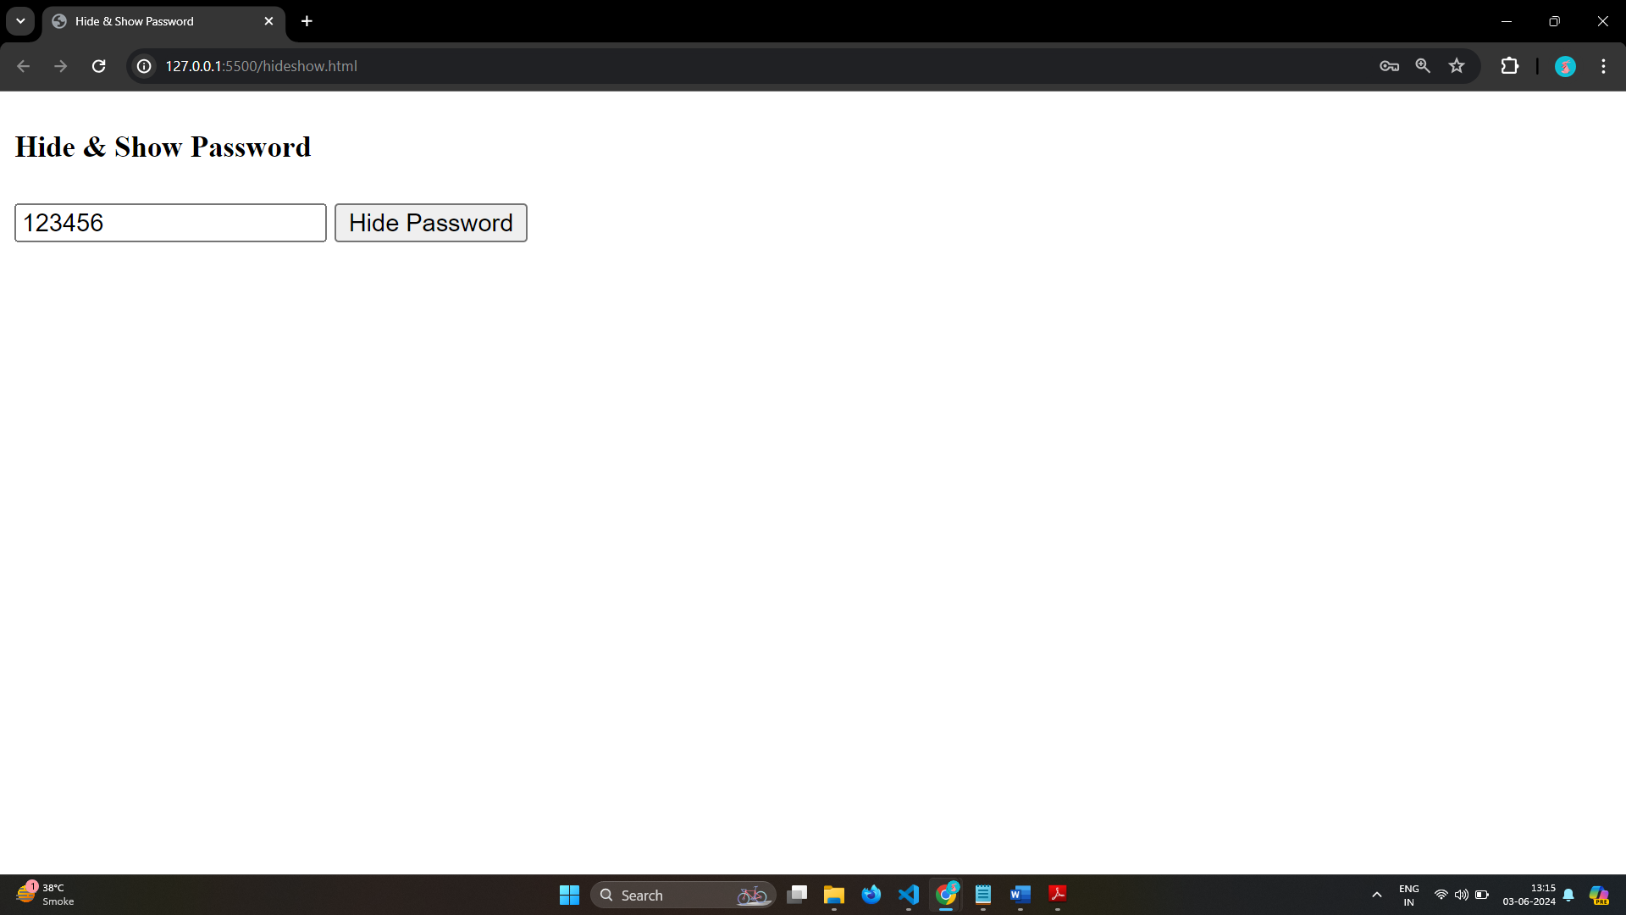







# Create basic math operation in JS



Ans:

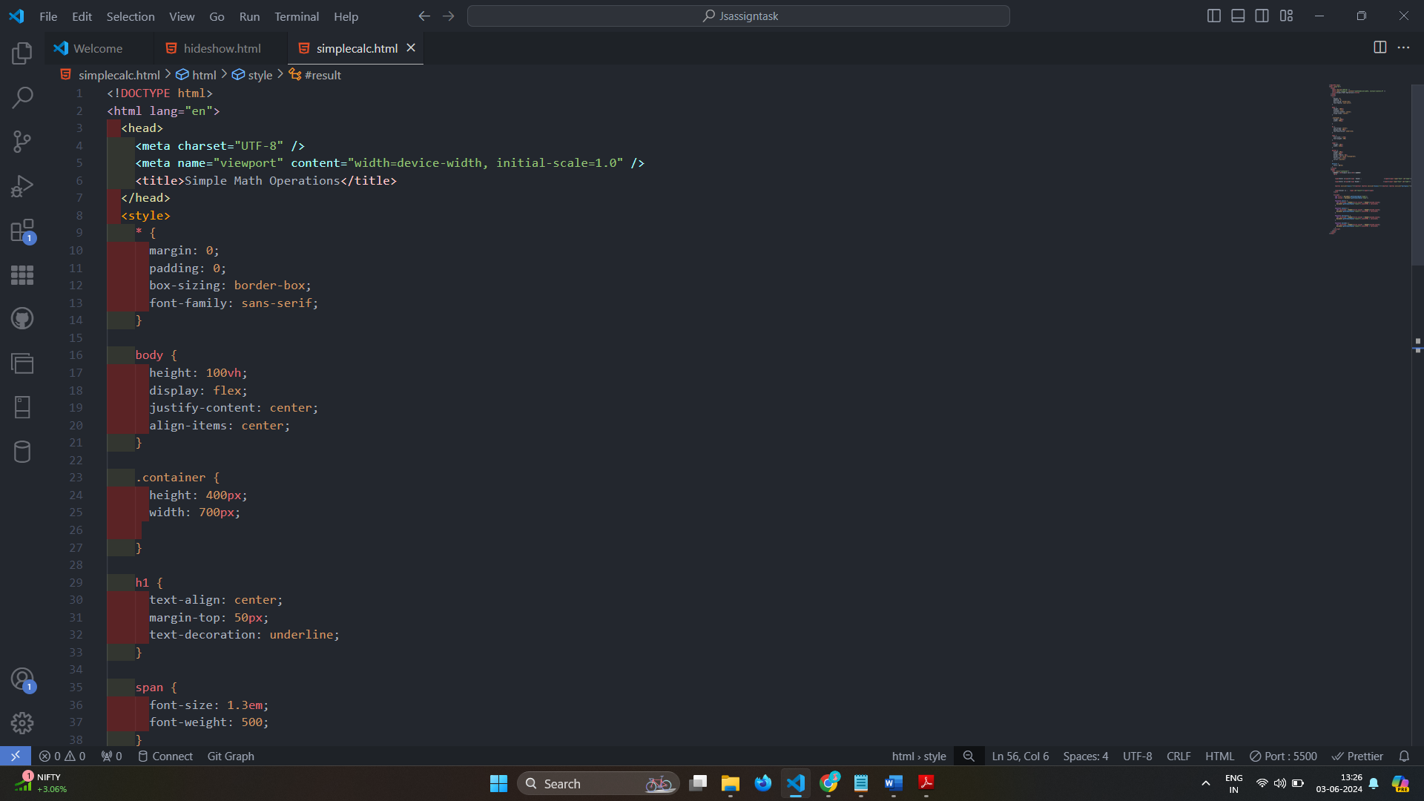

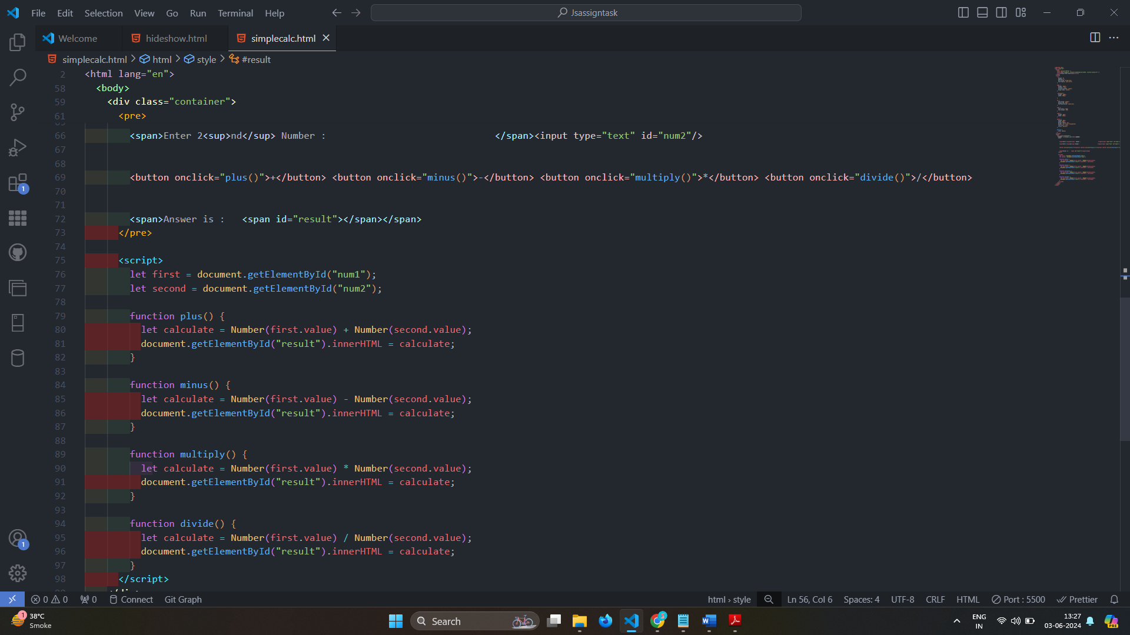

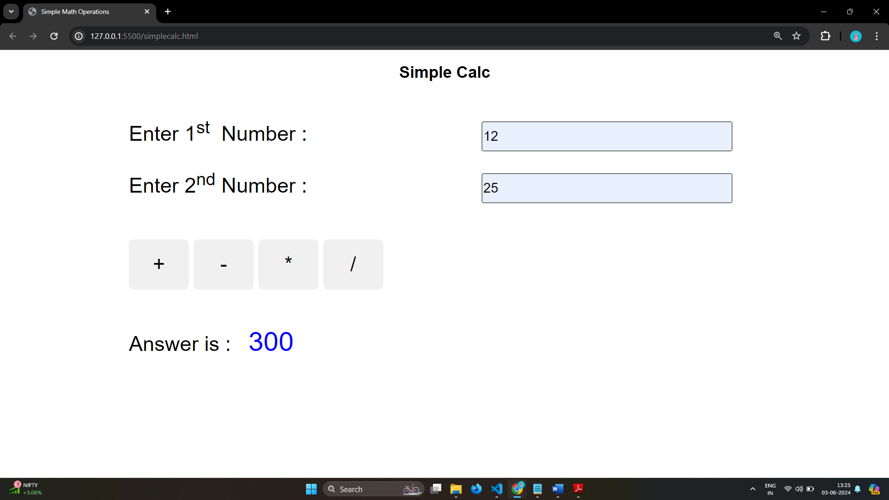

# Create result



Ans: 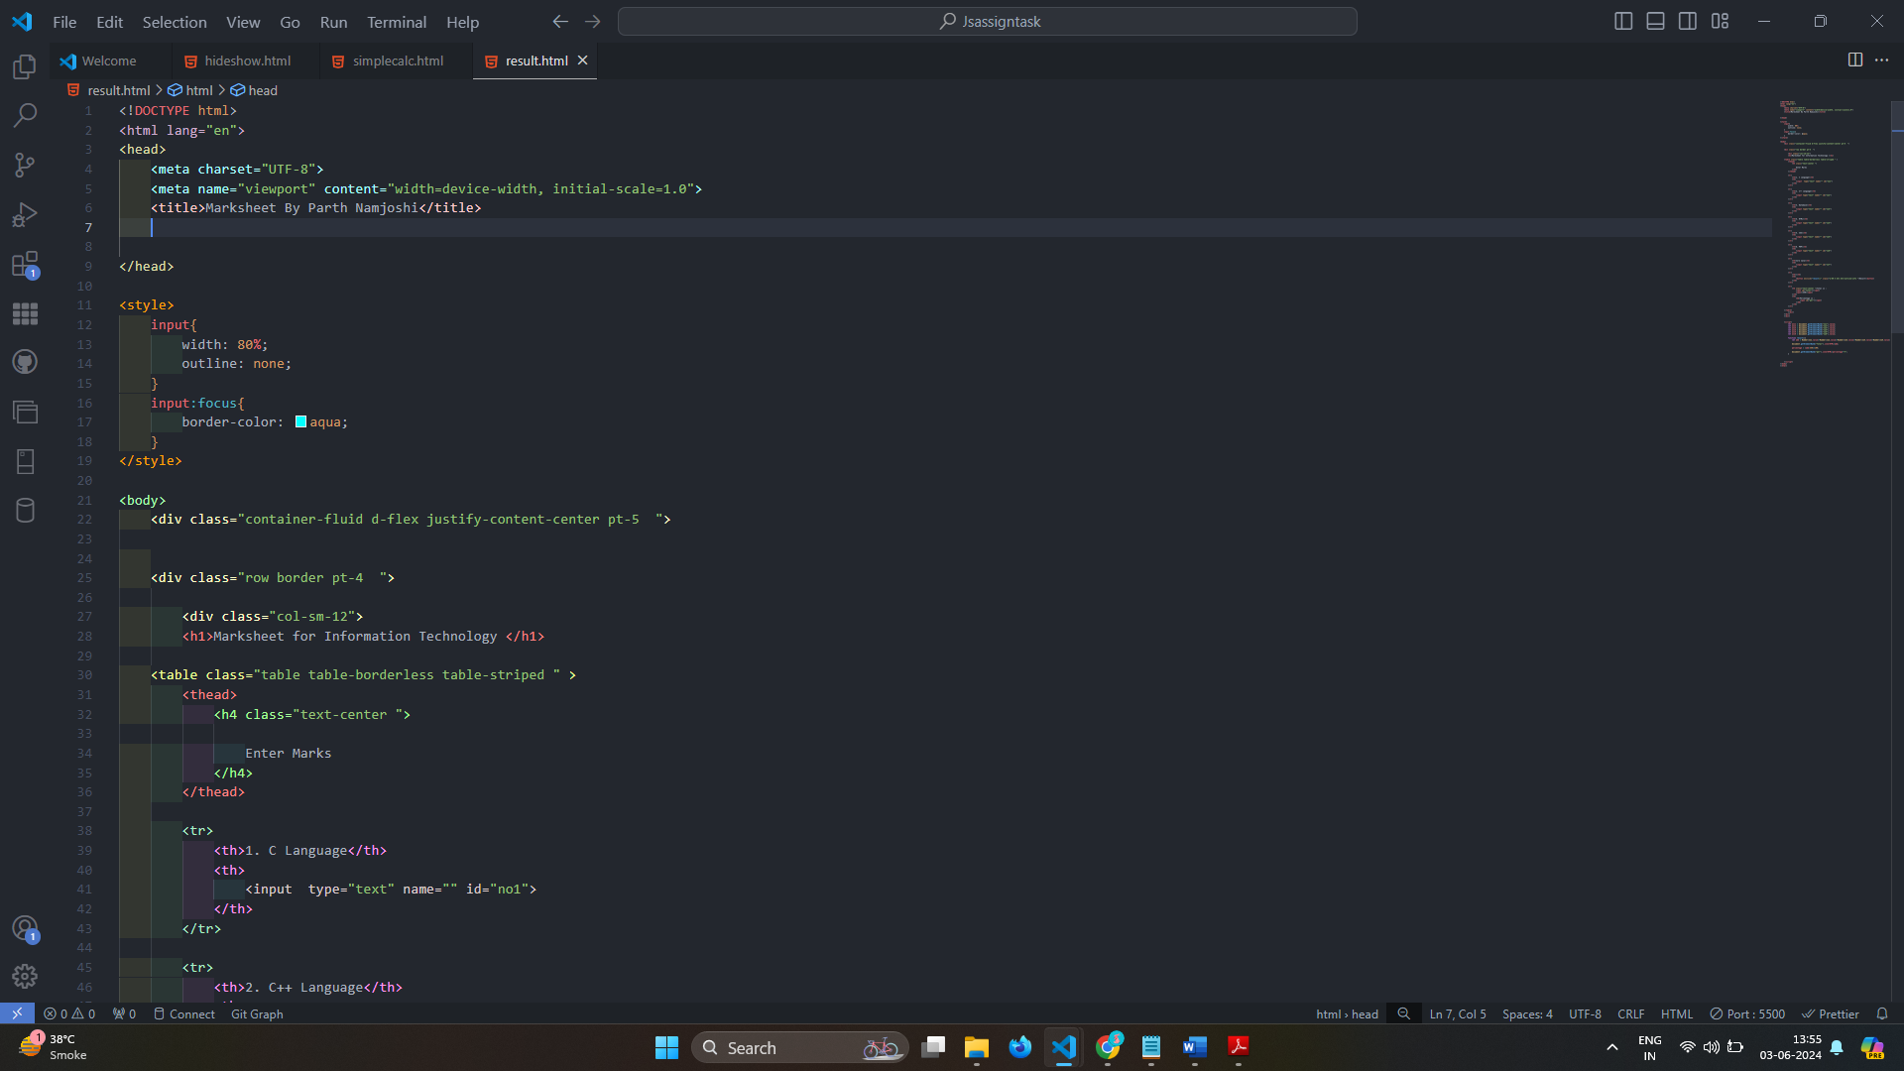

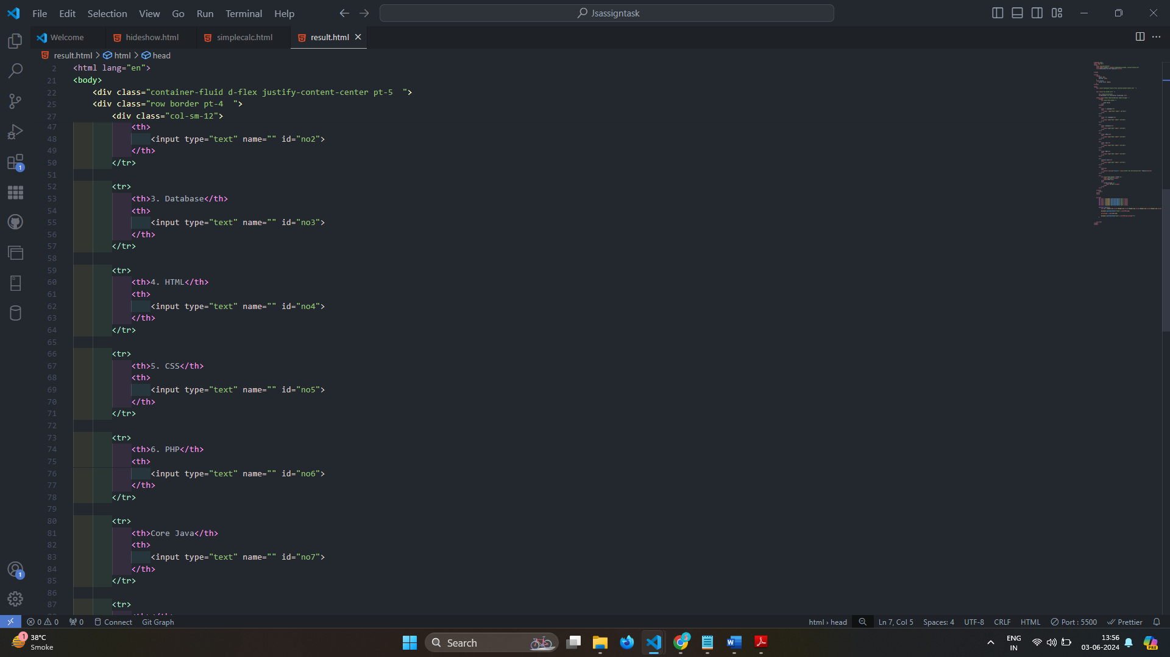

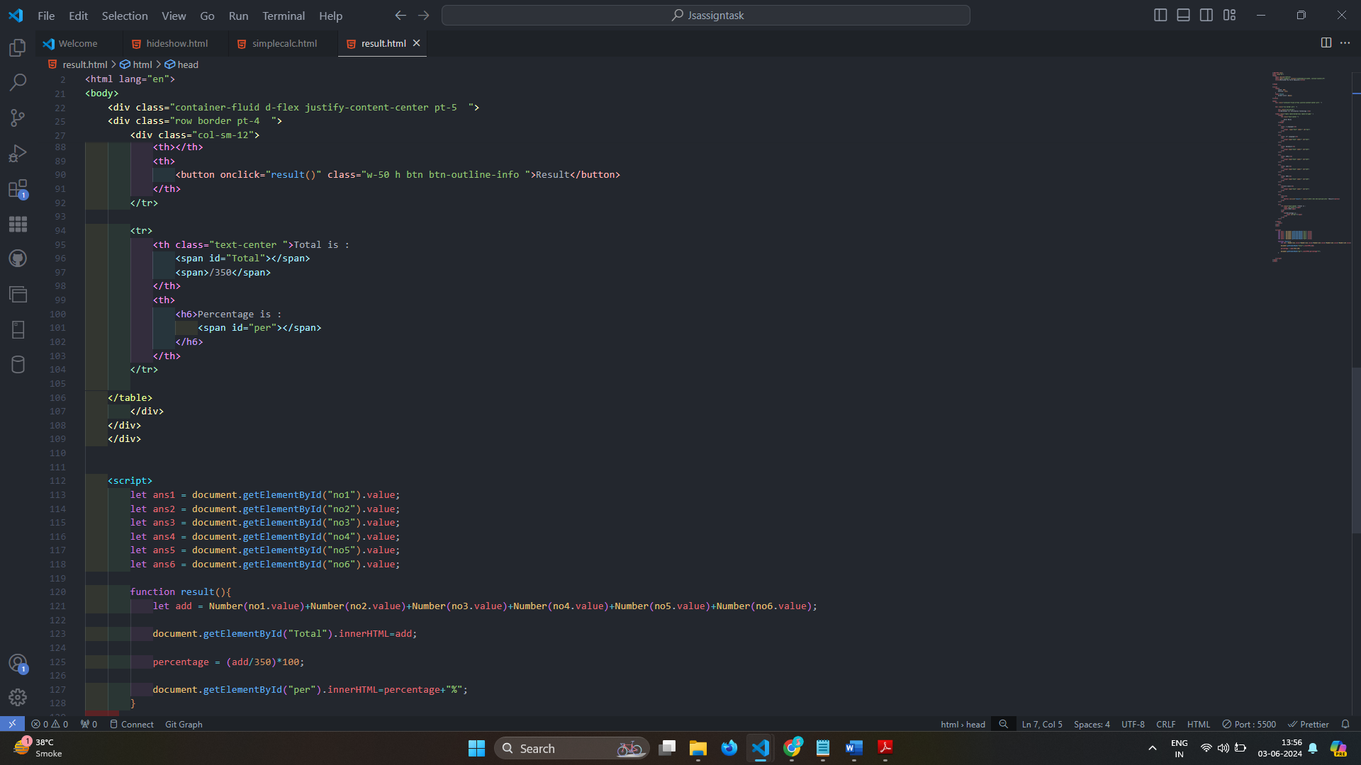

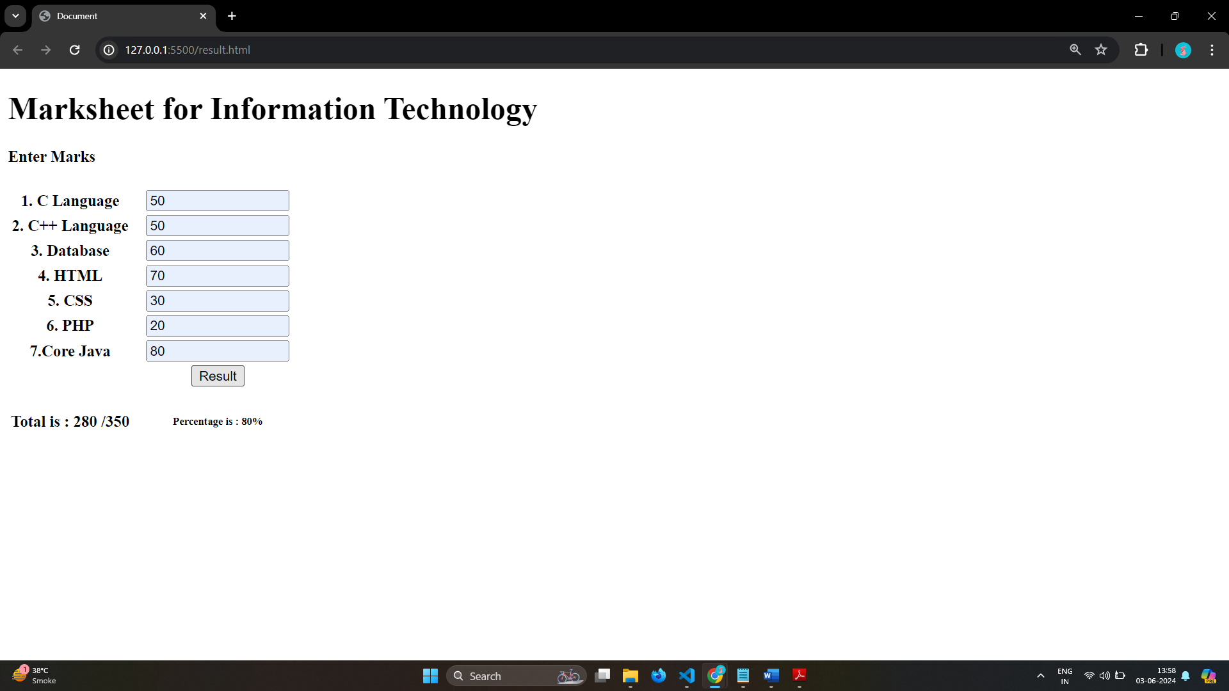

# Create a slider using JavaScript



Ans:

